

Job Description – Learning Support Assistant

Grading: LBR 3 Scale
Job Hours: 8.35am-3.35pm
Job Type: Fixed Term 12 months

We are excited to offer the opportunity for you to join our wonderful team at Redbridge Primary School as a Learning Support Assistant. Redbridge Primary School is a large four form entry school, with an ambitious learning community. We strive to achieve an environment where inspirational teaching and enrichment opportunities come together to create a true enjoyment and love of learning for our diverse community.
September 2023 marks an exciting new chapter for Redbridge Primary School following the promotion of one of our wonderful Deputy Head Teachers into the position of Head Teacher.
The future is very exciting indeed…we would love you to be part of it!
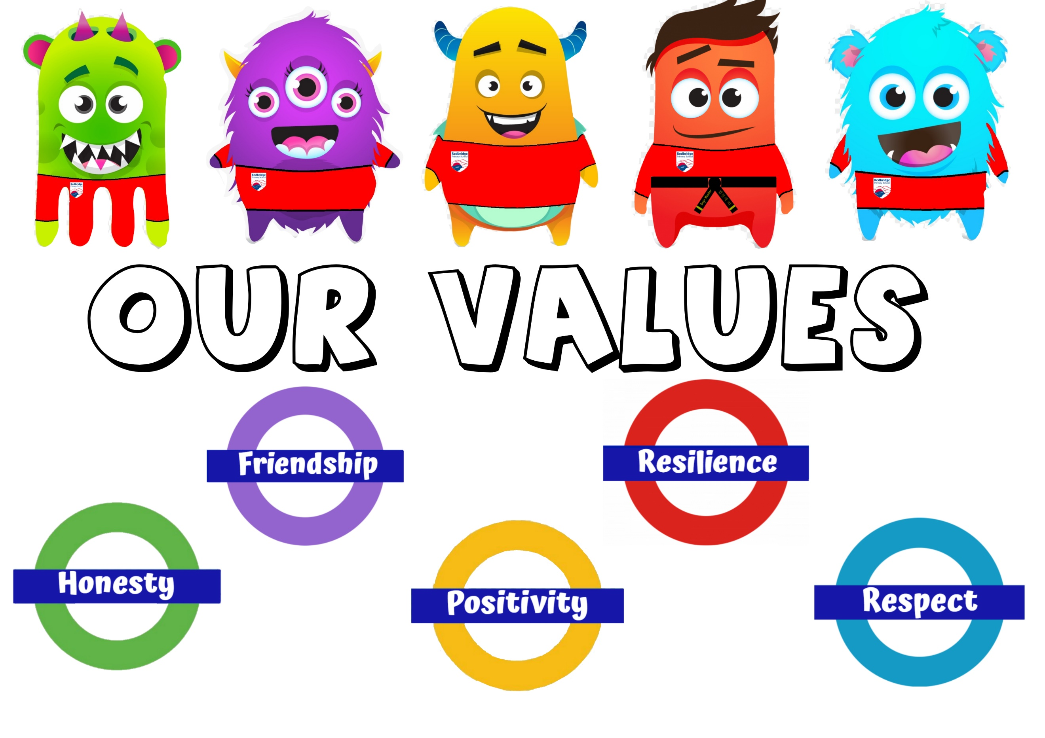

If you're looking for a great place to work, then Redbridge Primary School should definitely be at the top of your list. Here are some reasons why you should consider working at our school:
- Incredible Children: Our children are simply wonderful! They are kind, creative and enthusiastic about their learning. Everyone who visits our school comments on how welcoming and lovely our children are to be around.
- Dynamic Leadership: The school is led by a positive and experienced leadership team who are dedicated to ensuring that every child receives the best possible education. They are committed to being approachable and supportive to ensure that our staff team have the necessary tools and skills to undertake their jobs.
- Learning Environment: Redbridge Primary School prides itself on fostering an inclusive and welcoming environment where children can learn, grow and become the best version of themselves. Our curriculum places a strong focus on developing children's social and emotional wellbeing alongside their academic achievements, ensuring they thrive in all aspects of their lives.
- Family first approach: At Redbridge Primary School we don’t just accept, but we celebrate the fact that our staff have lives and their own families outside of school. Our people are at the heart of our success. We have developed a strong culture of collaboration and best practice. We look after, and invest in our staff with support, coaching, mentoring, as well as providing an award winning employee wellbeing service for all staff.
- Excellent Professional Development: The school places a strong emphasis on professional development, providing ongoing training and support to help you grow and develop as a teacher. You will have access to a wide range of resources, including training programs, coaching, and mentoring, enabling you to continually improve your practice.
- Supportive Community: At Redbridge Primary School, you will be part of a warm and welcoming community that is dedicated to providing the best possible education for its children. The school has strong links with our families, and the wider community, creating a supportive and collaborative learning environment.

Skills you must have:
- Experience of working with children with additional needs
- Experience of supporting families with children with additional needs
- Excellent teamwork
- Creative and forward thinking
- Flexible, excellent time keeper and ability to work to deadlines
- IT literate
Main areas of responsibility;
- Support children with additional needs under the directions of the teacher
- Feedback to children in a way that they understand how they have performed and what their next steps are
- Contribute to the Assessment of children following the school data system
- Contribute to written assessments and reports of individual pupils
- Work collaboratively with the SENCo and external professionals
- Develop life skills in our pupils through wider opportunities
- Attend professional development training sessions
- Provide a nurturing and purposeful environment for pupils
- Follow school policies and procedures
- Promote pupil progress through carefully designed support
- Contribute to wider school life
- Ensure EHCP provision is implemented
- Build and maintain positive relationships with children, staff and parents

Next Steps
If you have any questions about joining the team at Redbridge Primary, please contact us via e-mail, or call to arrange a conversation. We would also be more than happy to show you around our school.
Please have a look at our website and Instagram feed (redbridgeprimary.school) to get an insight into life at RPS!
Closing date for applications: Friday 22nd September 2023
Shortlisting will take place on: Friday 22nd September 2023
Interviews will be held: w/c 25th September 2023
Application forms should be emailed to: admin.redbridgeprimary@redbridge.gov.uk

Safeguarding Notice
Redbridge Primary School is committed to ensuring the highest levels of safeguarding and promoting the welfare of children and young people, and we expect all our staff and volunteers to share this commitment. All offers of employment are subject to an enhanced Disclosure and Barring Service (DBS) check, references, and where applicable, a prohibition from teaching check will be complete

