
HAREHILLS
PRIMARY
SCHOOL

Learn, laugh, love.

HEAD Teacher recruitment pack

Harehills Primary School actively promotes equality of opportunity for all staff, governors, pupils and parents, creating a harmonious learning community where all can succeed.


Letter to Applicants from our Chair of Governors Julia Shemilt.
Dear Applicant,
Welcome to Harehills Primary School, I hope that you can see from the pack and our website that Harehills Primary School is an inspirational and successful place to work. I have been the Chair at Harehills for over ten years and have seen it through some challenging times, but I am always proud of the passion and dedication of the staff team and the commitment to the children of Harehills Primary School, which I hope will shine through when you visit our school.
We are situated in an area of high deprivation, which is densely populated and has high mobility. This is managed with a high level of awareness, together with a strong commitment to our pupils. We have set high standards within school and the behaviour of our children is one of the ways we show that a school in this area can succeed and provide a strong start in children’s education and enable them to become confident, aspirational young people.
Following the retirement of our current Headteacher, we are looking for an experienced, passionate individual who shares our values and is committed to keeping the school moving forward on its journey to provide the best educational provision and practice for our children and families. As a successful leader, you’ll engage and inspire our children, parents, staff, and governors to continue to make our school a memorable and positive learning experience for everyone.
We see ourselves as a large team with a clear vision to be the best and governors work collaboratively with the Senior Leadership Team to achieve this. There are a large number of staff to manage, and we require an experienced leader who can inspire children, staff and the school community and provide a safe, happy environment for children to learn. The person we are looking for needs to understand our values and have vison to take the school on its next journey – this will not be easy, but it will be rewarding, and the school team will support you to succeed.
I wish you all the best in your application and I look forward to meeting you at interview,

Kind regards

Chair of Governors

Letter to Applicants from our current Headteacher Mrs Joanne Summerfield.
Dear prospective candidate,

I am delighted that you have shown an interest in becoming the next Headteacher of Harehills Primary School.

We may be a large three form entry school, but the sense of belonging is strong, and staff, children and parents work together as one big family. Our motto of ‘learn, laugh, love’ is reflected in every aspect of school life and as a result this is a happy and thriving place to be.

School continues to have many successes and is held in high regard. Overall, we are a strongly good school, and many aspects are securely outstanding. It is testimony to the strong relationships between staff, children, families, and governors that we have managed to sustain this throughout the challenges of Covid amongst other pressures. There is a commitment and willingness to do whatever it takes to achieve the best outcomes possible for every child.

Are you looking for a vibrant, inclusive school that celebrates its rich, cultural diversity, with polite, enthusiastic children who love to learn and relish every opportunity they are given?
Do you want to work with a talented, hardworking, and caring staff team and supportive governors? If so, then Harehills Primary is the school for you.

The school is in a very favourable position for its new Headteacher, and it is exciting to think of what the next stage of its journey will be.

I would love to show you around school so you can see what a special place it is. I cannot think of a more wonderful place to work.

Yours sincerely

Joanne Summerfield

Joanne Summerfield
Headteacher


About Our School

Harehills Primary School is a large (NOR 694), welcoming and warm environment for children and families aged 3 to 11 (with nursery) where we strive to provide an excellent quality of education. We are seeking a Headteacher who will take on the challenge of the Governors’ ambition to sustain a learning environment in which our children are engaged, enjoy learning, and have high aspirations. We are a local authority school located at the heart of a diverse community in Harehills, an inner-city area of Leeds.

Our children and school community are looking for someone who will:

- Have a clear vision for the future of our school.
- Provide strong, dynamic, and inspiring leadership and management.
- Be an excellent educator, committed to delivering and maintaining the highest standards in teaching and learning.
- Be an excellent communicator with the skills to positively maintain and develop our relationship with parents.
- Have a proven track record of developing and delivering the curriculum to help the school to reach its potential and more.
- Have high expectations for achievement across the full range of subjects and extra-curricular activity.
- Further develop our talented and committed staff team.
- Be committed to working in partnership with pupils, staff, parents, Governors, and the wider community.
- Ensure that the school’s caring ethos continues to be firmly embedded in all that we do.
- Be a team leader, team builder and team member.

At Harehills Primary School, we can offer you:
- An inclusive and dynamic school.
- A collaborative and inclusive culture with a focus on wellbeing.
- Happy, motivated, and creative children with excellent behaviour and a love of learning who make a positive contribution to the caring culture of the school.
- A well-informed governing body who will challenge and support you in equal measure.
- Enthusiastic and talented staff who are passionate about the children in their care.
- A supportive Local Authority including Learning Improvement Advisors, Consultants, and other services.
- Strong partnerships with other schools such as Cluster Inclusion Teams and the local Family of Schools Headteacher meetings.
- Active and mutually supportive links with the parents and the wider community.

About Our School

You will have the support of a highly experienced and knowledgeable SLT and Governing Body who are committed to wanting the best for our pupils at this early stage of their education and life.

If you are interested in finding out more, we warmly welcome a visit to meet our children and staff.

To arrange a school tour please send an email to Sam Willshaw at s.willshaw@harehills.leeds.sch.uk with your preferred date and time for your visit between 10th January 2024 to 24th January 2024, or by telephone on 0113 2350539.

At Harehills, we are passionate about celebrating the diversity of our children, families, and the staff community. We value the experience and contributions of people from all walks of life. We promote diversity and want a workforce which reflects the population of Leeds.

Our school is committed to safeguarding and promoting the welfare of children and expect all staff and volunteers to share this commitment. The successful candidate will be subject to a Disclosure and Barring Service (DBS) check.

Further information about our school can be found in our candidate application pack on our website, www.harehills.leeds.sch.uk Prospectus | PDF to Flipbook (heyzine.com) Early Years | Harehills Primary School or to request an application pack contact s.willshaw@harehills.sch.uk

Deadline for Applications: 29th January 2024 – Noon

Selection Process: 8th and 9th February 2024
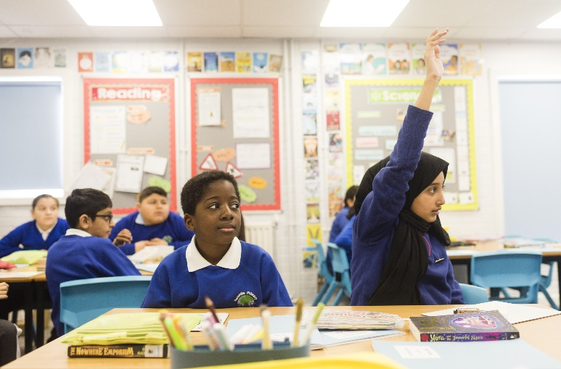
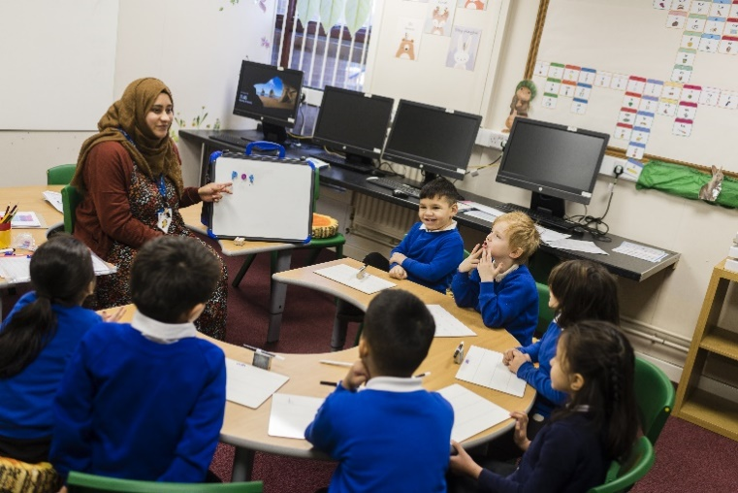


- Keep head boy and head girl and their deputies
- Playground friends- they help the children to feel safe during lunchtimes.
- Competitions- more competitions for things like writing and sports and more medals
- Respectful of all cultures
- Supportive of the community
- Give to charity.
- Take over day.
- School council is important.
- Sports day is a MUST.
- We must keep our lessons because we love our themes. They are really important and help us to learn.
- Fun
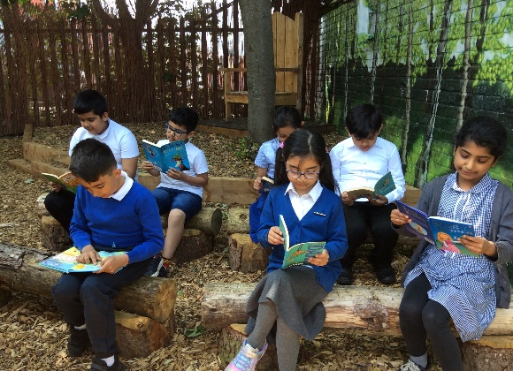
- Enthusiastic
- Good listener
- Keep attendance challenges and awards.
- Keep monster targets - they help us to improve our writing.
- Star of the week.
- Mrs Summerfield lets us wear different clothes on our birthday.
- Recycling- it is really important to look after the planet.
- It would be good if we could celebrate having more awards for improvement in lessons.
- We want to keep our MindMate Ambassadors to make sure our mental health is ok.
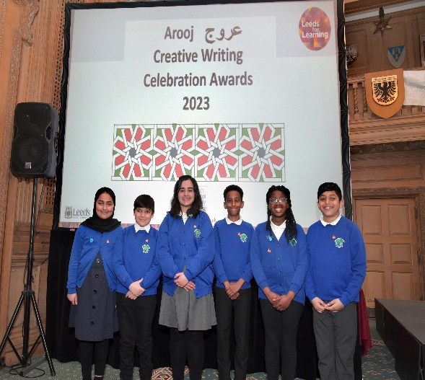
- Assemblies are really great.
- Be helpful.
- Be kind.
- Inclusive of everyone
- Good at speaking
- Someone who is generous.
- Someone who is really smart.

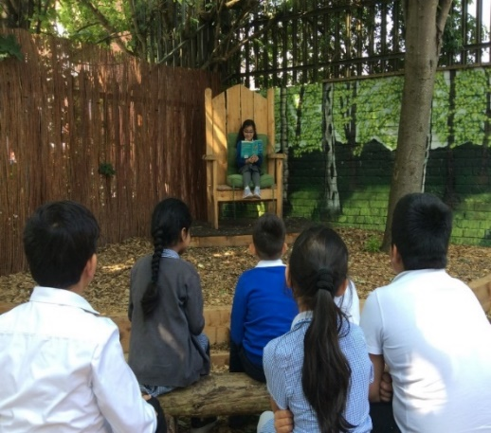
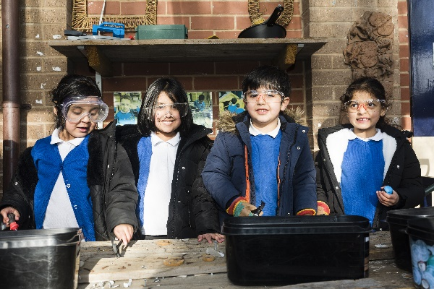



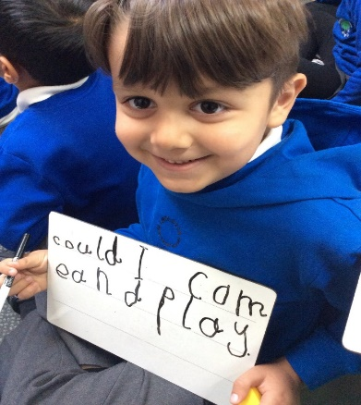

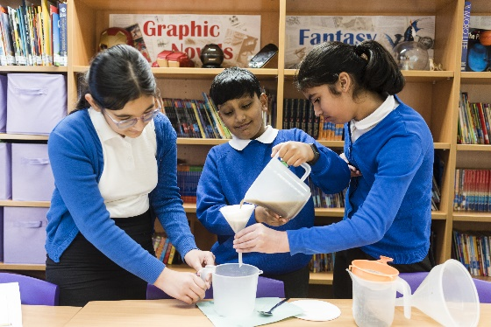
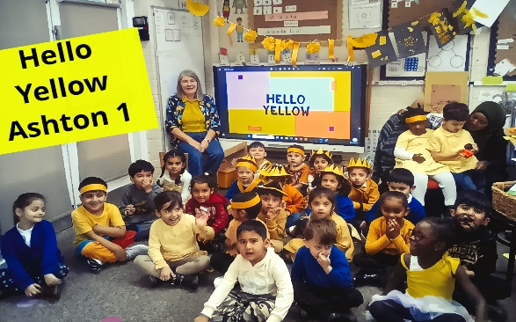


JOB DESCRIPTION
Headteacher
Location: Harehills Primary School
Pay Range: L21* – L27#
Main Purpose
The core purpose of the Headteacher is to provide professional leadership and management for the school. This will promote a secure foundation from which to achieve high standards in all areas of the school’s work. To gain this success the Headteacher must establish high quality education by effectively managing teaching and learning and using personalised learning to realise the potential of all pupils. The Headteacher should establish a culture that promotes excellence, equality and high expectations of all pupils.
Accountable to the Governing Body, the Headteacher provides vision, leadership and direction for the school and ensures that it is managed and organised to meet its aim and targets. The Headteacher, working with others, is responsible for evaluating the school’s performance to identify the priorities for continuous improvement and raising standards.

Statutory requirements
This job description reflects the National Headteacher Standards (2020). These standards are built upon The Teaching Standards (2013) which apply to all teachers, including headteachers.
The appointment is subject to the current conditions of employment of headteachers, contained in the Schools Teachers’ Pay and Conditions document, the School Standards and Framework Act 1998 and all other current education, employment and health and safety legislation.
The appointment is also subject to other current educational and employment legislations and policies laid down by the Governing Body under their powers derived from statutory sources.

Duties and Responsibilities
Section 1: Ethics and professional conduct
Headteachers are expected to demonstrate consistently high standards of principled and professional conduct. They are expected to meet the teachers’ standards and be responsible for providing the conditions in which teachers can fulfil them.
Headteachers uphold and demonstrate the Seven Principles of Public Life at all times. Known as the Nolan principles, these form the basis of the ethical standards expected of public office holders:
- selflessness
- integrity
- objectivity
- accountability
- openness
- honesty
- leadership

Headteachers uphold public trust in school leadership and maintain high standards of ethics and behaviour. Both within and outside school, headteachers:
- build relationships rooted in mutual respect, and at all times observe proper boundaries appropriate to their professional position
- show tolerance of and respect for the rights of others, recognising differences and respecting cultural diversity within contemporary Britain
- uphold fundamental British values, including democracy, the rule of law, individual liberty and mutual respect, and tolerance of those with different faiths and beliefs
- ensure that personal beliefs are not expressed in ways which exploit their position, pupils’ vulnerability or might lead pupils to break the law
As leaders of their school community and profession, headteachers:
- serve in the best interests of the school’s pupils
- conduct themselves in a manner compatible with their influential position in society by behaving ethically, fulfilling their professional responsibilities and modelling the behaviour of a good citizen
- uphold their obligation to give account and accept responsibility
- know, understand, and act within the statutory frameworks which set out their professional duties and responsibilities
- take responsibility for their own continued professional development, engaging critically with educational research
- make a positive contribution to the wider education system

Section 2: Headteachers’ standards

1. School culture
Headteachers will:
- establish and sustain the school’s ethos and strategic direction in partnership with those responsible for governance and through consultation with the school community
- create a culture where pupils experience a positive and enriching school life
- uphold ambitious educational standards which prepare pupils from all backgrounds for their next phase of education and life
- promote positive and respectful relationships across the school community and a safe, orderly and inclusive environment
- ensure a culture of high staff professionalism

2. Teaching
Headteachers will:
- establish and sustain high-quality, expert teaching across all subjects and phases, built on an evidence-informed understanding of effective teaching and how pupils learn
- ensure teaching is underpinned by high levels of subject expertise and approaches which respect the distinct nature of subject disciplines or specialist domains
- ensure effective use is made of formative assessment

3. Curriculum and assessment
Headteachers will:
- ensure a broad, structured and coherent curriculum entitlement which sets out the knowledge, skills and values that will be taught
- establish effective curricular leadership, developing subject leaders with high levels of relevant expertise with access to professional networks and communities
- ensure that all pupils are taught to read through the provision of evidence-informed approaches to reading, particularly the use of systematic synthetic phonics in schools that teach early reading
- ensure valid, reliable and proportionate approaches are used when assessing pupils’ knowledge and understanding of the curriculum

4. Behaviour
Headteachers will:
- establish and sustain high expectations of behaviour for all pupils, built upon relationships, rules and routines, which are understood clearly by all staff and pupils
- ensure high standards of pupil behaviour and courteous conduct in accordance with the school’s behaviour policy
- implement consistent, fair and respectful approaches to managing behaviour
- ensure that adults within the school model and teach the behaviour of a good citizen

5. Additional and special educational needs and disabilities
Headteachers will:
- ensure the school holds ambitious expectations for all pupils with additional and special educational needs and disabilities
- establish and sustain culture and practices that enable pupils to access the curriculum and learn effectively
- ensure the school works effectively in partnership with parents, carers and professionals, to identify the additional needs and special educational needs and disabilities of pupils, providing support and adaptation where appropriate
- ensure the school fulfils its statutory duties with regard to the SEND code of practice

6. Professional development
Headteachers will:
- ensure staff have access to high-quality, sustained professional development opportunities, aligned to balance the priorities of whole-school improvement, team and individual needs
- prioritise the professional development of staff, ensuring effective planning, delivery and evaluation which is consistent with the approaches laid out in the standard for teachers’ professional development
- ensure that professional development opportunities draw on expert provision from beyond the school, as well as within it, including nationally recognised career and professional frameworks and programmes to build capacity and support succession planning

7. Organisational management
Headteachers will:
- ensure the protection and safety of pupils and staff through effective approaches to safeguarding, as part of the duty of care and as the Designated Safeguarding Lead fulfil the statutory duties as defined in KCSIE 2021
- prioritise and allocate financial resources appropriately, ensuring efficiency, effectiveness and probity in the use of public funds
- ensure staff are deployed and managed well with due attention paid to workload
- establish and oversee systems, processes and policies that enable the school to operate effectively and efficiently
- ensure rigorous approaches to identifying, managing and mitigating risk

8. Continuous school improvement
Headteachers will:
- make use of effective and proportional processes of evaluation to identify and analyse complex or persistent problems and barriers which limit school effectiveness, and identify priority areas for improvement
- develop appropriate evidence-informed strategies for improvement as part of well-targeted plans which are realistic, timely, appropriately sequenced and suited to the school’s context
- ensure careful and effective implementation of improvement strategies, which lead to sustained school improvement over time

9. Working in partnership
Headteachers will:
- forge constructive relationships beyond the school, working in partnership with parents, carers and the local community
- commit their school to work successfully with other schools and organisations in a climate of mutual challenge and support
- establish and maintain working relationships with fellow professionals and colleagues across other public services to improve educational outcomes for all pupils

10. Governance and accountability
Headteachers will:
- understand and welcome the role of effective governance, upholding their obligation to give account and accept responsibility
- establish and sustain professional working relationship with those responsible for governance
- ensure that staff know and understand their professional responsibilities and are held to account
- ensure the school effectively and efficiently operates within the required regulatory frameworks and meets all statutory duties

Signature of Chair of Governors Date
Signature of postholder
Date
PERSON SPECIFICATION

Key:
App – Application Form
Ref – Reference
SP – Selection process.
This could include a range of assessment exercises, and a more formal interview.

Knowledge, Experience and Skills

 |  | Essential/  Desirable | How identified
Strategic Leadership
Experience of leadership roles |  | E | App/SP
Ability to build effective relationships with staff, parents, governors and external stakeholders |  | E | App/SP
Implements the schools vision and values |  | E | App/SP
Prioritises learning outcomes in all strategic decision making |  | E | App/SP
Ability to make and implement difficult decisions |  | E | App/SP
Implements a strategic plan across the whole school, identifying priorities and evaluating the impact |  | E | App/SP
Works with and motivates teams and individuals to implement changes across the school |  | E | App/SP
Awareness of the Leeds City and nationwide educational improvement agenda and other statutory changes in Education |  | E | App/SP
Understanding of entrepreneurial and innovative approaches to influence and drive forward school improvement |  | D | App/SP
Educational Excellence
Implementation of strategies which secure high standards of teaching and learning |  | E | App/SP
Experience of curriculum innovation and development that has resulted in raised standards |  | E | App/SP
In depth knowledge of the use of data to monitor pupil progress |  | E | App/SP
Effective use of assessment tools to monitor teaching and learning |  | E | App/SP
Ability to identify excellent classroom practice to enable teachers to improve, through effective feedback |  | E | App/SP
Regularly reviews own practice and continually participates in quality CPD |  | E | App/SP
A proven ability to motivate, lead and interact with staff, pupils and parents/carers. |  | E | App/SP
Operational Management
Recruits, develops, retains and manages a range of school staff |  | E | App/SP
Ability to deploy effectively staff and resources |  | E
Ensures effective performance management systems are in place and manage capability |  | E | App/SP
Ability to distribute work effectively |  | E | App/SP
Uses CPD to motivate, enthuse and develop all staff |  | E | App/SP
Effective use of robust and transparent effective interventions to ensure pupils maintain good progress |  | E | App/SP
Understanding of the main aspects of managing a school budget |  | E | App/SP
Financial management of school budgets |  | D | App/SP
Manages the school’s environment in line with health and safety regulations |  | E | App/SP
Implements changes to staffing structures |  | D | App/SP
Develops appropriate school development plans |  | D | App/SP
Securing accountability
Holds people to account for conduct and practice |  | E | App/SP
Works effectively with the governing body to ensure both parties fulfil statutory duties |  | E | App/SP
Provides performance data to parents, governors and school improvement officers |  | E | App/SP
Develops appropriate school policies and procedures |  | E | App/SP
Builds relationships and promotes the schools reputation with community groups, outside agencies and other schools which create innovative learning experiences for pupils and drive improvement in standards |  | E | App/SP
Works with parents and carers to improve pupil achievement |  | E | App/SP
In depth knowledge of relevant performance data and the ability to use it to drive school improvement |  | E | App/SP
Safeguarding
Can demonstrate knowledge of, and the ability to implement and adhere to, effective policies and procedures |  | E | App/SP
Ability to deal with sensitive issues in a supportive and effective manner |  | E | App/SP
Experience in strategies to manage behaviour |  | E | App/SP
Has experience of a multi-agency team approach |  | D | App/SP
Qualifications and training
Qualified Teacher Status or other educational qualification |  | E | App/SP
A degree or management qualification |  | E | App/SP
NPQH |  | D | App/SP
NCSL/CWDC Safer recruitment certificate  (Required within the first year of Headship) |  | D | App/SP
Personal qualities and attributes

Moral purpose (Equality, diversity and inclusion, children and adults treated with respect) |  | E | SP
Excellent communicator (Listening, putting a message across) |  | E | SP
Child centred |  | E | SP
Resilient | E |  | SP
Integrity | E |  | SP
Self-motivated and able to coach, mentor and motivate others | E |  | SP
Enjoys challenge | E |  | SP
Works to deadlines | E |  | SP
Enthusiastic and optimistic | E |  | SP
Excellent problem solving/analytical skills | E |  | SP
Emotional confidence (knowledge of strengths and areas of developments) | E |  | SP
Conceptual thinking (identify patterns between potentially unrelated concepts) | D |  | SP

