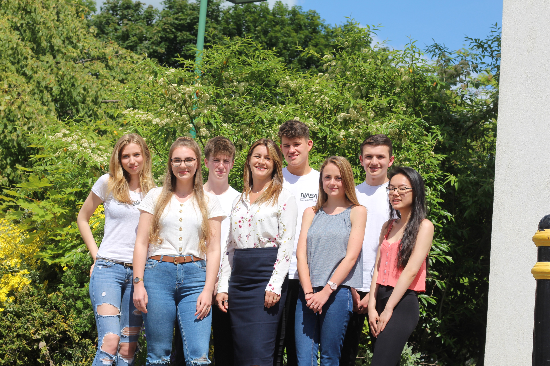
ob Title:

Part-time/Full-time Teacher(s) of
BTEC SD Performing Arts, A level Music and/or A level Theatre Studies

Pastoral Support Officer

Part-time/Full-time Teacher(s) of
BTEC SD Performing Arts, A level Music and/or A level Theatre Studies

Advertisement

Pastoral Support Officer

Scale: Grade 7 SCP 11-22

Contract: Full time (37hrs/wk), term time plus 10 days £20,619 - £23,685

Start date: 24th February 2020 or as soon as possible thereafter

This is an exciting time to join Durham Sixth Form Centre: we are an oversubscribed post-16 institution; our results are significantly above National Averages; we are expanding our premises; we have gained external recognition and national awards for our work; we are Outstanding as defined by Ofsted, March 2017.

We know that the very best way to continue to provide outstanding education is to ensure our teaching staff and support staff are outstanding. With this in mind we wish to appoint an energetic, highly organised Pastoral Support Officer to work as part of our Pastoral Team.

The successful candidate will have exceptional planning and time management skills; be able to inspire; have the ability to communicate effectively with post-16 students; and be committed to working in an inclusive environment in support of the values, vision, purpose and direction of Durham Sixth Form Centre.

The job description, person specification and application form are available from our website
www.durhamsixthformcentre.org.uk or alternatively from the Headteacher’s PA – Emma Tallentire. Applicants should complete the standard application form and submit a short letter of application. The closing date for applications is Wednesday 22nd January 2020.

“This school is committed to safeguarding and promoting the welfare of children and young people and expects all staff and volunteers to share this commitment”

Durham Sixth Form Centre:
- Is committed to safeguarding and promoting the welfare of children and young people and expects all staff and volunteers to share this commitment.
- Ensures all appointments are subject to an enhanced DBS check, satisfactory medical report and satisfactory references.
- Is an equal opportunity employer.
- Is a Local Authority Maintained school.
- Operates a strict no-smoking policy.

Dear Applicant,

Welcome to Durham Sixth Form Centre and thank you for your interest in the advertised post. I hope the following information gives you an insight into our school.

Durham Sixth Form Centre is the largest post-16 school in the North East of England (and 1 of 4 nationally), with approximately 1,500 students on roll. We are situated in the middle of Durham City Centre, a couple of minutes’ walk from both the bus and railway stations. Students generally enrol at Durham Sixth Form Centre from over 50 different secondary schools from across County Durham, Sunderland and into Northumberland.

We were inspected by Ofsted on 1st and 2nd March 2017 and are delighted with the outcome. We are an Outstanding post-16 school. Our students have an excellent record of success; they work hard to achieve it.

- Our A level results are above the national average and in the top 12% of schools in England.
- Students’ grades and points for A level are above both the County Durham average and national average.
- Students’ points and grades for their best 3 A levels are also above the national average.
- Our Applied General results (broad vocational qualifications) are above the national average and in the top third of schools in England.
- Students’ grades and points for Applied General are well above the County Durham average and national average.
- Our Tech Level (occupational qualifications) grades and points are well above the County Durham average and national average.

Most of our students continue their studies at university, some take up employment or apprenticeships; others stay with us into Year 14 where we run some Level 4 courses. Our award-winning Careers Information Advice and Guidance team support our students into higher education, employment or their chosen future pathways.

In 2013 we celebrated our Centenary year. We are housed in a 1913 former Girls’ Grammar School which was converted to Sixth Form accommodation in 1983. In addition to the original building there is now a Science Block; a 210 seated Theatre; our Hunter Resource Centre; Visual Arts Centre and Freemans Quay Leisure Centre. In 2019 we have expanded further to include our new Digital Media Centre which houses a grab-and-go Café, Conference Facility, TV Studio, small cinema room and additional classroom space.

Through sustained effort, and a clear focus and direction, Durham Sixth Form Centre is a truly embracing and dynamic organisation. We are committed to promoting the principals of equal opportunities and we aspire to an environment where all our students and employees can develop their potential. We have a strong professional development programme and have achieved CPD Mark accreditation, Investors in People and Governor Mark. Our recent Ofsted inspection report said ‘The Headteacher and the highly skilled leadership team have established a culture in which students flourish and grow. Consequently, there is a healthy appetite for learning and achievement in an environment that demands high expectations for academic, vocational and personal excellence’. The school operates according to values which we feel help to determine the culture, ethos and atmosphere of Durham Sixth Form Centre. We value:
- high quality, inspirational teaching and learning;
- excellent support, care and guidance;
- personal and professional integrity;
- ambition and progress for our students, our communities and ourselves.

If you are energetic and passionate about post-16 education and have the skills and aptitude required for the role then we would welcome your application and look forward to hearing from you.

Ellen Beveridge
Headteacher, January 2020

We seek the following in our Pastoral Support Officer:

Person Specification | Essential | Desirable
Five GCSE’s Grade C/4 or above including English and Maths. | ✓
Outstanding interpersonal and relationship building skills. | ✓
Flexibility to cope with a wide range of situations. | ✓
Ability to deal with delicate, difficult and confidential situations. | ✓
Ability to take difficult decisions. | ✓
Ability to ‘think on your feet’. | ✓
Excellent organisational skills with the ability to work to a high degree of accuracy with attention to detail, with energy and drive. | ✓
Ability to communicate effectively both orally and in writing. | ✓
Ability to inspire and challenge both students and colleagues. | ✓
The ability to bring out the best in people. | ✓
Ability to work as part of a team. | ✓
Experience of working with young people, parents and other stakeholders |  | ✓
ICT competency including use of spreadsheets. | ✓
The conviction to make a difference. | ✓
Boundless optimism, energy, enthusiasm and a sense of humour. | ✓
Proactivity and ability to take a lead. | ✓
Aptitude to evaluate, monitor and prioritise work with minimal supervision whilst meeting deadlines. | ✓
Exemplary health and attendance. | ✓
Committed to working in an inclusive school in support of the values, vision, purpose and direction. | ✓
To promote and safeguard the welfare of children and young adults. | ✓
A commitment to upgrading skills. | ✓

We have identified below where we anticipate gaining the information outlined in the Person Specification.

Person Specification | Application | Interview/  Selection Process | Reference prior to interview | Post offer check
Five GCSE’s Grade C/4 or above including English and Maths. | ✓ |  |  | ✓
Outstanding interpersonal and relationship building skills. | ✓ | ✓ | ✓
Flexibility to cope with a wide range of situations. | ✓ | ✓ | ✓
Ability to deal with delicate, difficult and confidential situations. | ✓ | ✓ | ✓
Ability to take difficult decisions. | ✓ | ✓ | ✓
Ability to ‘think on your feet’. | ✓ | ✓ | ✓
Excellent organisational skills with the ability to work to a high degree of accuracy with attention to detail, with energy and drive. | ✓ | ✓ | ✓
Ability to communicate effectively both orally and in writing. | ✓ | ✓ | ✓
Ability to inspire and challenge both students and colleagues. | ✓ | ✓ | ✓
The ability to bring out the best in people. | ✓ | ✓ | ✓
Ability to work as part of a team. | ✓ | ✓ | ✓
Experience of working with young people, parents and other stakeholders | ✓ | ✓ | ✓
ICT competency including use of spreadsheets. | ✓ | ✓ | ✓
The conviction to make a difference. | ✓ | ✓ | ✓
Boundless optimism, energy, enthusiasm and a sense of humour. | ✓ | ✓ | ✓
Proactivity and ability to take a lead. | ✓ | ✓ | ✓
Aptitude to evaluate, monitor and prioritise work with minimal supervision whilst meeting deadlines. | ✓ | ✓ | ✓
Exemplary health and attendance. | ✓ | ✓ | ✓ | ✓
Committed to working in an inclusive school in support of the values, vision, purpose and direction. | ✓ | ✓ | ✓
To promote and safeguard the welfare of children and young adults. | ✓ | ✓ | ✓
A commitment to upgrading skills. | ✓ | ✓ | ✓

PASTORAL SUPPORT OFFICER

Grade: 7 SCP 15-22

Hours: Full time (37 hours) – term time plus 10 days
Responsible to: Assistant Headteacher: Pastoral

Appraisal: Assistant Headteacher: Pastoral

Summary of the Key Areas of Responsibility:
To be a proactive member of the Pastoral Team. In the role the PSO should:
- Support the successful transition of learners into Durham Sixth Form Centre and beyond.
- Provide high levels of pastoral support, care and guidance to all learners and their families.
- Ensure all contact and communication with students in the Learning Hub (face-to-face, telephone, email) are dealt with in a courteous, professional and efficient manner.

Key Areas of Responsibility | Brief Outline
- Support the successful transition of learners into Durham Sixth Form Centre and beyond. | - Support the Pastoral Team to liaise with partner schools to ensure an understanding of student needs prior to enrolment.  - Assist the Recruitment Team with key transition events e.g. Y11 Open Day.  - Enrol Year 12 students onto a suitable programme of study in light of performance at KS4, interests and progression plans.  - Help to organise the Year 12 Induction Day.  - Work with students in the first half term to ensure all students settle quickly into school life.  - Support the re-enrolment of Year 13 students onto a suitable programme of study in light of performance in Year 12, interests and progression plans.  - Support students with careers education, information, advice and guidance including both access to HE and alternative routes.  - Support students applying to university through the UCAS process.
- Provide high levels of pastoral support, care and guidance to all learners and their families. | - Collate key information about the make-up of the cohort including relevant groups (Gender, MA, Disadvantaged, SEN, KS4 PA) to ensure there is an understanding of student needs so that all learners and groups of learners can be supported to achieve.  - Act as a first point of contact for both students and their parents, passing on key information so that the matter can be addressed and outcomes communicated as appropriate.  - Support the Pastoral Team to make relevant changes to programmes of study throughout the academic year in liaison with the student, parents and colleagues.  - Support students with emotional, social or welfare issues, directing them to other members of the Pastoral Team and support services offered within school as appropriate.  - Work closely with other members of the Pastoral Team, Student Support Services, the Health & Wellbeing Officer and the SENCO to ensure all student needs are met.  - Administrate the overview of student attendance at lessons so that it can be monitored and intervention put in place where necessary.  - Aid the Pastoral Team to respond to any student issues raised by subject teachers.  - Support the Pastoral Team to implement strategies which secure high standards of behaviour and attendance in line with the school staged sanction system.  - Hold parental meetings or organise meetings for other members of the Pastoral Team with students and their parents.  - Administrate and support the organisation, implementation and review of Student Support Plans with clearly identified next steps.  - Intervene with any student considering leaving Durham Sixth Form Centre, identify issues and liaise with other members of the Pastoral Team to act accordingly in order to retain successfully.  - Accurately record information about leavers / potential leavers and report trends.  - Monitor retention and destination information reporting trends.  - Support students appropriately so that they do not become a ‘Not in Education, Employment or Training’ statistic.  - Lead the Y12 Tutor Support Programme Team
- Ensure all contact and communication with students in the Learning Hub (face-to-face, telephone, email) are dealt with in a courteous, professional and efficient manner. | - Provide a central point of access for students requiring support (timetables, Systems Support (IT), exam queries).  - Administer supervised study periods for students/staff.  - Administer the provision of temporary lanyards to students and follow up accordingly.
In addition | - Be a visible presence in and around Durham Sixth Form Centre.  - Monitor student conduct in and around the site to ensure high standards are maintained.  - Organise and support student assemblies, seminars and workshops as appropriate.  - Support the organisation of Subject Consultation Evenings, including arranging meetings for identified students and their parents/carers.  - Attend Open Evenings.  - Attend Careers Events as appropriate.  - Be responsible for keeping both the Student and Parent Dashboards updated with relevant pertinent information.
Modelling | - To model the values, ethos and vision of the School in pursuit of excellence and equity, valuing individual achievement.  - To help build, communicate and implement a shared vision.  - To role model and actively promote high expectations for all members of the School community through the role within the structure.  - To contribute to the efficient management of School routines.  - To be an appraisal team member in line with School policy.  - To be aware of the responsibility for personal health, safety and welfare and that of others who may be affected by individual action/inaction.
Training/Qualifications | - The employee will be expected to undertake on-going research to develop their knowledge base and will undertake any CPD, inset and qualifications as deemed necessary by the Headteacher.  - Where formal qualifications are identified the employee will be required to sign an agreement to reimburse the school of any training costs incurred if the employee leaves before qualification and/or if they leave before a period to be specified after qualification.
Additional Hours | - In the event where the Headteacher requests additional hours to be worked over and above the contractual hours of 37 per week plus 10 days, time off in lieu (TOIL) will be given at flat rate as per Local Collective Agreement 2012. Timesheets must be submitted and approved by the Assistant Headteacher: Pastoral.
Day | Hours | Total hours in school | Lunch break | Total hours worked
Monday | 8.00am – 4.30pm | 8 hours 30 mins | 30 mins | 8 hours
Tuesday | 8.00am – 4.30pm | 8 hours 30 mins | 30 mins | 8 hours
Wednesday | 8.00am – 4.30pm | 8 hours 30 mins | 30 mins | 8 hours
Thursday | 8.00am – 4.30pm | 8 hours 30 mins | 30 mins | 8 hours
Friday | 8.00am – 2.30pm | 6 hours 30 mins | 30 mins | 6 hours
 |  |  |  | 38 hours

Note: This role will involve contact with parents which, due to their circumstances, are likely to have to take place out of the working hours. To this end the appointed colleague will work an additional hour/week (38 instead of 37). The additional time will be taken from the contractual plus 10 days. (1 hour per week x 39 weeks in the academic year = 39 hours). The remaining 35 hours will be covered for example, by attendance at our subject consultations evenings for parents. Any additional hours agreed above and beyond the 74 hours (plus 10 days) will be by negotiation and recompensed through time off in lieu (TOIL).

I have read and understand this job description and will carry out my duties accordingly and understand that is a working document that can be discussed, negotiated and changed at the agreement of both named parties’.

Signed: _____________________________ Date: _____________________________
Member of staff

Signed: _____________________________ Date: _____________________________
School HR and Data Manager on behalf of the School

Date for review: _______________________

Job Title: Pastoral Support Officer

Scale: Grade 7 SCP 11-22

Contract: Full time (37hrs/wk), term time plus 10 days £20,619 - £23,685

Start date: 24th February 2020 or as soon as possible thereafter

Should you decide to apply for the vacancy then please return a completed application form including the names, addresses and relevant contact details of two referees together with your short letter of application.

The letter of application should be no more than two sides of A4 and should set out the particular strengths that you would bring to the post; how you feel you meet the criteria outlined in the job description and person specification; a response to the following questions:

- Why are you interested in applying for the role?
- How would your skills meet the needs of the post?

Completed applications must be received by 10.00am on Wednesday 22nd January 2020 addressed to:

Emma Tallentire
Headteacher’s PA and Office Manager
Durham Sixth Form Centre
Providence Row
The Sands
Durham City
DH1 1SG

Or emailed to:

dsfc@durhamsixthformcentre.org.uk entitled ‘For the Attention of Emma Tallentire - Application for insert job title’.

Interviews are provisionally scheduled to take place during the following week.

If you have not heard from us within 4 weeks please assume that you have been unsuccessful on this occasion.

Durham Sixth Form Centre:
- is committed to safeguarding and promoting the welfare of children and young people and expects all staff and volunteers to share this commitment.
- ensures all appointments are subject to an enhanced DBS check, satisfactory medical report and satisfactory references.
- is an equal opportunity employer.
- is a Local Authority Maintained school.
- operates a strict no-smoking policy.

