JOB DESCRIPTION

Job Title: Teaching Assistant – Junior School
Reports to: Head of Junior School
Hours: 37.5 hours per week
Salary: £23,400 (Pro rata for term time only £18,121.50)
Application Deadline: 8.30am Monday 15 April 2024
Start Date ASAP
Guildford High Junior School is a lively, vibrant place where girls blossom personally, intellectually and socially. Open any classroom door and you will find happy pupils who are fascinated by the topics they are learning. We welcome girls from the age of four to eleven and provide a nurturing, stimulating environment as they take their first exciting steps into school life.
To Apply please click on the link:
https://ce0374li.webitrent.com/ce0374li_webrecruitment/wrd/run/etrec179gf.open?WVID=08237695fS&LANG=USA&VACANCY_ID=647250B2vR

Key Responsibilities:
The Teaching Assistant team works closely with form and subject teachers in assisting to provide a caring and stimulating environment for the girls in the school. The responsibilities will vary according to the needs of specific pupils or the form you are working with. These are full time positions during term time, Monday to Friday.
During lessons, the Teaching Assistant's time will be spent assisting teachers as directed and agreed with individual teachers, according to the needs of the children. This is an interesting and varied position, and you can expect your core role to include:
- Supervision of girls as they arrive at school
- Assisting the teacher as directed: this will include listening to pupils read and supporting the learning of individual and small groups of pupils
- Assisting the teacher with the observation and assessment of children and assist with record keeping as appropriate
- Discussing the welfare of the children in the form and help devise strategies for providing help where needed
- Assisting the teacher with the preparation of materials and resources for lessons and maintain resources in good order
- Assisting the teacher with the planning and compilation of displays and the provision of resources for creative activities
- Supervising girls during break and lunch times
- Accompanying girls on school visits and to be responsible for a small group of these girls
- Providing support in our wrap around care programme before and after school
Applicants will already need to have the legal right to work and reside in the UK and, if short-listed, be able to attend an interview at the school.

An example of a working week would look as follows:
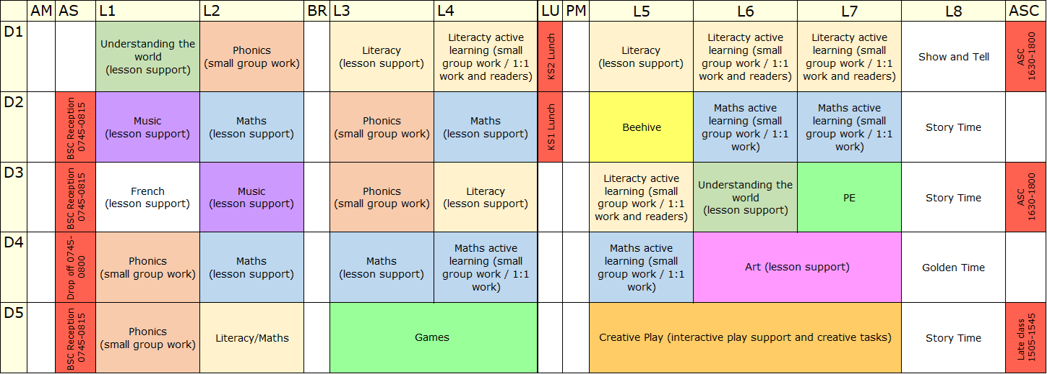
Why Guildford High School?
Whether you are already a TA or looking for somewhere to provide you with fantastic grounding for a future career in education or looking for something positive to do with a GAP year (and still benefit from the school holidays!) Working alongside talented, empathetic, and supportive staff in a very successful Junior School, the work will bring you into contact with staff, parents and pupils throughout the Junior School, so you will be developing your interpersonal skills constantly.
PERSONAL SPECIFICATION
Personal qualities
- Keen to contribute to providing an inspiring education
- Flexible, energetic and enthusiastic about providing the best educational experiences
- Eager to take advantage of the development opportunities available
- Willing to relish all aspects of school life, both curricular and extra-curricular
- An adult who our pupils will always remember.

Qualifications
- GCSEs: English Language and Mathematics GCSE Grade C/level 5+

Teaching and Learning
- Proficient skills in oral and written English, be good at listening, confident in the use of ICT and demonstrate great organisational skills.
- Ability to communicate warmly, confidently and professionally with pupils, staff and parents.
Philosophy and Ethos
- A commitment to safeguarding and promoting the welfare of children and young people
- High expectations for pupil attainment, personal development and conduct
- Commitment to best practice in pastoral support and student welfare
- Commitment to helping with extra-curricular activities and curriculum enrichment

