Post Description
We have a position for an experienced teacher with the ability to teach Physics or Chemistry to A level and at least one other Science subject at KS3/4. One of the posts, outlined in the department structure below, is available for the right candidate.

Curriculum Area Leader
(Mrs T. Bird)
Assistant curriculum Area Leader  Provision  TLR 2.5 |  | Assistant curriculum Area Leader  Provision  TLR 2.5
LPC  Biology  TLR 2.1 | LPC  Chemistry  TLR 2.1 | LPC  Physics  TLR 2.1 | LPC  Applied Science  TLR 2.1

You will be expected to teach across the age and ability range from mixed ability KS3 to A2 lessons including Oxbridge, Medical and Veterinary School Candidates. The Science department works closely as a team and supports all new members in their development. We are looking for someone with ideas and enthusiasm to contribute to the delivery of Science across the curriculum.

The department has a good blend of experienced staff and those new to the profession. The OFSTED report commented upon the excellent support and induction programme new teachers to the school receive.

The Science department was one of the highest performing departments at KS4 this year achieving 100% 9-4 in Biology, 98% 9-4 in Chemistry, 100% 9-4 in Physics, 79% 9-4 in Combined Science. At A level all disciplines achieved 100 pass rate with Biology 87% A*-C, Chemistry 72% A*-C and Physics 71% A*-C. Applied Science also achieved 100% pass rate.
The Science Curriculum
Key Stage 3
All Y7/8 groups are taught in mixed ability classes; differentiation, therefore, is particularly important. Over the past few years we have developed our KS3 into a more skills-based, multi-discipline course with units such as Life and Energise which all science teachers are expected to deliver.

Key Stage 4
We offer 2 routes of study at KS4; Separate Sciences and Combined Science on AQA’s Trilogy route. All students begin GCSE level science units in year 9 and are taught in sets based on attainment at KS3. The majority of our students continue on to complete a Combined Science award at the end of year 11. A small proportion will be selected for accelerated study to gain a GCSE in each Science and thus give them Biology, Chemistry and Physics awards. Results at all ability levels show positive value-added residuals; not surprisingly, therefore, many choose to continue to study Science in the Sixth-Form.
Post-16
We offer A levels in Biology, Chemistry and Physics as well as a level 3 BTEC in Applied Science (Single and double) with multiple groups in each of the three Sciences. Six 50-minute periods are allocated to each subject in the sixth-form and groups are shared between 2 teachers. Therefore, all members of the department get the opportunity to teach a level 3 qualification.
Extra-curricular
- KS3 Science club
- Robot wars club
- STEM club
- Widely respected transition courses with our partner primary schools.
Plus, entries into national competitions such as “top of the bench” and Olympiads.

The Department
The department comprises of 7 Biology teachers, 5 Chemistry teachers and 4 Physics teachers supported by 5 Laboratory Technicians.
As part of the National Forest Teaching School we play an active part in mentoring and developing student teachers as well as sharing good practice throughout our twilight programme.

Facilities and Resources
The Department has 11 Science laboratories and it is therefore possible for almost all lessons to be timetabled in rooms where practical work can be undertaken. These are most effectively maintained by the five technicians who provide a strong support for all teachers in the department.
The Department is well resourced with laptop computers and data-loggers. All laboratories are equipped with ceiling mounted projectors with 5 equipped with Interactive Whiteboards. All staff in the department have laptop computers.

Person Specification
The successful candidate should be:
- An excellent teacher of Biology, Chemistry or Physics with an ability to motivate pupils of all abilities to make progress
- Positive in outlook and believe in the power of education to improve children’s lives
- A team player, prepared to work with colleagues to move the department forward
- Passionate as a teacher and keen to inspire an interest in the subject across their classes and the school
- Have a thorough understanding of current developments and issues in the teaching of the subject
- Committed to continuing professional development
- Innovative and committed to develop solutions to raising achievements
- Knowledgeable of how assessment for learning, target setting and department improvement planning can raise achievement.
- Committed to equal opportunities
- Hardworking, committed, reliable and enthusiastic

In addition to be considered for a leadership role, we are looking for:
- The ability to effectively lead a team
- A high level of expertise in Science with a track record in raising standards
- An excellent teacher with a track record of success
- The ability to evaluate the quality of teaching and learning

Dunstall Rd, Barton under Needwood, Staffordshire, DE13 8AZ
T: 01283 247800 F: 01283 239333 E: recruitment@jths.co.uk W: www.jths.co.uk

D

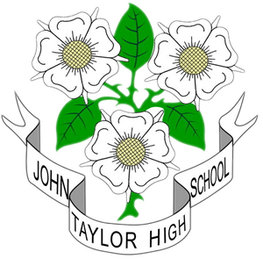

Assistant Curriculum Area Leader for Science TLR 2.5
(Ability to teach Chemistry and/or Physics up to KS5 an advantage)
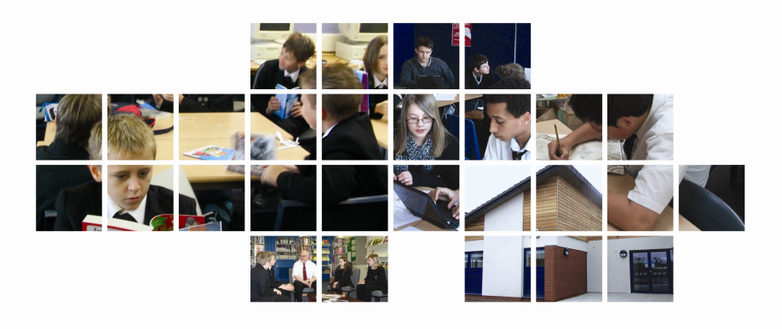

We subscribe to the Equal Opportunities policies of the Local Authority as employers. We are also fully committed to implementing child protection procedures and CRB checks.

Please complete the application form enclosed and send it to us, together with a letter persuading us that you have the experience and potential to fulfil the responsibilities and person specification by 9.00am by Monday 25th February 2019.

Head of School

