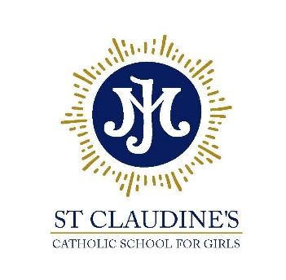

Diocese of Westminster

St Claudine’s Catholic School for Girls
Crownhill Road, London NW10 4EP
Tel: 020 8965 2986 | email: office@stclaudines.co.uk
Headteacher: Dr L McGowan, BMus (Hons) MA EdD NPQH FRSA

“Championing excellence and equality in all-girls’ education”

Learning Support Assistant

Salary: Scale 4, range 7-11 (Inner London, commencing on Point 7 - £20,812), plus London Weighting allowance of £2,094 per annum, pro-rated to 39 weeks
Working pattern: 08:30-16.00 Monday-Friday (08:30-16:30 Tuesdays & Wednesdays), 39 weeks per year (38 weeks term-time, plus 5 INSET days)
Required for: ASAP
Closing date: 26th September 2023
Interviews: w/c 2nd October 2023

*******

St Claudine’s Catholic School for Girls is a highly-successful Catholic girls’ comprehensive school (ages 11-19), where behaviour is outstanding and students are educated via a rich and diverse, holistic curriculum to become confident, articulate and independent young women.

We are seeking an experienced Learning Support Assistant to work within our SEND department. Reporting to our SENCO, the successful candidates will support students both in class and in leading withdrawal groups, as directed, assisting students with a range of learning needs, and fulfilling the school’s obligations for students with Education Healthcare Plans, as well as support for students with other learning and social/emotional needs.

Learning at St Claudine’s is rooted in the Gospel values in a warm, supportive and nurturing community. Even though we are a Catholic School, it is not a requirement to be Catholic and our international community welcomes staff and students of all faiths and none.

We are seeking a dynamic, hardworking and conscientious candidate with excellent interpersonal and organisational skills to join our busy school. Applicants for the role must have energy, enthusiasm and pride in a meticulous approach to work.

Candidates must be reliable and punctual, with an eye for detail and accuracy. Experience of working with children and young people is essential, and full training will be given.

Further details of this post are available on the school website: http://www.stclaudines.co.uk/joining-us/vacancies/

As part of our commitment to safeguarding and promoting the welfare of children you will be required to undertake a DBS check.

