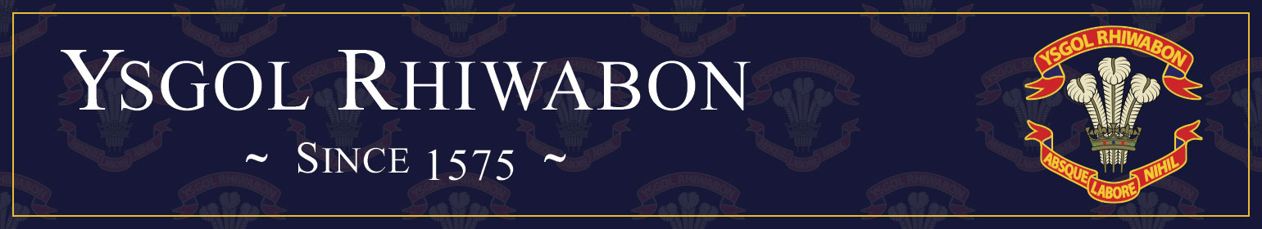

Vacancy Information Pack

Teacher of Science

Full Time, Permanent



Ruabon

Wrexham

LL14 6BT

**Tel**: 01978 822392

**Email**: [mailbox@rhiwabon-high.wrexham.sch.uk](mailto:mailbox@rhiwabon-high.wrexham.sch.uk)

[www.ysgolrhiwabon.co.uk](http://www.ysgolrhiwabon.co.uk)

**Headteacher**: Mrs M Ferron-Evans B.A. (Joint Hons), MSc, N.P.Q.H

|  |
| --- |
| **Full Time Teacher of Science** |
| **Required for September 2025**  We are seeking to appoint an enthusiastic and creative teacher of Science. This post would suit someone who is looking to develop middle leadership skills in the future.  We are looking for an innovative professional who is passionate about teaching and learning and committed to making a difference. The person appointed will be expected to teach across the age and ability range. You will need drive, energy and enthusiasm. In return we will provide you with;   * An induction support programme * Opportunities to play a role in shaping whole school development * A strong learning community with a clear focus on teaching and learning * An environment where your skills and talents can be recognised and developed through our excellent professional training.   The school is committed to safeguarding and promoting the welfare of young people and expects staff and volunteers to share this commitment.  This post is subject to an enhanced criminal records check from the Disclosure and Barring Service.  Wrexham Council welcomes applications from suitably qualified candidates regardless of race, gender, disability, sexuality, religious belief or age.  If you would like to be a part of our forward-looking, rapidly improving school and want the opportunity to develop your teaching career then please contact Mrs Emma Williams, PA to the Headteacher on Tel: 01978 822 392 or by E-mail: [**williamse45@hwbmail.net**](mailto:williamse45@hwbmail.net) to request an application pack.  **PLEASE RETURN COMPLETED APPLICATION FORMS DIRECTLY TO MRS EMMA WILLIAMS, PA TO THE HEADTEACHER VIA EMAIL OR POST** |
| **Closing Date – Monday 10th March 2025** |



Thank you for the interest you have shown in our school. Ysgol Rhiwabon, with its proud history, is a very special place to work. Our family ethos surrounds all who work and study here, creating a safe, supportive and nurturing environment. This is an exciting time in the development of our school and I hope you will agree that this role will present you with real opportunities to develop your career in the heart of a local community. I very much hope that, after reading the information below you will feel that you want to play your part in our process of rapid improvement and innovation, securing progress and achievement for all our students.

**About us**

**Headteacher**: Mrs M Ferron-Evans

**Age Range**: 11-16 years

**Number of pupils**: 512

**Staff**: 31 Teaching Staff and 14 Learning Support Assistants

It is with great pride and pleasure that I introduce Ysgol Rhiwabon. We are a caring, family school with excellent community links with Ruabon and its surrounding villages. Ysgol Rhiwabon has a proud heritage, which provides us with the firm foundations we need to develop the youngsters in our care. At the same time, we are a modern, innovative school with lots of exciting learning experiences available for our students. We continually review provision to ensure that we meet the needs of all our learners.

We have a very caring, hardworking staff in Ysgol Rhiwabon and visitors to our school comment regularly on the calm, happy, family atmosphere where standards of uniform and behaviour are high and where our young people are supported and challenged to be the very best they can be.

We continue to be one of few schools in Wales in the Prince’s Teaching Institute which involves our staff and students in outstanding training. As part of this, two of our students were invited to represent schools from across the UK in a Prince’s Teaching Institute Conference and they have both featured in national publications, commenting on inspirational teaching. Staff from our school are asked regularly to be consultants for the Princes’ Teaching Institute. This year we will lead in Science, History and at Senior Management Level. This keeps Ysgol Rhiwabon at the forefront of best practice across the UK.

In recent times our school has improved in so many ways, modernising and responding to the many changes which face our staff every year. Ysgol Rhiwabon is founded on strong traditional values, and it is this which will lead to our continued success in the future. We look forward to developing even stronger links in the village and beyond as our young people and staff see opportunities to learn and contribute both in school and the local and wider community. This is particularly important as we embrace the significant reforms which will develop education in Wales for future generations.

We are very proud of our school and the many achievements of our students and staff. We look forward to sharing this with you when you visit us.

**Mrs M Ferron-Evans**

**Headteacher**