THE GRANGE SCHOOL

Specialising in Business & Enterprise



TEACHER OF MATHEMATICS



THE GRANGE SCHOOL

The Grange School is a well established, friendly school, specialising in Enterprise.
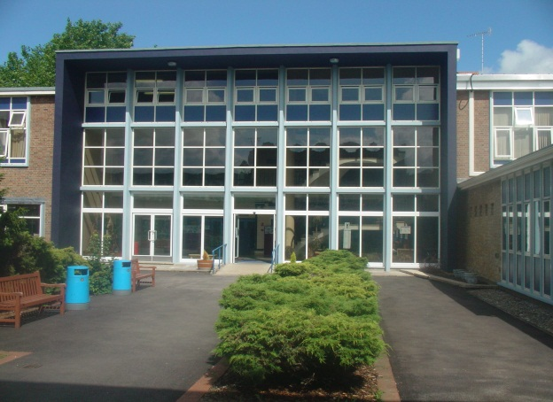
Enterprise is a driving factor throughout learning as evidenced by our Grange Enterprise and Learning Skills (GELS) which are embedded across the curriculum.



We aim to equip all students with the adaptability and flexibility to meet the demands of a rapidly changing world and to promote a sense of responsibility towards others, the school and the wider community. The support and guidance of students is based on a Year system and aims to develop co-operation, involvement and respect in all students.

A broad and balanced curriculum is provided for Years 7 to 9. In Years 10 and 11 all students will study English, Mathematics, Science, PE, RE, ICT/Computing and PSHCE (Personal, Social & Health and Citizenship Education). Students can then choose from a range of additional GCSE, BTEC and vocational courses. We offer a range of traditional and vocational courses at Key Stage 5. The curriculum in all Key Stages is further enhanced through wide ranging extra curricular experiences.

We aim to attract energetic and conscientious staff who have a commitment to the education of our students. The professional development of all staff is an important focus for the school. We strive to create a learning environment which serves the needs of all the members of our diverse and vibrant community.

THE GRANGE SCHOOL

TEACHER OF MATHEMATICS

JOB PROFILE

- To raise the level of achievement of all students.

- To be part of a team which will have an impact on students’ levels of numeracy and literacy, empowering them both within the curriculum and in their lives beyond school.

- To contribute to the team’s development of an exciting and dynamic curriculum, which will challenge and motivate all students.

- To have a commitment to an extra-curricular programme, which supports both the academic and cultural life of the school.

- To work within a strong and supportive team that is based on excellent communication and shared good practice.

- To foster good relationships with students and with home, including attendance at parent-teacher consultations.

- To support students’ learning by the use of the school’s policies of marking, assessment, record-keeping, reporting and target-setting.

THE GRANGE SCHOOL

THE MATHEMATICS DEPARTMENT

STAFF AND STRUCTURE

The department consists of eight subject specialist teaching staff, including one Lead Practitioner, one Strategy Manager with responsibility for Key Stage 3 and one Intervention Coordinator. They form a strong, hard working and enthusiastic team who work very well together to engender in students a love of Mathematics and a desire to learn. The teachers, from diverse cultures, bring a variety of experiences and teaching styles as well as coming from a wide range of academic backgrounds.

THE MATHEMATICS DEPARTMENT FACILITIES

In total there are seven classrooms allocated to the Mathematics Department. Five of these are at the front of the building with the other two, newly refurbished rooms, found centrally in the building.

We also have access to the new computer suites to deliver areas of the KS3/4 curriculum.

All our classrooms are equipped with interactive whiteboards.

EXTRA CURRICULAR

Students at The Grange School are very keen to progress in Mathematics; this is reflected in the number of students who choose to attend extra after school sessions at all key stages.

At KS3, students are encouraged to attend enrichment sessions. In Year 11, GCSE students are eager to attend revision sessions in the Spring/Summer terms.

New to this academic year is a lunchtime intervention club available to all Key Stages, which both stretches the more able student and supports learning.

Some students in KS4 visit Imperial College for Mathematic Conferences.

Students taking AS and A2 level Mathematics attend conferences (both locally and in London) and University taster days.

Candidates are invited to visit the school prior to interview.
Please contact Mrs Jenny Bell, PA to Headteacher, to make an appointment.
The Grange School, Wendover Way, Aylesbury, Bucks, HP21 7NH
Tel: 01296 390900
Fax: 01296 390991
E-mail: office@grange.bucks.sch.uk
www.grange.bucks.sch.uk

