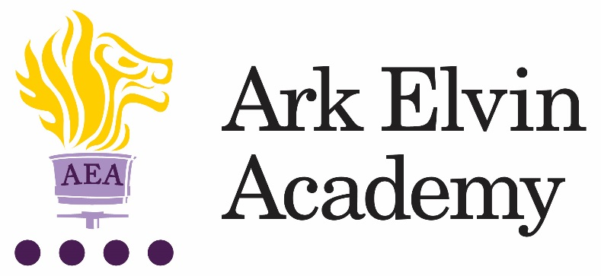

Job Description: Sixth form study supervisor
Reports to: Assistant Principal Head of Sixth Form
Start date: ASAP
Contract: 2 year fixed term contract, Part-time hours minimum 20hrs per a week but flexible and open to discuss hours at interview stage, term time only
Salary: Ark salary band 5 pay point 5-13 £25,762 - £29,419 (actual salary based on part-time hours 20 hrs per a week £12,310 - £14,058)

The Role
Our new Sixth Form is as unique as our pupils – we offer ambitious pupils an alternative route to the best universities and apprenticeships through our academic programmes - Professional and Foundation Pathway – and our wrap around support.
This is a key role within working alongside the AP Head of Sixth Form to provide high quality administrative support and working with pupils to develop their use of independent study time.
Key responsibilities
Administrative
- Sixth Form reception duties, deal with day-to-day student enquiries, issue off site passes to sixth form students once correct documentation is produced.
- Using school systems and programmes to
  - Attendance and punctuality tracking, including updating termly attendance display for 100% attendance and punctuality.
  - and make morning calls
  - Collection and collation of assessment and attendance data by lesson, daily and weekly summaries, half termly summary and termly report
  - Manage Academic Support Plans – collect and report data weekly to HoY.
- Support pupils with UCAS admissions - · Collection and collation of enrichment activities undertaken by students to inform UCAS applications.
- Administration of Sixth Form Applications, interviews, and contracts.
- Manage pupil bursary applications and logistics · Assist in printing/distributing sixth form student timetables, creating/printing sixth form student materials
- Generation of resource materials for pastoral programmes.
- Presentation of data for reports, progression information, destination, and marketing.
- Marketing; updating of web site, updating of subject offer booklet, updating sixth form prospectus, administrative support in preparation for Open evenings and Action Planning days.
- Administration support to process enrolment data at point of entry in September
- Administration of Induction Programmes
- General Administration Support to 6th Form Head of Year and Head of Subject.
Study Supervision
- Manage the culture in the study room to enable hard work from all pupils
- Work with HoDs and teachers to direct study for pupils
- Work with school librarian to build and curate a resource library online
- Support 1:2:1 or small groups with study skills intervention
- Manage and Supervise PM study club
Other
- Assist with administration of sixth form events and trips as directed by Head of Year or Head of Subject.
- Support student intervention strategies
- Assist in results day
- To undertake training and development relevant to the post and in line with the Academy’s developing profile.
- Undertake any other tasks as directed by the Principal or Head of Sixth Form

Person Specification: Sixth form study supervisor
Qualification criteria
- English & Maths GCSE (or equivalent) at Grade C or above ·
- Ideally qualified to at least A-level
- Right to work in the UK
Knowledge, Skills and Experience
- Experience of working in a school environment is ideal but not essential
- Experience of working with young people is ideal but not essential
- Experience of establishing successful learning relationships with a variety of children at the relevant age
- Relentless drive to do whatever it takes to ensure all pupils succeed.
- Embody our core values – integrity, courage, community, and mastery – in all aspects of work and conduct.
- The belief that with the right environment all of our pupils are able to excel at university, or in a meaningful alternative.
- The courage and conviction to make a difference.
- The ability to listen and communicate effectively.
- Empathy and the ability to understand the needs, aspirations and motivation of diverse individuals and groups.
- The ability to influence and motivate others.
- Develop and communicate a shared vision.
- Model desired behaviour and values.
- Develop plans with concrete outcomes and effective solutions.
- Evaluate results and identify necessary actions.
- Make fact-based decisions
Personal Characteristics
- Helpful and positive nature
- Able to communicate and relate well with students, parents and members of the community
- Keen to learn and develop own skills
- Reflective: able to review own performance
- Driven: Keen to take initiative and continually looking for ways to improve systems and procedures.
- Flexible attitude towards work; can adapt quickly to new demands
- Commitment to the values and ethos of Ark Elvin Academy especially a belief in our mission.
- Sustain energy, optimism, and motivation in the face of pressure and setbacks.
- Stay calm in difficult situations and maintain clarity of vision.
- Be adaptable in the face of adversity.
- Awareness of own strengths and limits.
- Commitment to ongoing improvement and learning.
- A passion for own role and that of others.
- Focus on achieving challenging goals and results.
- Resourcefulness and flexibility in delivering outcomes.
- Demonstrates resilience, motivation, and commitment to driving up standards of achievement.
- Acts as a role model to staff and students.
- Vision aligned with Elvin’s high aspirations, high expectations of self and others.

Specific skills
- Highly competent in the use of ICT – especially Excel and Word
- Experience of working with CMIS or similar school data management system
- Excellent communication skills, both written and oral
- Excellent administrative and organisational skills
- Ability to manage and disseminate information in a range of different media
- Extremely organised and able to deliver on time and to agreed quality standards
- Ability to work well as part of a team
- Understands the importance of confidentiality and discretion
Other
- The post holder must be committed to the equality of opportunity and the safeguarding and welfare of all pupils.
- This post is subject to an enhanced DBS disclosure.
Ark is committed to safeguarding and promoting the welfare of children and young people in our academies. To meet this responsibility, we follow a rigorous selection process, details of which can be provided if requested. All successful candidates will be subject to an enhanced Disclosure and Barring Service check.

