HEAD OF CRICKET
ST LAURENCE EDUCATION TRUST
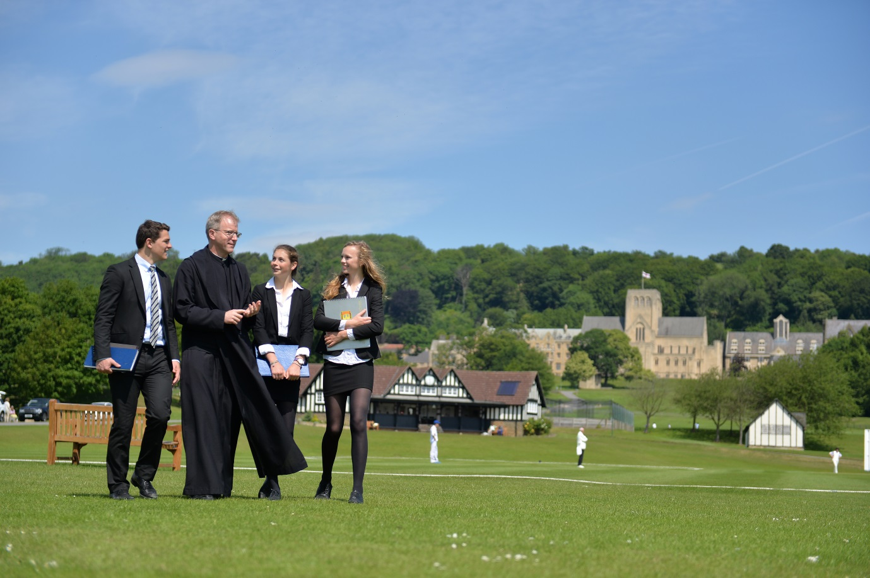

INFORMATION PACK
FOR CANDIDATES

Introduction

Ampleforth College is a Roman Catholic boarding co-educational Independent School (HMC), with c. 600 students aged between 13 and 18 years set in a rural environment in North Yorkshire.
The school was established by the Benedictine monks of Ampleforth Abbey in 1803 and it remains a work of the monastic community, with a small number of monks on the teaching staff, monks as House chaplains throughout the school, and monks working in partnership with lay people as trustees. The presence of a community committed to the highest standards of Catholic education ensures the preservation of an education rooted in the Catholic Benedictine tradition.
The monastic community has a long history, dating back centuries before the community finally settled in North Yorkshire in 1802. The works of the community include not just education at Ampleforth College and its prep school, St Martin’s Ampleforth, but also St Benet’s Hall, a Permanent Private Hall of the University of Oxford, the pastoral care of a number of parishes, and a dependent monastery in Zimbabwe, founded in 1997.

The School
Education has always been one of the main works of the Benedictine monastic community and a year after the community settled at Ampleforth in 1802, a school was established comprising twelve boys. Today, nearly six hundred students, male and female, from many parts of the world, come to Ampleforth to benefit from a Benedictine Catholic education.
In 1999 Ampleforth College was formally opened to VI Form day girls, and VI Form boarders followed in 2001. The school became fully co-educational in 2010-2011.

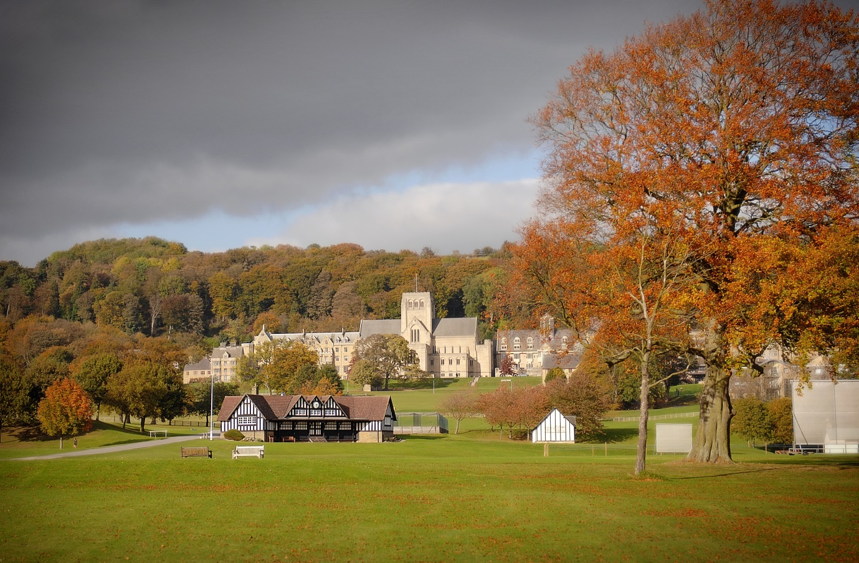

Benefits of Service

Professional Opportunities and Career Development

The St Laurence Education Trust supports and resources continuing professional development programmes for all staff. The Trust operates an annual professional review and appraisal scheme that both recognises the work of staff and identifies suitable training and development opportunities for them.

Working Environment

This is an enjoyable and stimulating place to work. Our staff body seeks to work to core values and codes of conduct developed from the Rule of St Benedict:

They are:

Attentiveness
Hospitality
Respect
Integrity
Stewardship
Equilibrium

Facilities such as the sports centre and golf course are available to staff and their families on subsidised membership.

The site was not originally designed with the motor car in mind. However, staff parking is available within a five minute walk of any part of the Ampleforth campus.

Employees with children in the school may be able to access discounts, discretionary bursaries, or salary sacrifice in line with current school policy. Fee remission is available for this post.

Remuneration and Benefits
- Ampleforth salary scale.
- Ampleforth discretionary allowance
- Contributory pension scheme
- Notice – one term on either side
- Rented accommodation may be available from the College
- Some assistance with removal expenses.

Selection Process

The Trust is committed to a policy of equal opportunity and will take every possible step to ensure fair and equal treatment of all.
All Trust policies and practices will support the commitment to equality of opportunity in respect of any recruitment, and selection process. No member of staff or applicant will be unfairly disadvantaged by the Trust policies or practices without justification.
The Application Process

The successful applicant will take up post in April 2020 or sooner. The interview process will include a formal interview. Further details will be provided once the short-list has been agreed.

Applications should be sent to:

The Human Resources Department, Ampleforth College, York, YO62 4ER.
Telephone: 01439 766817
Fax: 01439 766770

e-mail: HumanResources@ampleforth.org.uk

or from our website at:
https://www.ampleforth.org.uk/

Candidates should be aware that all posts in a school boarding environment must be interviewed on the basis of an application form. CVs will not be accepted in substitution.

Safeguarding and Child protection at Ampleforth Abbey Trust
Ampleforth College is committed to safeguarding and promoting the welfare of children.
All applicants must be willing to undergo recruitment screening processes including interview, references from past employers and a Disclosure and Barring check will be carried out on all successful applicants.
All posts at Ampleforth are exempt from the Rehabilitation of Offenders Act 1974. We therefore require applicants to declare all convictions, cautions and bind-overs, including those regarded as ‘spent’. All information provided will be treated as confidential.
Our Child Protection Policy can be accessed from the following link:
Child Protection Policy
Any offer of employment is made subject to a full range of checks and satisfactory references.

The Role

We are looking for a committed Head of Cricket to join our team of specialised sport coaches. As Head of Cricket you will strategically deliver a well-rounded 11-18 cricket programme that seeks to provide opportunity for all pupils. You will be responsible for the overall administration of cricket in accordance with agreed School policies and establish a Five Year Development Plan / Skills Audit for cricket. You will organise and manage all cricket fixtures across all age groups and teams, working closely alongside the Sports Admin Assistant ensuring all transport, umpiring and catering arrangements are in place. In addition to this, you will be responsible for developing individual players by providing player pathways to professional clubs, Universities and local cricket clubs. You will provide relevant CPD for your team of cricket coaches and ensure that each coach understands their role effectively.

Ampleforth College has a long and distinguished sporting tradition. With both boys and girls enriching the sporting life of the school enormously. The philosophy of the department has been to provide a rich and varied sporting experience for all, as well as specialist provision for the most talented. We are proud to offer further sporting opportunities.

Our sporting facilities are second to none, set in a stunningly beautiful valley of the North Yorkshire Moors. Recent developments include; re-laying the hockey Astroturf pitch, renovation of the swimming pool in the St. Alban Sports Centre, building a ‘High Performance Suite’ for strength and conditioning and a brand new changing facility down in the valley.

Further details are available on the college website (www.ampleforth.org.uk)
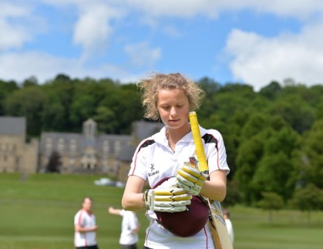

Job Description

Responsible to the Director of Sport at Ampleforth College, the successful candidate will work with students of all ages and abilities to develop their talents and enthusiasm in cricket. The ability to offer a curriculum subject up to at least GCSE will be considered an advantage. Performing duties in the most cost-effective and efficient way, demonstrating all due care to safer practice for children and for all relevant Health and Safety legislation. Satisfy all criteria and checks relating to suitability to work in a school environment.

General Responsibilities of Teachers:
- To support the policies and aims of the School and to exercise the highest standards of professionalism.
- To teach and coach in such a manner as to maintain the best academic standard, to support the individual needs of pupils and to encourage an enthusiasm for, and an interest in, the subject.
- To keep up to date with current educational developments and to attend any necessary courses as advised or instructed by the Director of Sport or Director of Professional Development.
- To undertake, as directed, agreed supervisory tasks and to be a House Tutor, supporting activities within the house
- To attend Staff Meetings, Staff briefings and Parents’ meetings.
- To attend full School Assemblies and Year Group Assemblies as appropriate.
- To contribute to the general breadth and quality of pupils’ experiences within the School by
    - helping to provide opportunities for curriculum enhancement
    - contributing to sport and to the running of activities.

SPECIFIC RESPONSIBILITES - HEAD OF CRICKET:
Responsible for the strategic development, leadership and management of 11 – 18 cricket provision at St. Martin’s Ampleforth and Ampleforth College.
Main Duties:

- Strategically deliver a well-rounded 11-18 cricket programme that seeks to provide opportunity for all pupils.
- Responsible for the overall administration of cricket within Ampleforth College in accordance with agreed School policies.
- Establishing a Five Year Development Plan / Skills Audit for cricket. This should cover performance, coaching and facilities at all levels (including SMA).
- Organising and managing all cricket fixtures across all age groups and teams at Ampleforth College. Working closely alongside the Sports Admin Assistant ensuring all transport, umpiring and catering arrangements are in place each week.
- Developing individual players by providing player pathways to professional clubs, Universities and local cricket clubs.
- Lead and manage all cricket coaches ensuring that they understand their roles each week and manage the external coaches that are in place which provide support to the cricket programme.
- To share good practice with all coaches.
- Attracting and recruiting potential players to the College and developing external links.
- Managing the weekly cricket programme (including contingency plan) in communication with the Director of Sport and ensuring all equipment and storage areas are maintained appropriately.
- In partnership with the Director of Sport, overseeing the continual development of coaching staff.
- Delivering a broad set of enrichment opportunities promoting cricket within the school.
- Organising, managing and supporting all relevant House competitions.
- Reviewing and recommending budgets for the sport in conjunction with the Director of Sport.
- Supporting the cricket programme through coaching the 1st XI.
- Being responsible for the organisation of regular sport tours in line with the departmental policy.
- Making recommendations for additional, but appropriate ‘sport specific’ staffing to the Director of Sport, supporting the development of the sport through specialist sessions.
- Working alongside the Marketing Department promoting sports events, taster days, recruitment drives.
- To ensure risk assessments are developed, understood and enforced at all coaching sessions.
- Ensure Safeguarding and Health and Safety regulations as stated by Ampleforth College are adhered to at all times.

Person Specification
The person appointed will satisfy all or most of the following:

- have a good degree in subject directly related to sport or another curriculum subject
- be committed to sharing their enthusiasm for their sport with students of all ages and abilities
- be well organised and adaptable, able to prioritise tasks and work effectively as part of a team
- to have a Level 2 cricket coaching qualification alongside significant experience of coaching children between the ages of 11-18.
- have experience of playing first-class, professional or high level representative cricket
- have sympathy with the aims and ethos of a Roman Catholic Benedictine boarding school
- be able to satisfy all criteria and checks relating to suitability to work in a school environment
- be committed to sharing their enthusiasm for their subject with students of all ages and abilities
- be well organised and adaptable, able to prioritise tasks and show initiative
- have the ability to evaluate and improve their own performance
- have the ability to establish good working relationships
- have good ICT skills including the use of ICT to enhance teaching and learning
- be able to contribute to the extra-curricular life of the school
- have a willingness to take on a pastoral responsibility

