SPORTS COACH

Candidate Pack

(Part time and temporary)
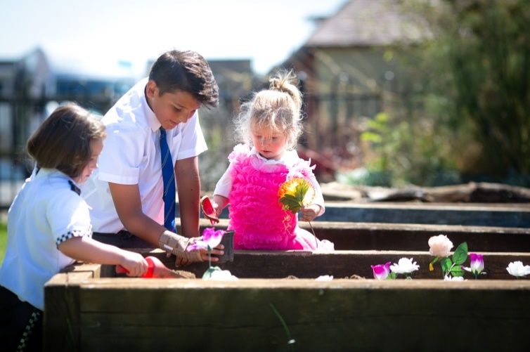

Introduction
An energetic, enthusiastic Sports Coach is required to help lead this highly regarded co-ed prep school through an exciting phase of development and expansion. This successful candidate will work alongside the Director of Sport to provide engaging and purposeful coaching sessions.
Application Date: Apply by noon on Thursday 9th December 2021
Interview Date: Tuesday 14th December 2021
Contract start: January 2022
Contract end: 9th July 2022 – potential to be extended for a further year.
Location: Cricklade, Wiltshire (SN6 6BB)
Contract type: Part Time Minimum 10 hours a week up to 14 hours a week based upon the needs of the school and arrangements of school fixtures.
(Monday, Tuesday, Wednesday and Thursday afternoons)
Contract term: Temporary. Potential to be extended for a further year.
Cricklade Manor Prep (formerly Prior Park Prep) is a long-established Independent Prep School located in the heart of Cricklade, Wiltshire. Cricklade is a short drive from the M4 and A419, making it easily accessible from Cirencester, Swindon, Malmesbury and surrounding areas.
The school is housed on an 8-acre site within the town, including a handsome Grade II listed manor house, a separate Pre-Prep department housed within a walled garden, a number of purpose-built classroom blocks and extensive sports facilities including AstroTurf and grass pitches, a sports hall and swimming pool.
The Experience
Cricklade Manor Prep educates boys and girls from age 2 to 11. At the end of their time at the school, pupils move on to a wide range of independent, grammar and maintained schools. The school’s mission is built around three key pillars: Challenge, Motivate & Prepare.
The school aims to:
- Develop the academic, musical, creative, sporting and other talents of each boy and girl.
- Provide outstanding pastoral care in a secure, happy, nurturing environment, underpinned by principles of tolerance, kindness and respect.
- Create an outward-looking ethos, building links with parents and the local community.
- Prepare leavers for entry to senior schools at 11+.
- Enable leavers to be confident, capable, caring and independent minded.
To find out more about the school visit: www.cricklademanor.com
The Future
In September 2017, the school joined the Wishford Schools group and Guy Barrett was appointed as Headmaster to lead an exciting period of investment, modernisation and development. The school was relaunched as Cricklade Manor Prep in January 2018 and has been through an exciting few years of development and growth.
Wishford Schools
Wishford Schools is a small, friendly group of nine independent schools. The group aims to provide an excellent education to all pupils, giving every child the opportunity to shine. Standards and expectations are high, and staff and pupils are challenged and supported to give their best.
For more information on the Wishford Schools group, please visit: www.wishford.co.uk

The Opportunity
Cricklade Manor prides itself on being able to offer sport for all, at a level appropriate to the child. We are extremely fortunate to benefit from outstanding facilities including: a multi-purpose indoor sports hall, 8 acres of playing fields of which we have 1 x grass cricket wicket and 1 x astro-turf cricket wicket, 2 x astro-turf hockey pitches, 2 outdoor netball courts and a 4 lane 25m outdoor swimming pool.

Pupils benefit from 4 lessons of Games coaching per week of which 2 lessons are dedicated to fixtures. Our offering sees Boys’ play rugby in the Autumn, hockey in the Spring and mixed cricket and athletics in the Summer. Our Girls’ play hockey in the Autumn, netball in the Spring and mixed cricket and athletics in the Summer.

We continue to raise the profile of sport across our school. In accordance with The Cricketer magazine ‘Good Schools Guide’ we have been listed as one of the Top 50 Prep Schools to offer cricket in the Country for the past 3 years. We have been awarded with the ‘Your School Games’ Gold award for delivering high quality PE and Games. We also successfully support a number of pupils with 11+ sports scholarship to top senior schools.

Candidates are sought who can demonstrate:
- Suitable qualifications and playing credentials.
- An enthusiasm and passion for a range of sport, with a focus on: Rugby, Hockey and Cricket.
- A maximum of 3 points on your driving license.
- Ability to adapt sessions at short notice.
- Excellent communication and relationship-building skills.
- An energetic, proactive approach.
- Willingness to contribute fully to school life.

A full job description and person specification can be found below.
An affinity with independent schools would be advantageous, but experience within the sector is not a requirement.
Remuneration & Terms
£20 - 22.50ph based upon experience and relevant qualifications.
Application Process & Important Dates
Applicants should obtain an application form from: https://www.cricklademanor.com/vacancies/
and submit this by email to Lesley.bayliss@cricklademanor.com

The closing date for applications is noon on Thursday 9th December.

Cricklade Manor Prep is committed to safeguarding and promoting the welfare of children. Applicants must be willing to undergo child protection screening appropriate to the post, including checks with past employers and the Disclosure and Barring Service.

Job Description

Sports Coach
Responsible to: | Headmaster  Deputy Head  Director of Sport
Purpose of the job: | Sports Coach to share the responsibility for the efficient running of the school and the provision of successful pastoral care and academic progress of all pupils.
Relationships: | The post holder is directly responsible to the Headmaster, the Deputy Head and Director of Sport and works closely with fellow teachers.
Responsibilities: | Teaching and Learning  - Working alongside the Director of Sport to run engaging and purposeful coaching sessions.  - To provide a safe, friendly, stimulating environment in which the pupils can flourish.  - Lead teams for fixtures against schools from the local area.  - Communicate effectively to Staff, Pupils and Parents.  Pastoral  - To take responsibility for the pastoral care of pupils allocated.  - To promote the general progress and well-being of individual pupils and of any class or group of pupils assigned, maintaining good order and behaviour in line with the school's policies and expectations.  - To maintain the high standards of dress and behaviour for their pupils.  - To adhere fully to all school policies including: Anti-Bullying, Safeguarding and Behaviour policies.  Administration and other responsibilities  - To Drive groups of 8 children to local fixtures.  - To undertake break/lunchtime supervision duties as required.  - To organise/assist with after-school activities as required.  - To maintain high standards of professionalism at all times.  - To ensure good and effective liaison across the school and to promote positive relationships.  - To follow and support all school policies and procedures.
Annual Review: | This job description will be reviewed annually and may be subject to amendment or modification at any time after consultation with the post holder. It is not a comprehensive statement of procedures and tasks but sets out the main expectations of the School in relation to the post holder’s professional responsibilities and duties.

Person Specification
The successful candidate will have the following skills, experience and qualities:

Skills
- An enthusiasm and passion for Cricket.
- Ability to adapt sessions at short notice.
- Excellent communication skills and ability to build relationships with pupils, parents and colleagues.
- Excellent planning, administration.

Experience
- Suitable qualifications and playing credentials.

Personal Qualities
- Lead by example with honesty and integrity.
- A ‘can do’ attitude and the willingness to work hard to get things done.
- A strong entrepreneurial spirit.
- Ability to play a significant role in the local community, raising the school’s profile.
- Ambition, energy, enthusiasm and commitment.
- A confident and outgoing personality.
- Flexible and adaptable.
- A full, clean driving licence.
- A good sense of humour!

