Hills Road Sixth Form College, Cambridge
Appointment of a Teacher of Art & Design

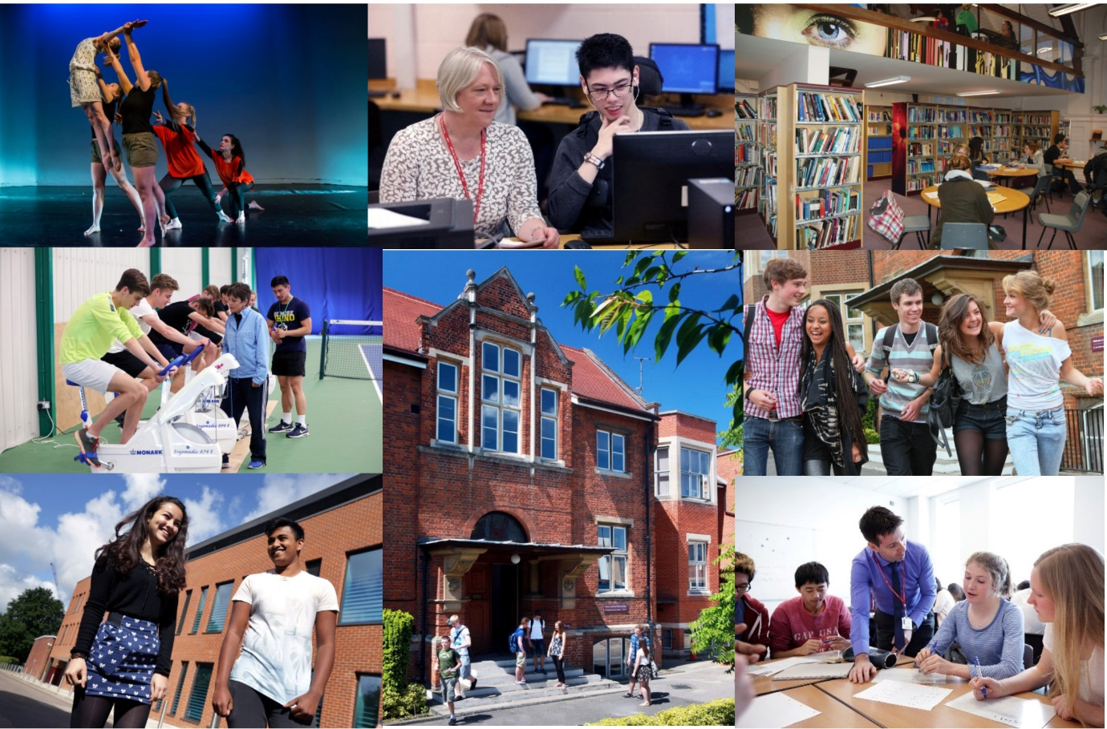

Opportunity ● Quality ● Achievement

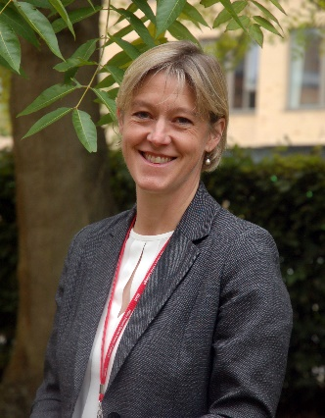
Welcome from the Principal

Thank you for your interest in Hills Road Sixth Form College and in this post. We really hope that the information in this booklet will support you in making an application to our College and will provide all you need for deciding whether our College is right for your next career step. We hope it is!

Choosing an institution where you find a fit in terms of ethos and values is hugely important. Hills Road Sixth Form College enjoys a strong national reputation, having topped Sixth Form College performance league tables for outcomes since their inception over twenty years ago. But that doesn’t make us complacent. We still want to evaluate and improve the ways in which we work with young people to get the best for them and from them, whatever that might take.

We are therefore looking for a colleague to join us who shares that drive and wants to make a real difference by communicating a passion for their subject and sharing that enthusiasm and expertise with our students. As a specialist A level College we have a fantastic cohort of students to work alongside and we will be seeking a colleague who is committed to making A level learning experiences as good as they can be. Through the application and interview process, we’ll be keen to understand your ideas and approaches to delivering the best learning experiences and outcomes for A level students.

As an education organisation, we’re keen on learning and will be keen to support you to keep developing in your time with us and to share that learning with others. At our biennial Learning Fairs, we share action research projects of ways in which we’ve been working with students to secure increasingly positive outcomes. As part of the Cambridge and Suffolk Schools Alliance, we have opportunities to learn from schools across both counties in the primary and secondary age ranges too which in turn informs our thinking about the best ways to meet the needs of A level learners.

As a busy, vibrant community of nearly 2,400 young people, there’s always a great deal going on and lots to be part of and take part in. Extra-curricular opportunities abound and we hope you will want to get involved with the extraordinary range of activities that is on offer. If you would like to talk through a prospective application or to explore the College’s ethos and values a little more, please don’t hesitate to make contact for an informal chat.

Finally, I do appreciate the time commitment involved in completing a job application and, if you do decide to apply, can I thank you for the investment of time you have chosen to make. Whatever the outcome, can I wish you all the very best with securing a positive difference for young people, wherever that may be.

With very best wishes
Jo Trump
Principal

Overview of the College

The College

The College operates on an attractive site just over a mile south of the centre of the historic city of Cambridge. The site has been occupied from 1903 when it was originally home to the Cambridge and County School for Boys. Since its inception in 1974, succeeding the former boys’ grammar school, the College has concentrated mainly on providing Advanced level courses to students in the Cambridge area. Having responded to strong and sustained demand for places over a number of years, we now have over 2,400 full-time 16-19 students for whom we provide a choice of 34 A level subjects plus the Extended Project Qualification, an extensive programme of enrichment and extra-curricular activities and responsive individual support and guidance. The breadth, depth and challenge of this curriculum are at the heart of our long-standing educational vision.

The College is a member of the Cambridge Area 14-19 Partnership: there are ten other centres for post-16 education: Cambridge Regional College, Long Road Sixth Form College, The College of West Anglia, The Cambridge Academy of Science and Technology, (formerly the UTC Cambridge), and six school sixth forms. The Cambridge Area 14-19 Partnership provides a common application procedure for post-16 courses and co-ordinates the information and guidance services for student transfer at 16+. The great majority of our full-time sixth form students are recruited from 18 maintained secondary comprehensive schools in the Cambridge area, 12 of which do not have their own sixth form.

We deliver an Adult Education programme, mainly during evenings and some weekends. The number of part-time adult student enrolments is around 4,000 a year. The range of courses reflects the needs of a much wider community in Cambridge and the surrounding area.

The Hills Road Sports and Tennis Centre is solely owned by the College and operates as Cantabrigian Ltd. While providing an outstanding facility for staff and students of the College, it also serves as a community sports centre working in partnership with Cambridge City Council and the Lawn Tennis Association. Local residents use the centre on a pay-as-you-play basis or via the membership scheme. Activities range from tennis and fitness room sessions to squash, cricket and Pilates.

College Performance

Hills Road Sixth Form College enjoys a national reputation for excellence and, in its last two Ofsted inspections, was rated outstanding in all graded areas.

In summary
- In the Government’s examination performance table for ‘points per examination entry’, the College has consistently posted the highest score of any sixth form college in the country.
- In recent years the tables have included the percentage of students achieving at least AAB at A level in at least two of the Russell Group's 'facilitating subjects'. Year on year, Hills Road has recorded the strongest sixth form college percentage.
- The College’s in-year learner level retention rate on study programmes, as used for funding purposes, has averaged 99.4% over the past six years. In last year’s first set of retention figures to feature in the SPT, both our 97% retention rate from Year 12 to Year 13 and our 98.7% retention rate in Year 13 were the second highest for a sixth form college.
- A level pass rates have remained close to 99.5% for five years.
- Value added has tended to be positive overall indicating that, on average, Hills Road students achieve better results than might have been expected based on their prior GCSE outcomes.
- Often after a gap year, around 90% of our leavers progress to Higher Education; two thirds go to the most sought-after Russell Group universities.
- Hills Road students consistently thrive in higher education with 41% earning first class honours degrees in 2017 according to the latest Sixth Form College Association report which is based on HESA data.
- Hills Road has been shortlisted in 2017, 2018 and 2019 as a finalist in the TES ‘Sixth Form College of the Year’ award.

Exam Results 2018

The 2018 A Level results are very similar to the typical, strong level in recent years and are likely to translate into another top performance in the Government’s post-16 league tables:

 | 2018  HRSFC | 2018  National
A* | 13.4% | 8.0%
A* - B | 71.6% | 52.7%
A* - E | 99.5% | 97.6%

College Ethos

At Hills Road we are strongly committed to providing our students with a broad sixth form education characterised by academic excellence, high quality learning experiences and extensive enrichment opportunities. Students are encouraged to achieve the highest standards not only in the classroom but also in a range of extra-curricular activities which help them to develop new skills, think independently and exercise their responsibilities as global citizens. We seek to promote a caring and supportive atmosphere with a strong sense of community in which all students are valued equally as individuals and treated as young adults.

From teaching and tutorial departments to administrative and support functions, Hills Road staff are deployed within specialist teams where their expertise, knowledge and skills may be used to best effect: each student has a specialist tutor with whom s/he meets regularly; subject departments offer lunchtime workshops where students can receive one-to-one support with homework queries or extension work; help with all aspects of learning, from essay writing to time management, is available from the specialist team in the Study Skills Department; and the Careers Department advises students on the world outside and beyond Hills Road, from work experience to UCAS applications. The Student Services Team respond to all manner of student need and ensures a qualified staff member is available throughout the College day to respond to student concerns in respect of wellbeing and mental health.

Specialisation brings considerable benefits to staff as well as to students: not only does it have a significant impact on the quality of teaching, support and guidance, but it also helps to enrich working relationships and to promote a culture of learning and continuous improvement. Teams are encouraged to work in creative and collaborative ways and to reflect on their own and each other’s performance.

College Facilities

Throughout our history the buildings have been extended and refurbished to meet changing needs. All lessons take place in high quality, purpose-built accommodation. In addition to excellent classrooms which are fully equipped with digital media resources, the College enjoys first class facilities including: extensive open-access IT facilities, a Library and Resources Centre, The Robinson Theatre, a modern well-equipped Music Department with recital room and practice rooms, an Art and Design Centre and specialist laboratories for science and language learning. Indoor and outdoor sports facilities are excellent, with the Sports and Tennis Centre located on the main site and a well-maintained ten-acre sports ground, including a modern pavilion, situated within a short walk from the College. The most recent addition to our facilities is The Linda Sinclair Building, a fabulous three-storey building at the edge of our site which provides outstanding accommodation for the Mathematics, Performing Arts and Sport departments.

We recently opened a new Student Services area at the heart of the College site. This houses the Supported Independent Learning Service, the Careers department, a new library-style student study space and a reception area staffed by members of the Student Services Team.

College Finances

Since incorporation the College has managed its finances effectively and has continually met the financial criteria under the different funding bodies. The College’s financial returns have been consistently assessed as ‘outstanding’ over many years, including 2018. For the years ending July 2016 and July 2017 the score was ‘good’ as a result of cash being invested in the most recent stage of the College’s Property Strategy as above. Full management accounts are produced each month in order to monitor and manage the finances and to report to senior management and the Corporation in a timely manner. Sound financial management has allowed the College to maximise the potential for investment in human and physical resources and, in particular, to fulfil the phases of its long-term property strategy.

A Stimulating Environment

We hope this has helped to convey some of the qualities which make Hills Road Sixth Form College a stimulating and rewarding place in which to work and learn. If your application is successful, you will experience a College which enjoys a happy and purposeful atmosphere and a unique blend of opportunity, quality and achievement.

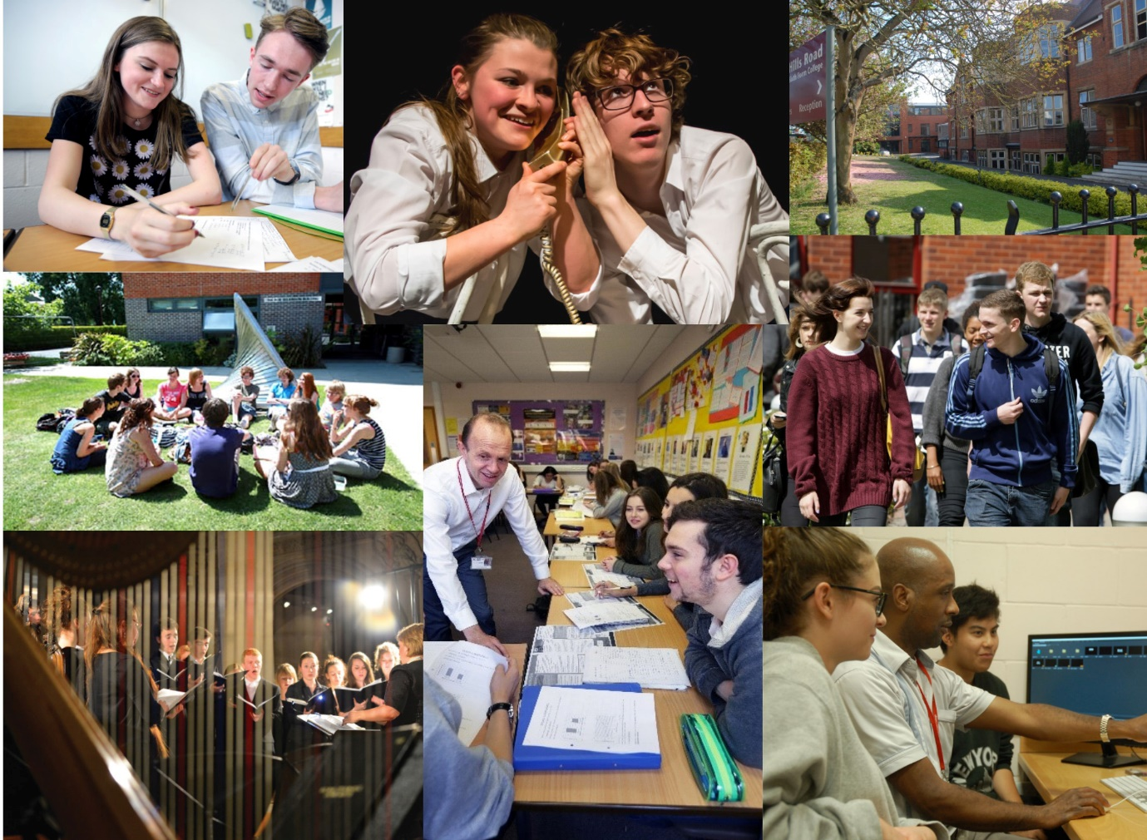

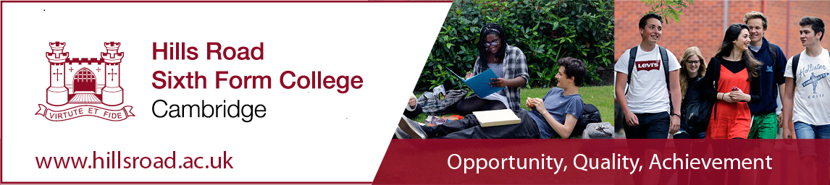

We currently have the following exciting opportunity for an enthusiastic, innovative and well qualified teacher to join us from 27th August 2019.

Teacher of Art and Design (Part time approx. 0.85 fte – permanent)
Pro-rata of £23,396 - £38,748 depending on experience

This is an excellent opportunity for an able and enthusiastic teacher to join this well-established and lively creative team. We are looking for a part-time teacher of A level Art and Design to teach 0.85 of a full time equivalent timetable.

The closing date for the above posts is 9am on Monday 25th February 2019.
Interviews will be held on Tuesday 5th March 2019.

Details and an application form for the above posts may be obtained from
our website.

The College is committed to safeguarding and promoting the welfare of its students and staff and expects all members of the College community, volunteers and visitors to share this commitment. The College actively promotes equality and diversity and welcomes applications from all sections of the community

PART TIME TEACHER OF ART AND DESIGN (0.85 Full Time Equivalent)

The Post

We are looking for a part-time teacher of A level Art and Design to teach 0.85 of a full time equivalent timetable. We are seeking someone who is strong in drawing and painting specialisms and also has the flexibility and enthusiasm to support students wishing to work in other areas e.g. 3D/print/digital/textiles etc.
In common with all members of the Department, the person appointed would have some delegated responsibility within the Department.
This is an excellent opportunity for an able and enthusiastic teacher to join this well-established and extremely creative department. The person appointed must have a lively and stimulating approach to teaching and learning, the ability to teach to a high standard and a commitment to equality of opportunity and the learning and well-being of young people.

The Department

The Art and Design Department, which was awarded a grade 1 in the most recent Ofsted inspection, is an energetic and supportive team in a very successful College. This year there are four members of the teaching team (including the vacant post), and three technicians. Departmental meetings are held regularly.

Accommodation and Resources

The Department is accommodated in a purpose-built teaching block. The extensive facilities comprise specialist teaching rooms, a large open sculpture area, a garden, a staff base room, a dedicated computer suites and storerooms.
We have a well-equipped workshop with access to a variety of power tools including welding, bandsaw and vacuum former. We also have a supportive relationship with Barclays EagleLabs which is close to the College, here students can access laser cutting and 3D printing facilities.
Teaching staff are provided with computer access in the department base room. There are extensive learning resources on our department 365 SharePoint site, all of which can be accessed by students from home as well as within College; further resources are available from our very well-stocked College Library. We also have College wide Wi-Fi and this increasingly used to support independent research on mobile devices in lessons. We also have a department website see:
www.hillsart.net

Courses Offered, Examination Results and Progression

Most teaching sets contain up to 22 students and are taught by two teachers.

Course | Awarding Body | Number of sets in Year 12 | Number of sets in Year 13
Art and Design | OCR | 4 | 4
Photography | OCR | 1 | 1
History of Art | Edexcel | 1 | 1

Results in our subjects are strong and many of our students go on to higher education to study art and design related courses, a good number regularly achieve places at top national institutions.

Extra-curricular Activities

The Art and Design Department is a substantial contributor to the College’s Enrichment programme, and we offer short courses in History of Art, Life Drawing, Creative Structures, Ceramics, Fashion Photography, Digital and Chemical Photography.

We also take students on a variety of national and international visits to support their learning; current destinations are London, Amsterdam, Venice and Paris.

We have a large annual exhibition for the year two Art and Photography courses, and also extensive web galleries of student work on the department’s website.

Thank you for your interest in this post.

Jonathan Sansom
Head of Art and Design

February 2019

Job Description
Teacher

Purpose: To teach students within the College and to carry out such other associated duties as are reasonably assigned by the Principal or Head of Department, and to make a positive contribution to the wider life and ethos of the College

Reports to: The Head of Department and, where appropriate, to the Head of Subject, in respect of departmental matters and curriculum development

Main Accountabilities:

Set high expectations which inspire, motivate and challenge students

- establish a safe and stimulating environment for students, rooted in mutual respect
- set goals that stretch and challenge students of all backgrounds, abilities and dispositions
- demonstrate the positive attitudes, values and behaviour which are expected of students.

Promote good progress and outcomes by students

- be accountable for students’ attainment, progress and outcomes
- be aware of students’ capabilities and their prior knowledge, and plan teaching to build on these
- guide students to reflect on the progress they have made and their emerging needs
- demonstrate knowledge and understanding of how students learn and how this impacts on teaching
- encourage students to take a responsible and conscientious attitude to their own work and study.

Demonstrate good subject and curriculum knowledge

- have a secure knowledge of the relevant subject(s) and curriculum areas, foster and maintain students’ interest in the subject, and address misunderstandings
- demonstrate a critical understanding of developments in the subject and curriculum areas, and promote the value of scholarship
- demonstrate an understanding of and take responsibility for promoting high standards of literacy, articulacy and the correct use of standard English, whatever the teacher’s specialist subject

Plan and teach well-structured lessons

- impart knowledge and develop understanding through effective use of lesson time
- promote a love of learning and encourage young people’s intellectual curiosity
- set homework and plan other out-of-class activities to consolidate and extend the knowledge and understanding students have acquired
- reflect systematically on the effectiveness of lessons and approaches to teaching
- contribute to the design and provision of an engaging curriculum and scheme of work within the relevant subject area(s).

Adapt teaching to respond to the strengths and needs of all students

- know when and how to differentiate appropriately, using approaches which enable students to be taught effectively
- have a secure understanding of how a range of factors can inhibit students’ ability to learn, and how best to overcome these
- demonstrate an awareness of the physical, social and intellectual development of young people, and know how to adapt teaching to support students’ education at different stages of development
- have a clear understanding of the needs of all students, including those with special educational needs; those of high ability; those with English as an additional language; those with disabilities; and be able to use and evaluate distinctive teaching approaches to engage and support them.

Make accurate and productive use of assessment

- know and understand how to assess the relevant subject and curriculum areas, including statutory assessment requirements
- make use of formative and summative assessment to secure students’ progress
- use relevant data to monitor progress, set targets, and plan subsequent lessons
- give students regular feedback, both orally and through accurate marking, and encourage students to respond to the feedback.

Manage behaviour effectively to ensure a good and safe learning environment

- have clear expectations and routines for behaviour in classrooms and take responsibility for promoting good and courteous behaviour both in classrooms and around the College in accordance with appropriate College policies
- manage classes effectively, using approaches which are appropriate to students’ needs in order to involve and motivate them
- maintain good relationships with students, exercise appropriate authority, and act decisively when necessary.

Accountabilities that relate to all staff at the College:

- demonstrate behaviour and values consistent with the person specification for this role
- promote equality of opportunity in accordance with the College’s Single Equality Scheme
- maintain high standards of attendance and punctuality
- have proper and professional regard for the ethos, policies and practices of the College
- this includes those where each member of staff has an individual duty to act and for which the College can be held vicariously responsible for the actions of its employees:
  - equality and diversity
  - safeguarding the welfare of young people
  - health and safety

Person Specification for the post of part-time teacher of Art and Design

 | Essential | Desirable | Evidence
Qualifications and training | - Good honours degree in Art and Design or a closely related subject  - Specialist skills across a range of art making techniques (primarily drawing and painting)  - Relevant teaching qualification e.g. PGCE or willingness to complete a PGCE or equivalent qualification |  | Application form/ Letter of application/Interview day/portfolio at interview
Experience | - Experience of teaching Art and Design, which for PGCE students will be at least relevant teaching practice | - Experience of teaching Art and Design at A level  - The flexibility to teach across specialist areas, e.g. textiles, painting, printmaking, digital media, 3D making and constructing  - Experience of developing schemes of work at A level | Application form/ Letter of application/Interview day
Special requirements |  | - Applicant will be a practicing artist | Letter of application/ Interview day/ portfolio at interview

In addition, the successful candidate will demonstrate, or have potential to develop, strengths in the following areas.

Classroom teaching | - Lively, energetic and well-planned classroom teaching  - Development and use of effective and varied resources for use in the classroom  - Clear focus on maximising student potential and encouraging high levels of attainment by all students  - Strong and positive commitment to individual students  - Creativity in contributing to the on-going development of schemes of work | Letter of application/ Interview day/ References
Professional standards | - Commitment to equality of opportunity  - Commitment to collaborative teamwork  - Good organisational skills and commitment to meeting deadlines  - Flexibility and ability to undertake new activities  - An on-going commitment to the study of art and design  - A willingness to support the activities undertaken by the department  - Competent in the use of IT  - Willingness to undertake appropriate staff development | Application form/ Letter of application/ Interview day/ References

How to Apply for the Post of Teacher of Art & Design

Applicants are asked to do the following:

- complete the Hills Road Sixth Form College application form
- complete the equality and diversity monitoring form
- write a supporting letter of application
- supply a brief CV

The completed application form should be submitted via email to recruitment@hillsroad.ac.uk. All documents should be submitted by 9.00am on Monday 25th February. Please note that applications received after the closing date may not be eligible for consideration.

Interviews will be held on 5th March 2019

Hills Road Sixth Form College will base its decision as to whether to invite you for interview solely on the details provided on your application and how well they match the criteria for this post.

Hills Road Sixth Form College is committed to ensuring equal opportunities in all aspects of employment and selects staff on merit, irrespective of race, religion, sex, disability or age. You are not obliged to complete the equal opportunities monitoring form, but any information given will help us to monitor the effectiveness of our equality and diversity policy.

If you have a disability you are invited to request any special arrangements you may require for interview, or any adjustments you may anticipate would be needed in your working arrangements, by contacting the Human Resources Team on 01223 278063 (direct line). Further information about accessibility to the site can be found on our website under ‘Equality and Diversity/Site Plan’ and also from ‘AccessAble: www.accessable.co.uk.

Thank you for your interest in this post and in the College. We do hope that you will decide to apply, and we should like to thank you in advance for taking the time and trouble to do so. For more information about working life at the College please go to our website http://www.hillsroad.ac.uk.

Human Resources

