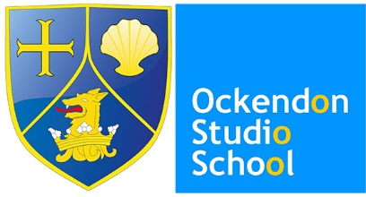

The Ockendon Academy and Studio School

A Brief History

The School itself began life with the opening of what was then known as Lennard’s Secondary Modern School in 1954. The school was the second senior school on the estate, being built in addition to the Courts School, which closed during the 1970s. A small number of years later, as the estate developed into what is now South Ockendon, two additional senior schools were added to the estate Culverhouse School for Boys’, opening in 1956 and Culverhouse School for Girls’ opening in 1957 and built on the Culverhouse Farm estate.
In 1971, Lennards was merged with the two Culverhouse Schools to create The Culverhouse School, which was based in Barle Gardens, South Ockendon with the former Lennards site being used for lower school (year 1 students), Culverhouse Girls’ for middle school (year 2 and 3 students) and Culverhouse Boys’ for upper school (Years 4 and 5).
In October 1988 the former Culverhouse Boys’ and Culverhouse Girls’ schools closed their doors to students for the final time. The Culverhouse School was now a one-site school, and following on from consultation with staff, students and the local community, Culverhouse was rebranded as The Ockendon School the following year.
Our current principal, Mrs. Barbara King joined the staff of The Ockendon School in 2000 and helped to turn around what was then a seriously failing School into the high achieving, outstanding school that we are today.
Our conversion to a new-style Academy in January 2011 marked a new benchmark in the history and development of our outstanding establishment, and The Ockendon Academy came into begin.
In 2012 The Ockendon Studio School was opened, a ‘school within a school’ for fourteen to nineteen years olds. The focus is on connecting education with employment, making students ready to enter the world of work or further education.

