April 2021

Dear Applicant,

Thank you for expressing an interest in the post of permanent part-time Design and Technology Teacher at Ysgol Penglais School. You will be joining the school at a very exciting time as we live our vision for Penglais.

‘Ysgol Penglais School is a happy, ambitious and high-achieving school where everyone is ‘respected and valued’. We are working hard with staff, students, parents and the governing body to ensure that Ysgol Penglais School becomes the school that our students and community deserve. We are continually working to achieve the highest standards of student achievement, behaviour and teaching and learning. Our recent GCSE results show significant improvements with 33% of all grades awarded at A*/A and 80% at A* - C.

We have an experienced body of staff who work hard and manage to maintain a supportive and friendly ethos. Our students want to achieve more than they thought possible and want to be challenged and supported to do so. There are many different needs within the school and the ALN department work hard across the school to support students when needed. The 6th form is very strong with nearly 300 students, achieving excellent results again this year.

By joining Ysgol Penglais School, you will be supported professionally to achieve excellence in your role. I can promise you a demanding but ultimately rewarding experience as we move forward to becoming an excellent school.

The enclosed information gives you a snapshot of the school. If you would like further information, please contact Helena Clements by email at hcl@penglais.org.uk, or on 01970 624811. I look forward to receiving your application.

Yours sincerely

Mair Hughes
Pennaeth/Headteacher

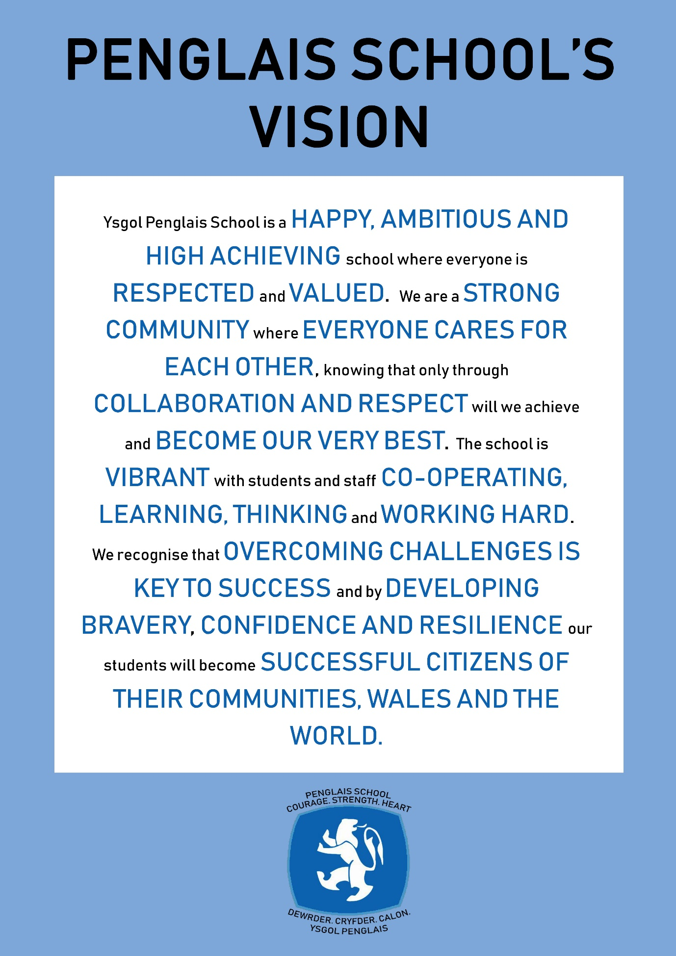
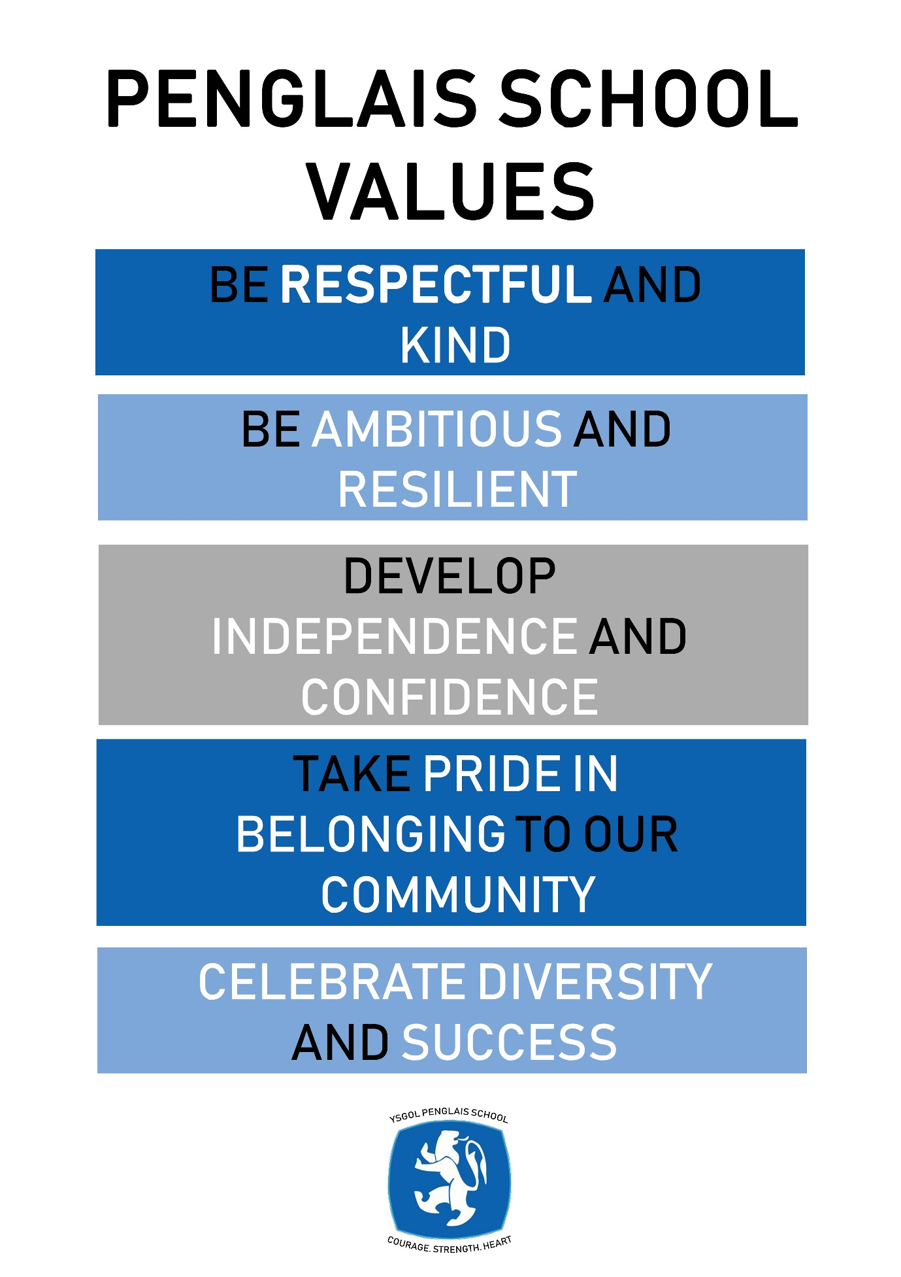

Please read these notes before completing the application form

It will help us if you follow these instructions:
- We would prefer you to fill in your application using Word or a word compatible format and submit it by email. Please include everything you wish the panel to consider on the form rather than in any separate document or covering email.

- Please give the full name and title of both your referees, and ensure that the full address, telephone numbers and email addresses are included. Your referees will be contacted if you are short-listed.

- If you are short-listed we will contact you by telephone or email

- Please submit your application form by midnight by the date below to hcl@penglais.org.uk

- You will be asked to sign a hard copy if you are appointed

- Ysgol Penglais School is committed to safeguarding and promoting the welfare of students and expects all staff to share this commitment. All our staff are required to complete a DBS (Disclosure Barring Service) check and declare previous convictions.

- We are fully committed to equality of opportunity and aim for our staff to reflect the school community. It will help us to monitor the success of our recruitment strategies if you complete the ethnic monitoring information page of the application form. The information you provide will be treated as confidential and will not be made available to the short-listing panel.

Part-time Design and Technology teacher (MPS 0.4)

We seek to appoint an excellent Part-time Design and Technology teacher who can support the development of Design and Technology in the school to ensure that all students achieve outstanding outcomes in this subject. We are looking for a full time and part time posts, one of which must have Food Technology as a specialism.

The right candidate will thrive on the challenge of working with our staff and students to ensure that teaching and learning is consistently good and outstanding; that the learning experience of the students is based on challenge and creative thinking and that all students achieve highly and develop in confidence. You will be committed to finding inclusive approaches to inspiring students and to improving the life-chances of all our students. We are prepared to consider various possibilities for the two posts, including two part-time roles for the right candidates.

This is an ideal opportunity for an ambitious candidate to play a key role in increasing the aspirations and success of our students, thereby contributing to the journey of Ysgol Penglais School in becoming an excellent school.

Ysgol Penglais School has much to offer:

- a research-based school with good relationships between staff and students
- a commitment to the professional development of all its staff to become outstanding teachers and leaders
- access to the bustling university town of Aberystwyth
- located on the beautiful Ceredigion coast, an area of natural beauty

For further details please contact Helena Clements (PA to the Headteacher) on 01970 624811or email hcl@penglais.org.uk

Ysgol Penglais School is committed to safeguarding and promoting the welfare of children, young people and vulnerable adults and expects all staff and volunteers to share this commitment. Successful candidates must be willing to undergo Enhanced DBS and other checks appropriate to the post.

Ysgol Penglais School is an equal opportunities employer.

Closing date: 13th May 2021

Job Description – Design and Technology Teacher (0.4)

Job title: Part-time Design and Technology Teacher
Salary grade: Mainscale 0.4
Accountable to: Faculty leader

Core Purpose:
- To deliver consistently high standards of teaching and learning
- To ensure good progress conduct of students within the lessons
- To share and support the school’s responsibility to provide and monitor opportunities for personal and academic growth
- Under the reasonable direction of the Headteacher, carry out the professional duties of a school teacher as set out in the current School Teachers’ Pay and Conditions Document (STPCD)

Key accountabilities | Key tasks
Accountable for delivering high quality teaching and learning that will ensure good progress | - Ensure that their subject teaching inspires students to achieve or exceed their goals  - Take account of, and plan for, the needs of all students taught, including SEN, EAL, PPG and Gifted & Talented students  - Encourage students to explore and evaluate different learning strategies within their subject  - Ensure that students understand the requirements and learning outcomes for the subjects  - Mark books regularly, according to the school expectations, and give regular feedback to enable all students to make good and outstanding progress  - With the Faculty Lead and subject leads, contribute to the development of good practice in the subject to ensure that learning is good or outstanding in the subject  - Contribute to the regular review of the curriculum
Accountable for the progress of students in the classes | - Make effective use of data to diagnose and track student performance in order to raise attainment  - Ensure student records are regularly updated to enable the tracking and monitoring of progress  - Take overall responsibility for the performance and progress of students taught, including published exam outcomes  - Work collaboratively with colleagues to prepare students for public examinations, including contributing to exam preparation and revision sessions  - Undertake marking and standardisation and provide information for exam entries in line with school and statutory requirements
To share and support the school’s responsibility to provide and monitor opportunities for personal and academic growth | - To be a Form Tutor to an assigned group of students  - To promote the general progress and well-being of individual students and of the Form Group as a whole  - To liaise with the Year Leader to ensure the implementation of the school’s pastoral system  - To register students, accompany them to assemblies, encourage their full attendance at all lessons and their participation in other aspects of school life  - To evaluate and monitor the progress of students and keep up-to-date student records as may be required  - To alert the appropriate staff to problems experienced by students and to make recommendations as to how these may be resolved.  - To communicate as appropriate, with the parents of students and with persons or bodies outside the school concerned with the welfare of individual students, after consultation with the appropriate staff  - To contribute to PSHE and citizenship and enterprise according to school policy  - To apply the Behaviour Management systems so that effective learning can take place  - To ensure that school rules and procedures with regard to attendance, punctuality and school uniform are consistently and fairly applied
Accountable for always ensuring the vision and values of the school are promoted | - Always ensure highest expectations for all students in their conduct and learning, showing a real ambition for all students  - Follow the positive behaviour for learning policy and promote it at all times  - Contribute to school-wide initiatives in the subject  - Contribute to the programme of extra-curricular activities, enrichment events, and visits and journeys relating to the subjects  - Embrace opportunities to work with colleagues to enhance and improve practice
Accountable for the safeguarding of students | - Contribute to the safeguarding of students and to child protection using the procedures outlined in school policies  - Ensure that health and safety policy and risk assessments are followed.
Other | - Be aware of and comply with policies and procedures relating to child protection, health, safety and security and confidentiality, reporting all concerns to an appropriate person  - Ensure that the school’s Equal Opportunities Policy is implemented and contribute to its regular review  - Attend and participate in regular meetings  - Attend training where appropriate and exploit other opportunities for continuing professional development  - Recognise own strengths and areas of expertise of themselves and the team and use these to advise and support others  - Lead and assist in the supervision, training and development of staff  - Participate fully in the school’s performance management programme  - Undertake other duties commensurate with the status of the post as may from time to time be determined by the Headteacher
This job description is not necessarily a comprehensive definition of the post. It will be reviewed at least once each year, but may be subject to modification or amendment at any time after consultation with the holder of the post
Person Specification

Qualifications | - Graduate status  - Qualified Teacher Status
Experience | - Evidence of being a good to outstanding classroom teacher  - Evidence of being an excellent form tutor  - Evidence of monitoring student progress and teaching and learning
Knowledge and Skills | - Knowledge and understanding of your subject up to A level and of assessment procedures at key stages 3-5  - Ability to promote a positive attitude to learning and to school  - A high standard of written and oral communication  - Ability to use ICT effectively
Personal qualities | - Enthusiasm for teaching and learning and for your subject  - Commitment to continuous professional development of yourself and others  - Be able to relate well to students and a commitment to positive and healthy outcomes for young people  - Be able to listen effectively and be sensitive to others  - A demonstrable commitment to the safeguarding of students and child protection  - A demonstrable commitment to equal opportunities  - Sense of humour  - Excellent attendance and punctuality
Other | - A willingness to take part in extra-curricular activities  - Commitment to the school’s ethos, aims and its whole community

April 2021

