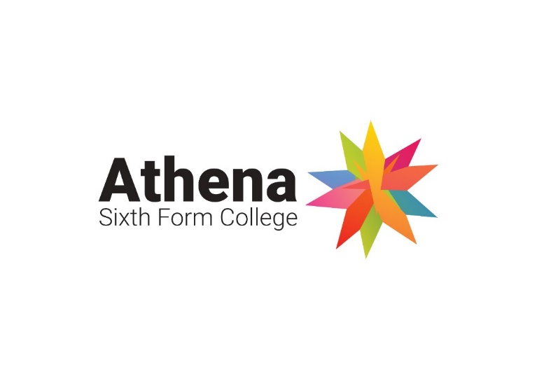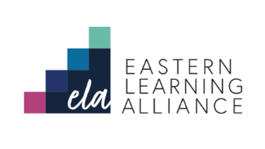

Dear potential candidate

**Working with us**

Thank you for your interest in this role – please do take a look at our website, and in particular the “News” pages where you will find previous editions of our newsletter “Discover More About DMA” which will give you a taste of our vibrant and dynamic school.

You will also find a copy of the report following our recent visit from Ofsted in April 2022 – we were delighted to be recognised as a “GOOD” school for the first time in many many years. Some highlights from the report that have made us particularly proud:

“Pupils praise how their teachers take care of them.”

“Pupils enjoy learning… they demonstrate a deep understanding of complex ideas.”

“Teachers provide pupils with support to help them improve further.”

“(DMA) provide(s) an ambitious and broad curriculum.”

“The curriculum promotes inclusivity, diversity, and equality.”

“Leaders have also instilled a powerful ethos which nurtures and rewards important human values such as compassion, empathy, and resilience. Pupils are kind. They work hard and support others.”

We are absolutely committed to improving the educational outcomes of our students even further as we embark on the journey to offer and even better experience for our whole school community.

If you would like to arrange an informal discussion over the telephone or visit the school before you submit your application, please do not hesitate to get in touch via email ([kcoupland@dma.tela.org.uk](mailto:kcoupland@dma.tela.org.uk)).

I hope to receive your application and discuss this further with you at interview.

Best wishes



Dr Natalie Paine  
Acting Headteacher