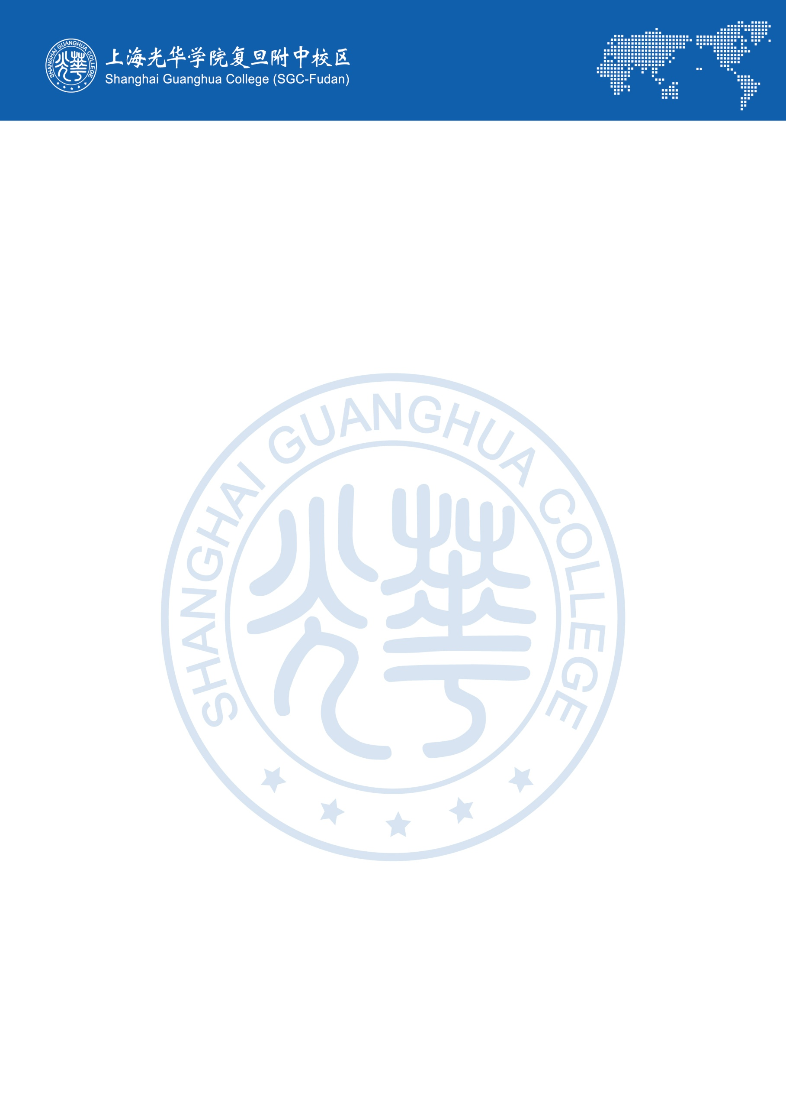
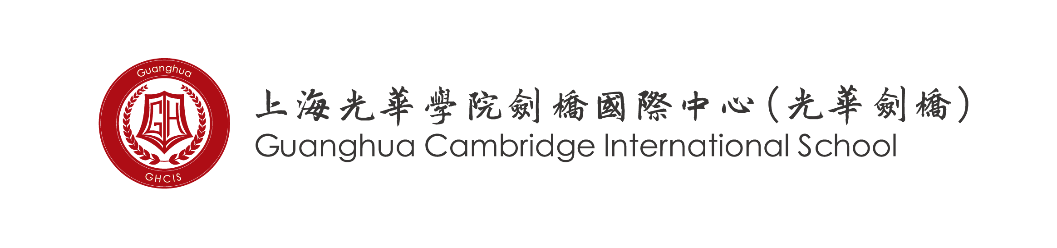
Guanghua Cambridge International School (GHCIS) is seeking
experienced and dedicated A level teachers

School Profile

Due to the differences between the education systems, Chinese students find the direct move from a Chinese high school to a Western University exceedingly difficult. Language learning and cultural differences in educational systems make it challenging for a Chinese high school graduate to do well, if s/he has not been exposed to foreign language content instruction at home.

An appreciation of these problems by Chinese parents has led to a growing demand for offering an internationally recognized curriculum (A level) for Chinese high school students who intend on continuing their education overseas. Guanghua Cambridge International School has taken a key role in offering this academic alternative.

More than eight years have passed since our first opening in August 2011. We have thrived from a promisingly new school of 88 students to a moderately influential school of around 1000 students and more than 150 teaching and administrative staff. Our first graduating class of 17 students received nearly 80 offers including 3 from Oxford University (UK), 5 from Imperial College London (UK), 1 from Parsons School of Design (US), and 4 from top Canadian universities, marking an auspicious start. Further on, greater achievements have been proudly brought to us by our students this year (Sep. 2019); a total number of 1378 offers have been received by our graduating class of 2019, among which 11 were from Cambridge or Oxford University, 16 from London School of Economics and Political Science, 48 from Imperial College London and 113 from University College Of London. We have also received some 339 offers from US universities, as well as 88 offers from the top Canadian universities (University of Toronto, University of British Columbia and McGill University). As a result of this, GHCIS was ranked in the top three A-level schools in China in terms of university destinations.

The school's culture and ethos define the school's identity. Our school’s motto is 'Happy International School'. We strongly believe that happy teachers create a happy school. Based on our past experience in the international educational field, we realize how important good relationships are in a school and how a buzzing and friendly environment helps teachers and students in the process of productive teaching and learning. We welcome and respect cultural diversity. The school is committed to create a relaxed but disciplined working environment, to attract top talented professionals and keep a high retention rate.

New branch school

Due to the success of the school, we are opening a new branch school in August 2020. The new branch is located in Pudong, 10 kilometers away from Pudong Airport. With well designed classrooms, meeting rooms, a dance studio, an art room and a library, the new campus provides a cosy, quiet and pleasant working and learning environment for teachers and students.

The new campus also provides on-campus accommodation; each staff member can have a clean, modern room with en-suite.

As a new campus, there are many opportunities to develop along with it, making this an ideal job prospect for dedicated educators seeking a warm working environment with opportunities to progress.

A generous and comprehensive remuneration package (including competitive salary, on-campus accommodation, roundtrip airfare, medical coverage, etc.) will be provided to all successful candidates. Due to the nature of the course, preference will be given to native English speakers.

Person specification
GHCIS could be an attractive option for you if you,

- Hold a valid degree and can demonstrate excellence and expertise in this subject
- Are a qualified teacher
- Have relevant teaching experience
Welcome cultural diversity; appreciate different thinking between Easterners and Westerners
Would like to have a unique teaching experience with well-behaved Chinese students
Are a committed educator and passionate teacher
Care for students and put students at the centre of everything

Job Description
A teacher in Guanghua Cambridge School always aims for the highest standards of professionalism both as a teacher and a team member of our staff.

Although this job description is not exhaustive, subject teachers will be responsible for the following:

- Having a general lesson plan for all lessons. The plan should be based on the published Scheme of Work and include lesson objectives, teaching methodology and homework details.
- Teaching strictly to the CIE syllabus for each subject (please see more course details on www.cie.org.uk). Teachers should use the course book adopted by the school for each course and may supplement with any suitable resource material when necessary.
- Becoming familiar with the programs and courses of study used at the school to ensure the teaching quality.
- Assigning homework, periodic tests, and providing clear and actionable feedback in a timely manner.
- Preparing school reports twice each term: once at the mid-term and another in the end of the term. School report preparation includes students’ individual test/exam scores or grades with teacher’s comments on student’s general performance, effort level, strengths, and areas for concern.
- Meeting with parents to discuss students’ progress according to the school’s arrangements. Those meetings are likely to be held after school hours or during the weekends.
- Promoting and adhering to school policies, such as uniform, classroom rules and other disciplinary policies.
- Recording attendance at lessons, and finding ways to investigate absence; report prolonged or regular absence to class supervisors.
- Participating in and/or help to organize extracurricular activities
- Being observed by the Academic Director, Subject coordinator and/or designated personnel for evaluation purposes and to get support, encouragement and feedback for teaching.
- Following a set timetable for classes. Personal arrangements for replacements and switching classes are not allowed without management’s consent.
- Regularly evaluating his/her own performance and progress.
- Providing useful suggestions to students regarding their University entry requirements and write recommendation letters when required.

Remuneration Package:

For successful candidates, the school will provide a competitive remuneration package, which includes:

- Starting salary: all depends on the teacher’s academic qualifications and number of years of relatable teaching experience.
    - For Newly Qualified Teachers: the entry point ranges from RMB 16,000 – RMB 18,000 (taxable), plus RMB 7,000 (net) housing allowance per month.
    - For teachers who have three or more years' experiences in the relevant subject areas, salary will be in the range of RMB 19,000 – RMB 23,000 (taxable)., plus RMB 7,000(net) housing allowance.
    - For teachers wishing to live on campus, they can do so for a fee of 1,000 RMB per month (thus retaining 6,000 RMB of the 7,000 RMB housing allowance)
    - Completion bonus for a two year contract, which is equivalent to one month salary (excluding housing allowance).
    - Annual reimbursement for round trip airfare economy class up to a maximum of RMB 8,000 between your home country residence and Shanghai
    - Up to one week free accommodation upon initial arrival into China
    - Medical Insurance
    - Paid Chinese Statutory Holidays
    - Paid mandatory health check (on arrival in China) and all visa extension fees

Application Process

Please send a CV to jobs@ghedu.com

FAQs (Frequent Asked Questions)

- How long is the contract length?
The normal contract length for teachers and staff is one to two years. A two year contract is preferred, in order to maintain the continuity of the program and so a one year contract won’t earn a gratuity bonus.
- Does the school help me to sort out visa issues?
Yes. You will be advised on how to apply for a visa to enter China. Once you arrive in Shanghai, our administration staff will ensure you have the valid visa and help you to apply for the Foreign Expert Certificate, to change your visa type to ‘employment’. You just need to follow the instructions given by us and the school will handle the rest.
- Will there be anyone picking me up at the airport?
Once you give us your flight details and arrival date, we will send a local member of staff to meet you at the airport.
- Where do I stay after I arrive in Shanghai?
The school will provide up to one week’s free accommodation upon your arrival. The hotel will be pre-booked and paid, and one of our local staff will take you to the hotel.
- Do you provide on-campus accommodation?
We don’t usually provide on-campus accommodation. Instead, we give a monthly housing allowance in order to allow teachers freedom to choose their living space. However, for the new branch school, accommodation will be available if teachers would prefer to live on-site.
- Are you going to help me to find an apartment?
Yes - upon your arrival, our administration staff will contact the estate agencies and prepare a list of flats for you to view.
- How much does the accommodation cost in Shanghai?
The rent varies from location to location. The housing allowance (7,000 RMB/ month) will enable you to get your own apartment in central Shanghai.
- How much deposit do I have to pay initially?
Normally, three months’ rent and one month deposit are required to be paid in advance (in addition, an agent fee would also need to be paid which is usually 1/3 of the monthly rental price). So, we advise staff to prepare some funds to cover the initial costs; the school can also offer a housing loan (of up to 3 months’ rent), if necessary.
- How is the salary paid and what’s the tax rate?
The monthly salary will be directly deposited to your account in Bank of China and is comparable to the standard pay scale for teachers. Taxes are approximately 20%, after the first RMB 4800 and are taken directly out of your monthly salary. Salaries are paid on the first day of the month (for the previous month), and are paid in RMB. It is worth noting that you will not be required to pay National Insurance or Council Tax in China.
- Do I get medical coverage?
The school will provide medical coverage for you. Insured staff can go to the English-speaking departments of all state owned key hospitals in Shanghai. Detailed benefits will be given after the commencement date of your employment.
- What does your school calendar look like?
Our school has two semesters in an academic year. The autumn term normally starts from the end of August and ends before the Chinese New year, while the spring term starts after the Chinese New year and finishes at the end of June.
- What are the school holidays?
Please see the attached calendar for the academic year 2019-20 for an accurate representation of holidays.
Apart from the winter and summer holidays, the school also breaks for all Chinese statutory holidays, which include the following:

Summer Holiday | 7-8 weeks, mid June – mid August
Winter Holiday | 3 weeks in Jan/ Feb (dates depend on Lunar calendar)
Tomb Sweeping Festival | 1 day in April
May day Holiday | 1 day: 1st May
Mid Autumn Festival | 1 day in late September or beginning of October
National Day | 7 days: 1st – 7th October
Christmas Day | 1 week
New Year’s Day | 1 day: 1st January

- Does your school have a dress code?
Yes, we expect all staff members to dress wisely and appropriately to work at our school.
- Does your school have an orientation program?
For all new expatriate teaching staff, we will provide an induction program which is divided into two parts. The first part is the understanding of Chinese culture and the values and ethos of our school. The second part is about working and teaching in our school, including the guidelines and policies of our school.
For any questions or informal inquiries, please don’t hesitate to contact our recruitment team: jobs@ghedu.com

