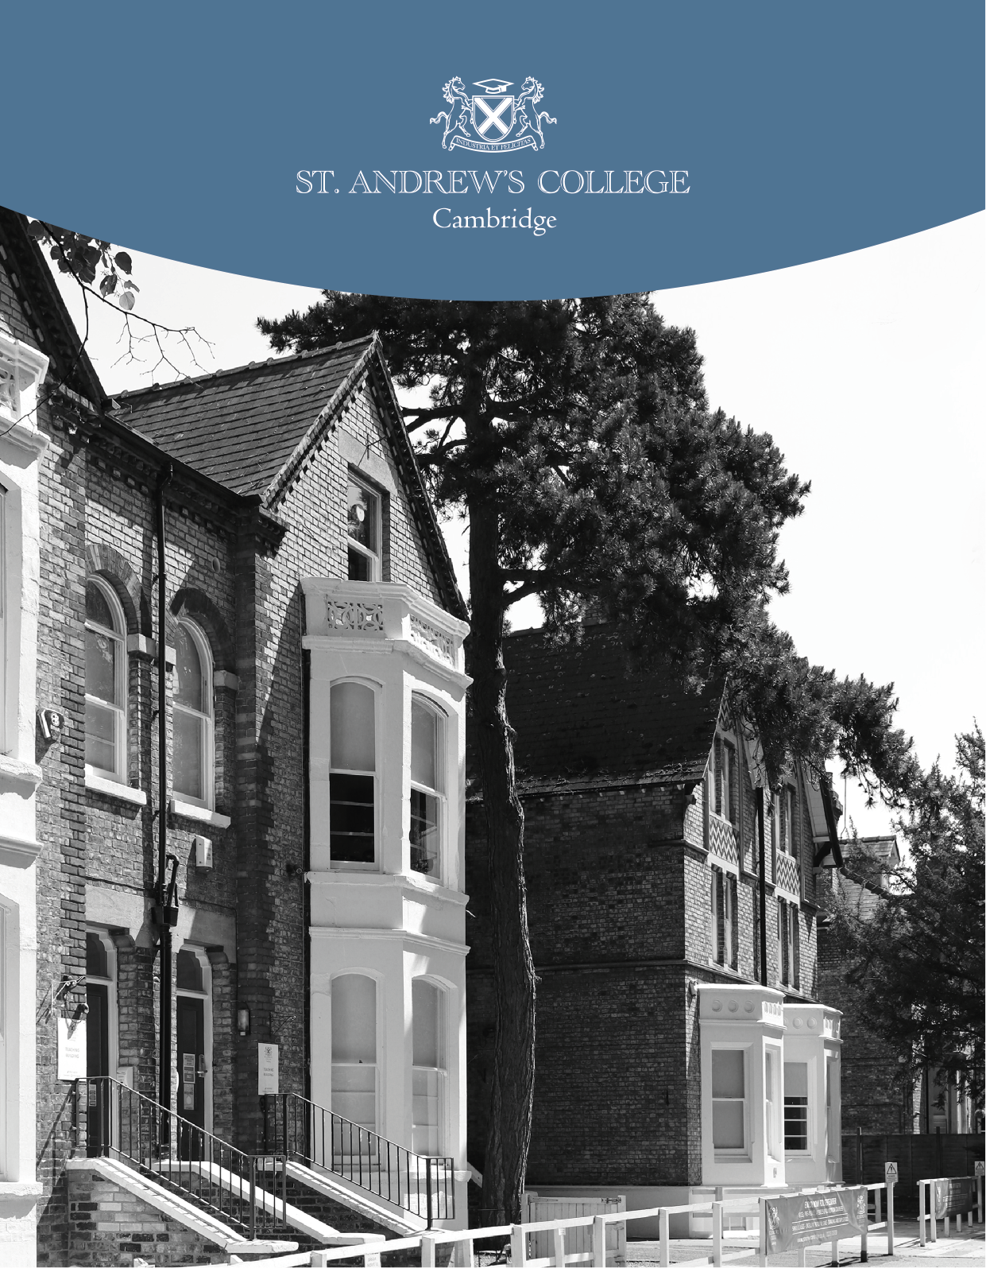

Additional Educational Courses Manager, Job Description, Job Specification and Objectives.

Job Title: Additional Educational Courses Manager
Location: St Andrews College, Cambridge
Salary: £30,000 - £35,000 per annum
Reports to: Head Teacher
Job Summary:
The Manager - Additional Courses is responsible for overseeing the planning, implementation, and management of supplementary educational programs at St Andrews College, Cambridge. This role includes the recruitment and supervision of teaching and administrative staff, management of timetables, coordination of student trips, and oversight of accommodation arrangements for additional course participants. The Manager will also serve as the primary liaison between the college and external academic institutions or agents. Additionally, the role involves delivering English for Academic Purposes (EAP) and English as an Additional Language (EAL) instruction.
Key Responsibilities:
- Program Management:
  - Develop and manage additional courses, ensuring they meet educational standards and student needs.
  - Coordinate with academic departments to integrate supplementary programs effectively.
- Staff Recruitment and Supervision:
  - Recruit qualified teaching and administrative staff for additional courses in conjunction with the college’s HR Department.
  - Manage and schedule hourly-paid teaching staff, ensuring optimal allocation of teaching hours.
  - Conduct performance evaluations and provide professional development opportunities.
- Timetable and Logistics Management:
  - Develop and manage course timetables, ensuring efficient use of resources and facilities.
  - Organize and oversee educational trips and extracurricular activities associated with additional courses.
- Accommodation Coordination:
  - Arrange and manage accommodation for students enrolled in additional courses, ensuring their welfare and safety.
- External Relations:
  - Act as the primary contact for external academic institutions and agents sending students to the college.
  - Maintain and develop partnerships to enhance the college's supplementary programs.

- Teaching Responsibilities:
  - Deliver EAP and EAL instruction to students, utilising effective teaching methodologies.
  - Develop and update curriculum materials to meet the evolving needs of students.
- Professional Development (INSET):
  - Plan and deliver in-service training (INSET) sessions to enhance product awareness and teaching effectiveness among staff.
Qualifications and Experience:
- Bachelor’s degree in Education, English, or a related field; a master’s degree is preferred.
- Possession of CELTA and DELTA certifications.
- Proven experience in teaching EAP and EAL courses.
- Demonstrated experience in program management and staff supervision.
- Excellent organisational and time-management skills.
- Strong interpersonal and communication skills.
- Ability to build and maintain relationships with external partners.
- Familiarity with arranging student accommodations and coordinating educational trips is desirable.
Skills and Competencies:
- Leadership and team management.
- Curriculum development and instructional design.
- Budget management and resource allocation.
- Problem-solving and decision-making abilities.
- Cultural awareness and sensitivity.
- Proficiency in using educational technology and management systems.
Working Conditions:
The role is primarily based on-site at St Andrews College, Cambridge. Some flexibility in working hours may be required to accommodate program needs, including occasional evenings or weekends for events or trips.
Application Process:
Interested candidates should submit a cover letter detailing their relevant experience and qualifications, along with an application form, to: emma.warner@standrewscambridge.co.uk
Applications will be reviewed on a rolling basis until the position is filled.
St Andrews College, Cambridge, is committed to safeguarding and promoting the welfare of children and young people and expects all staff to share this commitment. The successful applicant will be subject to an enhanced DBS check.

This job description outlines the primary duties and responsibilities for the role of Manager - Additional Courses at St Andrews College, Cambridge. It is not an exhaustive list and may be subject to change to meet the evolving needs of the college.

