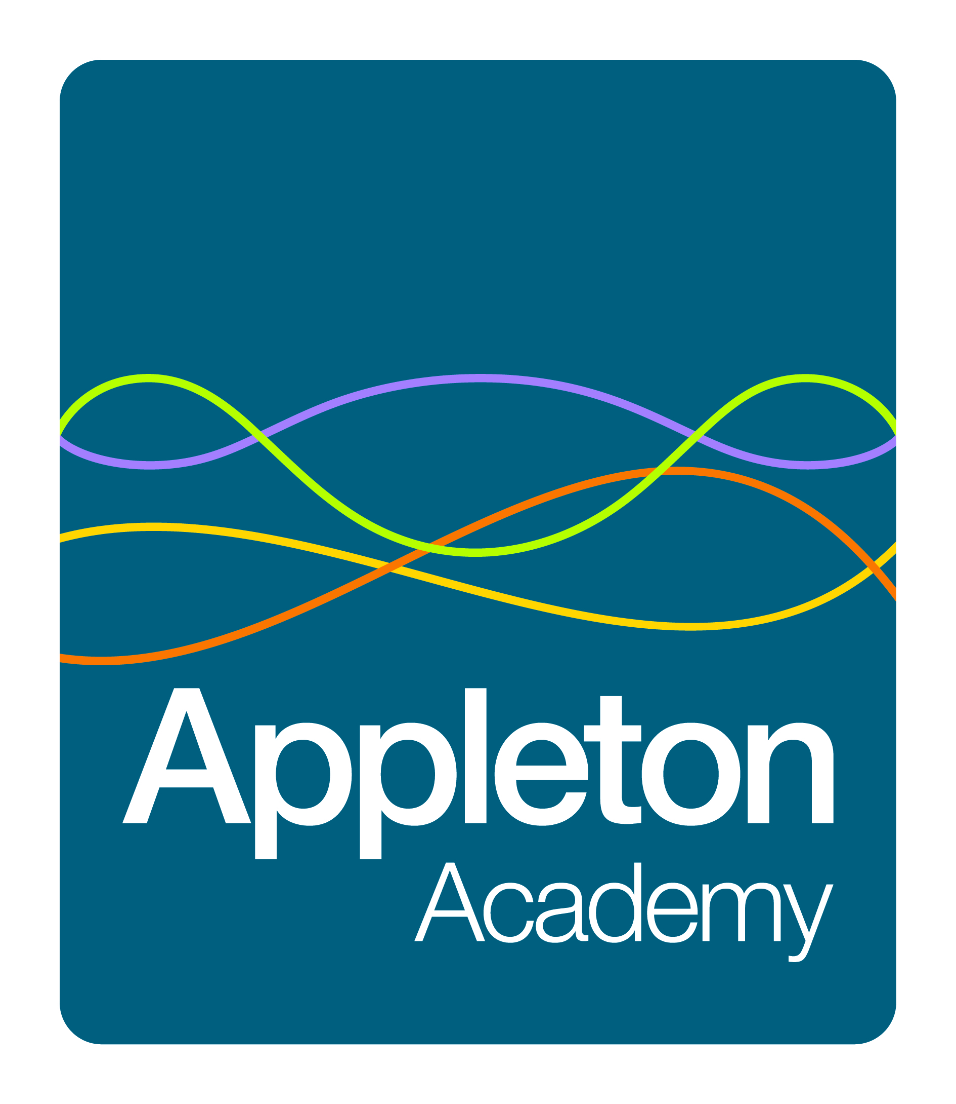
Aspiration and Achievement in Wyke

Personnel Specification

Post Title: Secondary Teacher

The specification should be related to a candidate’s specific subject qualification, with relevant experience and qualifications being given on the application form or attached information

Attributes | Essential | Desirable | How Identified
Physical | Good health |  | Application Form  References
Qualifications | Qualified Teacher Status – Secondary Age Range  Subject related degree | Graduate Status | Application Form  References
Experience | Teaching learners of secondary school age | Teaching or working with learners of primary age and post 16  Form Tutoring or mentoring learners  Evidence of wider school activities | Application Form  References
Specialist Knowledge | National Curriculum  GCSE syllabus  BTEC syllabus as appropriate | Creative and interactive teaching approaches | Application Form  References  Interview
Practical/Intellectual Skills | Good pupil management skills  Familiarity with ICT in learning  Use of formative assessment |  | Application Form  References  Interview
Disposition/Attitude | Commitment to excellence and the achievement of learners  Commitment to team work  Commitment to equal opportunities  Willing to take part in and lead extracurricular activities  Hardworking, imaginative and adaptable |  | Application Form  References  Interview

January 2016

