Ysgol Eirias

Gwybodaeth i
Ymgeiswyr
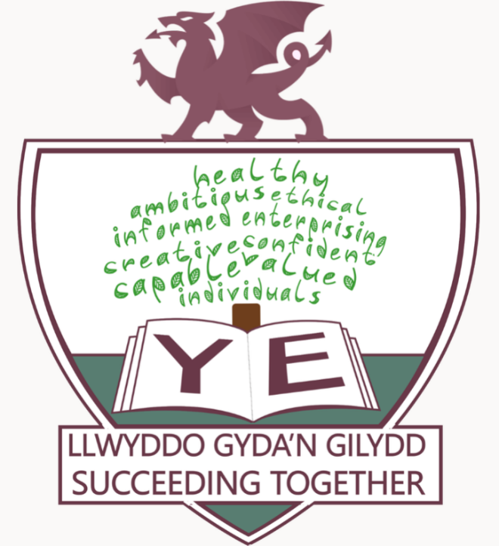
Information for Applicants

Ysgol Eirias
Gwybodaeth i Ymgeiswyr
Information for Applicants

Ysgol Eirias
Ysgol Eirias is a highly successful fully comprehensive school of exceptional academic performance. We have a local and national reputation as a very successful school with consistently outstanding GCSE and A Level results as well as being a forward-thinking and dynamic school with leading practice. We have regularly been named as one of the top ten UK schools by the Sunday Times, including in 2022. We are an incredibly proud, outward facing, collaborative and progressive school and we pride ourselves on the broad range of collaborations that the school engages with or leads. We are reflective and evaluative: constantly looking to improve.
There are 1253 learners on roll with 217 in the Sixth Form and a teaching and support staff of 142. We have a strong and experienced staff with very low turnover. Significant strength in Professional Learning ensures that development and leadership opportunities are presented through a Career Development Pathway. We have previously presented on the National stage on Professional Learning, and the work we have done on teaching and learning facilitated by the SLO model through our Pioneer work. We have a strong focus on wellbeing and compassionate leadership. This is to the benefit of our learners, staff, parents and governors and is reflected in the school’s vision: Succeeding Together – Llwyddo Gyda’n Gilydd.

Estyn
The school has recently been inspected (November 2022) and awaits the full written report in February 2023.
Ysgol Eirias has been involved in a number of Thematic and Engagement visits by Estyn:
- 2020: Leadership Development – Case Studies of Professional Learning for School Leadership
- 2020: Business and Social Studies at A Level
- 2020: Effective School Support for Disadvantaged and Vulnerable Learners
- 2019: Pilot Engagement Visit
- 2018: The Professional Learning Continuum: Mentoring in Initial Teacher Education
- 2018: A Level in Sixth Forms and Further Education Colleges
- 2018: Effective Practice – Rising to the Literacy Challenge
- 2017: Good Practice in the Humanities
- 2017: Science at Key Stage 3 and Key Stage 4
- 2016: Best Practice in the Creative Arts at Key Stage 3 and 4
Comments from Estyn include:
“In Eirias, the mentor role is seen as a privileged position, which offers rewarding professional development for staff in preparation for middle leadership, or for those who simply wish to take on greater responsibilities at a key point in their professional development. The school has identified career development pathways for staff. This includes a mentoring pathway to support the development of relevant skills, and ensure the ongoing professional development required for mentors, or for those who see this as a future development pathway.”
"The school had vulnerable pupils, many of whom were LAC, who were not engaging fully in their learning. Leaders worked in collaboration with regional consortium officers and found evidence-based training in trauma and attachment. This led to staff developing a deeper understanding of the impact of traumatic experiences on brain development and learning. As a result of these projects, vulnerable pupils experienced: • improvements in their social, emotional and behavioural skills and stronger social networks • a positive attachment to school which in turn has improved attendance of many LAC • improved engagement in lessons • better self-regulation and ability to transition back to lessons after break times • improved relationships with peers and staff • a greater degree of empathy and understanding from staff.”
“Learners engaged in a lively and exceptionally well-run formal debate. The teacher facilitated the session professionally by acting as ‘the speaker’ to make sure that learners followed similar protocols to those used in parliamentary debates. All learners made useful contributions to the debate and most were confident and articulate. Many learners made effective use of specialist terminology to highlight links.”
“Staff at Ysgol Eirias have shared research and successful practice in supporting LAC with cluster primary schools to benefit a wider number of pupils in the area. Taking a whole school approach, leaders across the cluster shared the vision of ‘Nurture UK’ that no child fails through lack of nurture and educational opportunity.”
“The school has identified career development pathways for staff. This includes a mentoring pathway to support the development of relevant skills, and ensure the ongoing professional development required for mentors, or for those who see this as a future development pathway.”
“The school uses a range of robust internal and external data to evaluate performance and to formulate strategic action plans for A level performance at whole-school and faculty level. Leaders also make effective use of findings from lesson observations, work scrutiny, and conversations with sixth form learners to evaluate their performance and provision at A level. Over time, the school has sustained strong learner outcomes at A level across most performance indicators.”

School Site and Surrounding Area
The school has an attractive single site in Eirias Park which overlooks the sea and surrounding headlands. During the school day, Ysgol Eirias has access to an extensive range of world-class sporting facilities offered by Eirias Park.
There is a good social mix within the school and the pupils are pleasant and co-operative. The school has modern extensions to house laboratories, design facilities, computer suites and additional teaching areas. In 1998, a capital building programme was completed with the opening of additional classrooms and enlargements to the school’s infrastructure. In 2010, a Language and Technology block was opened. The school has a purpose-built sixth form centre.
Colwyn Bay is a seaside resort on the North Wales coast with a population of over 30,000. It is situated in a sweeping bay which extends from Old Colwyn in the east to Rhos-on-Sea in the west. The whole area is characterized by its natural scenic beauty.
Colwyn Bay offers many amenities. In addition to a shopping precinct, it has a well-equipped Leisure Centre and sport facilities, a theatre, the Welsh Mountain Zoo, Porth Eirias (watersports) and the 30 acre Eirias Park which includes national rugby facilities and live concerts. It is within easy reach of North Wales beauty spots such as Snowdonia, Betws-y-Coed, Angelsey, Caernarfon and Porthmadog. Situated close to the A55 expressway, Colwyn Bay is easily accessible from the main motorway network. Chester is within a 45-minute drive and Manchester is just over an hour away.
Pioneer Work and Curriculum for Wales
In 2015, the school was successful in applying for Pioneer status for the New Deal for Education. Following the successful application, a number of pilot schemes and case studies have been conducted in preparation for the Curriculum for Wales. The case studies and action research projects have included the new curriculum in Maths and Numeracy and supporting Professional Learning.
Year 7 are working under the new Curriculum for Wales programme. The school has undertaken huge amounts of work to roll out the new curriculum, especially around assessment, reporting and curriculum design. Primary School liaison and cluster working has been instrumental in the understanding of the progression steps. The school also operates as part of a collaborative Alliance with three other large secondary schools across the region. One of the focus areas for the Alliance working this year is on Year 8 curriculum design and therefore, once again, a focus on progression. This is in addition to a second focus on the role of Middle Leaders and their role in improving standards.
Lead School for ITE
Ysgol Eirias is very proud of its status as Lead School for ITE working with CaBan (Bangor University). Following a pilot Hub scheme in 2015 – 18, the school worked closely with Bangor University to co-construct a new ITE programme. The school has been one of the first and few Lead Schools across North Wales since 2018. As well as collaborating with Bangor University to “grow tomorrow’s teachers” and supporting Professional Learning for staff, being a Lead School is a significant contribution to the recruitment and retention crisis and a great opportunity to further develop leadership in school, for both staff and learners.

Curriculum
The curriculum is organised to reflect the essential philosophy of the school that every learner should follow a broadly based relevant and balanced course of study for the five years of statutory education. Year 7 is following Curriculum for Wales under the following Areas of Learning and Experience (AoLEs):
- Mathematics and Numeracy
- Science and Technology
- Languages, Literacy and Communication
- Expressive Arts
- Humanities
- Health and Wellbeing
The school has been recognised for the innovative work with Year 7 in project-based learning: the work has evolved to embrace the Curriculum for Wales.
In Years 8 and 9 currently, the learners are following the National Curriculum and experience subjects as follows: English and Drama, Mathematics, History, Geography and RS, Welsh, French or German, Science, Technology, IT, Art and Music.
In Years 10 and 11, all pupils follow courses in English, Mathematics, Science, Welsh, PSE, PE, RE and WBQ. In addition, they choose from 3 option areas.
Sixth Form
The Sixth Form is open entry to all pupils for whom we have appropriate courses and who reach the minimum grade requirements. A broad, wide-ranging curriculum with a comprehensive range of courses is offered to meet the needs of varied abilities and interests. In addition to a wide range of A Levels, an increasing range of vocational courses is offered. Most of our learners go into Higher Education after the Sixth Form studies and we have large numbers of learners accessing Russell Group universities post 18 across a variety of disciplines. We are proud of the large, successful sixth form that we have at Ysgol Eirias. Many of our learners stay into sixth form from Year 11 and we frequently draw external applicants.
School Uniform
There is a school uniform for all students including the Sixth Form and there are high expectations around maintaining a smart personal appearance.
Commitment to Wellbeing
The school places a great emphasis on learner and staff wellbeing – it has featured as a bespoke part of the School Development Plan since 2017 but has been a stronger feature since the return to school following the national Covid 19 lockdown. With an increase in the numbers of learners presenting with Additional Learning Needs, a changing Free School Meal profile and challenges with learner attendance, the school has embraced the rollout of the new Wellbeing Framework: A Framework on Embedding a Whole-School Approach to Emotional and Mental Wellbeing. The school has increased the capacity of its Nurture, ALN and Inclusion provision and recently implemented a Local Authority wide anti-bullying (KiVa) programme. The school also operates a trusted adult scheme and has recently redesigned its PSE and RSE provision in line with learner feedback and the roll out of the new RSE statutory framework.

Extra-Curricular Activities
A wide range of extracurricular activities, together with voluntary community work, is seen as a vital part of life at Ysgol Eirias. Clubs and societies meet after school and an effective programme of extracurricular activities is available to all pupils. This has been a significant feature of our ‘Build Back Better’ approach following the pandemic.

