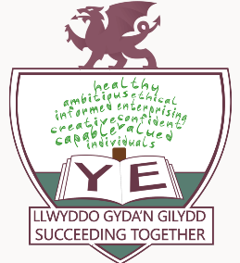
YSGOL EIRIAS

APPOINTMENT OF HEADTEACHER
PERSON SPECIFICATION

 | Essential | Desirable | Measured
QUALIFICATIONS AND TRAINNG | - Qualified Teacher Status  - Degree  - Recent and relevant management training  - NPQH (or equivalent) | - Higher Degree or Management Qualifications | - Application  - Reference
EXPERIENCE | - Senior experience of 11-18 range  - Leadership at Deputy level or above  - Strong track record of leadership achievement at senior level  - Effective management of staff and understanding of financial resources  - Successful innovator | - Senior experience in at least two comprehensive schools  - Experience of financial management at senior level  - Experience of working in a school with Sixth Form provision | - Application  - Reference  - Interview
LEADERSHIP & MANAGEMENT | - Successful curriculum leadership  - Effective implementation of improvement strategies  - Successful budget management  - Effective provision of teaching, learning and assessment strategies  - Successful in leading school development and strategic planning  - Successful management of monitoring, evaluation and review procedures  - Up to date knowledge of curriculum developments | - Experience in the development of the Curriculum for Wales | - Application  - Reference  - Interview  - Presentation
PERSONAL SKILLS AND QUALITIES | - Dynamic leadership style  - Personal impact and presence  - Excellent classroom teacher  - Excellent interpersonal and communication skills  - Willingness to work with the Governing Body in the development of school’s strategic vision  - Self-confident  - Resilience  - Thinks creatively to solve problems and identify opportunities  - Works under pressure to deadlines  - Able to manage change and lead innovation  - Clear education philosophy  - Excellent attendance record  - Digital competence | - Entrepreneurial flair  - An ability to initiate and oversee capital projects  - Effective understanding of IT skills and applications | - Application  - Reference  - Interview  - Presentation

