

JOB DESCRIPTION

JOB TITLE: Programme Manager – Management & Professional

REPORTS TO: Head of School – Business, Management & Professional

AREA: Management & Professional

GRADE/SALARY: Salary up to £45,963 per annum

REMISSION: up to 400 hours per year

POST NO: LC017

CLOSING DATE: Sunday 19th November 2023

INTERVIEW DATE: Wednesday 29th November 2023

DBS: Enhanced DBS check with children’s barred list check

PURPOSE:

The Programme Manager will shape the growth and development of the Management and Professional school, developing appropriate programmes which meet the needs of the curriculum plan and the College. Working closely with the Head of School, they will oversee the effective and efficient delivery of these programmes to ensure the highest quality of teaching, learning, and learner outcomes.

To increase student numbers, meet the local and regional needs and generate income by successfully engaging with external organisations and community groups.

PRINCIPAL DUTIES:

- To work closely with the Head of School to deliver on their strategic direction for the curriculum. To support and lead on the development, review, and enhancement of the curriculum for Management and Professional courses in alignment with the College's vision, academic standards, and industry requirements, skills gap, emerging trends and employer needs.

- To foster strong relationships and collaborations with industry partners to ensure that our courses meet current industry demands and provide relevant skills outlined by WMCA and other stakeholders to develop a sustainable curriculum offer in line with local and regional and national priorities.

- To provide effective leadership and management of staff involved in the delivery of the Management and Professional school, alongside the Head of School.

- To coordinate with the Head of School, academic staff and industry experts to ensure the relevance, accuracy, and currency of course content, developing a flexible and innovative management and professional curriculum, for examples Bootcamps, SWAPS, online delivery.

- To supervise and support instructors to ensure effective delivery of courses and adherence to established academic standards and teaching methodologies.

- To conduct regular assessments of programmes to evaluate the quality of teaching, learning outcomes, and overall student experience. The Programme Manager will help to bring about continuous improvement in learner success, ensure the effective and efficient delivery of learning as well as fostering a culture of innovation in respect of teaching and learning and curriculum development.

- To work with admissions and marketing teams, to attract high-quality students to the Management and Professional School. This may involve working with employer services to organise recruitment events, implementing targeted marketing campaigns, establishing employer boards, and forming partnerships with relevant educational institutions.

- To produce timetables in liaison with staff as appropriate.

- To foster strong relationships and collaborations with industry partners to ensure that our courses meet current industry demands and provide relevant skills and knowledge to students.

- To organise and attend relevant promotional events both internally and externally (this may include occasional unsociable hours).

- To develop new links and sustain current partnerships with the local authority, primary schools, secondary schools, job centres, Unity Group, libraries and other relevant groups to secure recruitment and increase student numbers in line with set targets.

- To work in conjunction with the Assistant Principal and Head of School to run an effective and efficient curriculum area.

- To develop an unemployed offer as directed by local and College priorities.

- To meet annual income, recruitment, retention and achievement targets within the provision.

- To ensure that student interview and recruitment processes are responsive and of high quality.

- To plan and manage resources effectively, including staffing, budgets, rooms and learning resources.

- To be proactive in maintaining and developing quality standards on Community programmes and demonstrate a commitment to quality improvement.

- To advise the Head of School on matters relating to the management, delivery and development of learning within the curriculum area.

- Teach a number of hours as agreed with the Head of School.

- To ensure the College's safeguarding and student conduct procedures are adhered to within the curriculum area.

- To champion Equality and Diversity.

- To embed sustainability within the curriculum.

- To adhere to policies, procedures and values of Solihull College & University Centre.

- To undertake all mandatory training in a timely manner as required e.g. Safeguarding, Prevent.

- To actively promote equality, diversity & inclusion and to champion anti-racist practice.

- To support the College to become a Sustainable Net Zero organisation by 2030 and support the delivery of its Sustainability Strategy.

- To undertake necessary Health and Safety responsibilities, duties and training as required by this post.

- To undertake any necessary Data Protection responsibilities, duties and training as required by the post.

- Such other duties as required which are broadly consistent with the general functions and grading of this position.

EQUAL OPPORTUNITIES:

Solihull College & University Centre is committed to a comprehensive policy of Equal Opportunities. All employees are required to abide by this policy and ensure its compliance throughout the College.

SAFEGUARDING:

Solihull College & University Centre is committed to ensuring a safe environment for all students and expects all staff to engage fully with this commitment.

CORE VALUES:
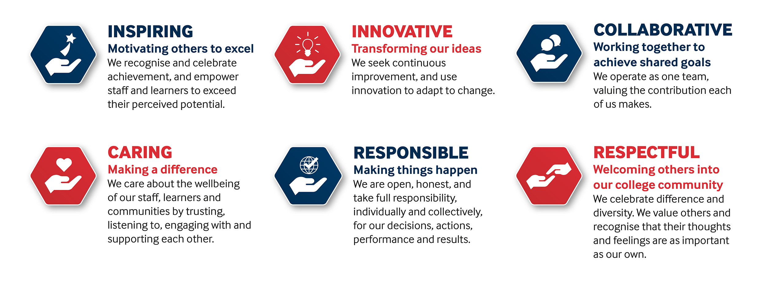

SOLIHULL COLLEGE & UNIVERSITY CENTRE
PERSON SPECIFICATION

JOB TITLE: Programme Manager – Management & Professional

SALARY: Up to £45,963 per annum

POST NO: LC017

SPECIFICATION | ESSENTIAL | DESIRABLE
EDUCATION/  TRAINING | Significant experience in Management courses and/or related provision  Higher level qualifications in either Accounting, Management, HR or Project Management  Level 5 teaching qualification or working towards  Level 2 English and Maths qualification or equivalent | Masters
RELEVANT EXPERIENCE | Experience of working in a Ieadership and/or management role in FE sector  Significant experience of  programme / curriculum  development  Experience of working with a range of external  organisations/stakeholders to develop curriculum models which meet the needs of local  communities  Significant experience of  working with hard-to-reach learners | Understanding of the  various funding models  that support management and professional courses and related areas
SKILLS / APTITUDES | Excellent communication skills  Ability to network effectively  Ability to motivate others and lead and work effectively as part of a team  Able to manage change and conflict  An awareness of sustainability and climate change and how it applies to Further Education
OTHER  REQUIREMENTS | Dedication to the development  and maintenance of Quality Flexible approach to work  Energy and Enthusiasm  Strong commitment to Equal Opportunities  A commitment to the Safeguarding of Young People and Vulnerable Adults and an awareness of the Government ‘Prevent’ strategy  Commitment to the College’s Values

