

Candidate Application Pack

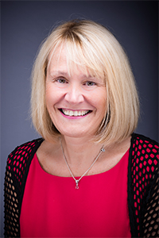

Dear Sir/Madam

We are delighted that you would like to join the family of Washwood Heath Multi Academy Trust (“WHMAT”).

We are currently a family of five academies (three secondary and two primary) serving a discrete, diverse and multicultural community.

Our underlying moral purpose is that “*we are stronger working together in partnership*”. However, we continue to respect the unique identity of each academy whilst encouraging a collaborative approach to all that we do.

At the heart of WHMAT is a focus on developing all staff so that they remain happy and motivated to provide the best possible teaching and support to our pupils. This, in turn, gives our young people the best possible chances of developing into well-rounded individuals.

WHMAT hopes to grow over the next five years, by attracting local establishments who share our values. As it grows, I am confident that we will continue to have a positive impact on our local community stakeholders.

Good luck with your application and I look forward to welcoming you into our family!

Yours sincerely

**Bev Mabey**

**Chief Executive Officer of Washwood Heath Multi Academy Trust**

Our Family of Schools

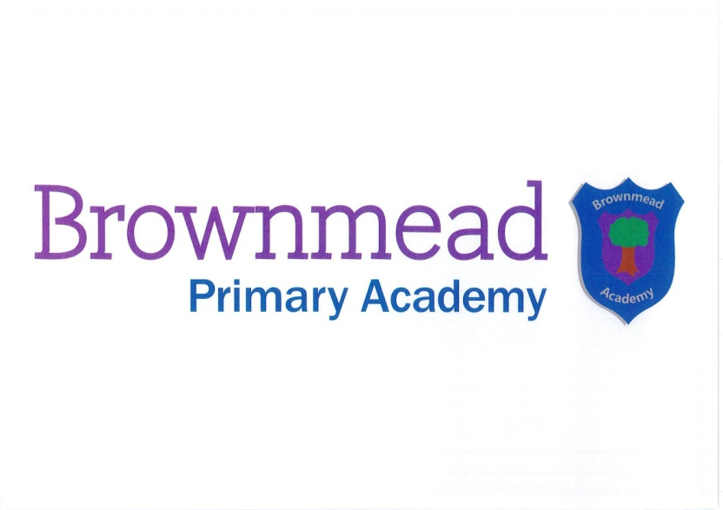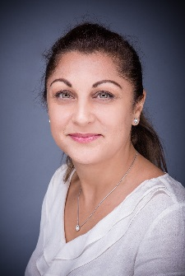

Brownmead Primary Academy is a popular school in the heart of Shard End. We cater for 240 children, in our growing school, with a two-form Reception class for the first time this year. We stand by a set of Brownmead Values that were written by all stakeholders and these values will promote the education that our children deserve. We offer our families a caring and supportive environment, where children are allowed to grow and develop, to become the best citizens they can be. We offer a broad curriculum with an emphasis on enjoyment and provide children with many opportunities for enriching life experiences. We have strong partnerships throughout WHMAT and these provide the bedrock of our continued development.

**Mr Winters Head of Academy**

Gossey Lane Academy is a popular and friendly school in the heart of Kitts Green. Our mission "Together we Aspire" encapsulates the values which underpin our ethos and motivate our children to reach their full potential. We provide our children and their families a safe supportive environment in which they thrive. Our education offers a rich and varied curriculum, involving a range of opportunities to learn in different ways . We have formed effective partnerships within WHMAT, and also with other local schools, which has included work related to the Arts. These firm foundations allow our children to holistically grow from strength to strength.

**Mrs Amin Head of Academy**

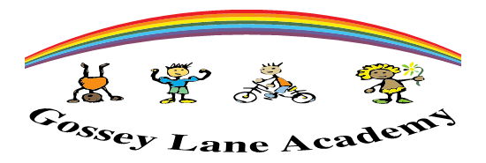



Saltley Academy is a mixed comprehensive school of 1014 students, aged 11-16. The school was created on 1st March 2015. Since WHMAT was first involved in the school, it has achieved excellent examination results with achievement in English, Mathematics and a number of other subjects above the national average, as is the progress for all students. The Academy has already developed a reputation for creative and effective strategies for engaging with issues such as 'British Values'. The team ethos of the Academy community has also contributed to a very successful retention and recruitment programme, with the Academy fully staffed with a healthy mixture of experience and colleagues at the early stages of their career.

**Mr Weir Head of Academy**

**Mr Etheridge**

**Head of Academy**

Tile Cross Academy is a small and caring 11-16 mixed comprehensive school that was created on 1st May 2017.  As part of WHMAT partnerships and collaborative working are at the heart of everything we do.  We have high expectations for our students and we aim to provide a high quality education in an atmosphere of mutual respect where each individual is valued as an important member of our school community.  With the wide range of backgrounds and cultures in our school population we celebrate diversity and difference, whilst recognising that we are all equal.  We strive to develop and nurture the values, skills and attributes which create good citizens and lifelong learners, so that every student can discover, develop and achieve their full potential and be successful in whatever path they choose.   Our broad and balanced curriculum prepares our students to meet the challenges of a rapidly changing society, ready and willing to grasp the opportunities available to them and be positive about their futures.

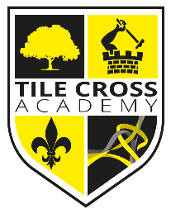

TILE CROSS

**ACADEMY**

 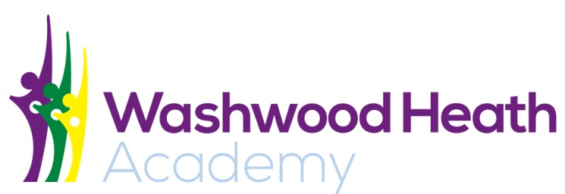

Washwood Heath Academy is a large 11-18 academy with 1400 students, 140 in the Sixth Form.  The majority of our students are from minority ethnic backgrounds and a high proportion of students speak English as an additional language.  We are passionate about supporting and challenging our students and staff to be creative, resilient, team players and pride ourselves on being open-minded and respectful of all cultures and backgrounds that make up our diverse learning community. At Washwood Heath Academy, growing future leaders is one of our key priorities. At all key stages, our wider curriculum offers opportunities and experiences beyond that of the classroom.

**Mrs McLachlan Head of Academy**

**Mrs Lowe**

**Deputy Head of Academy**

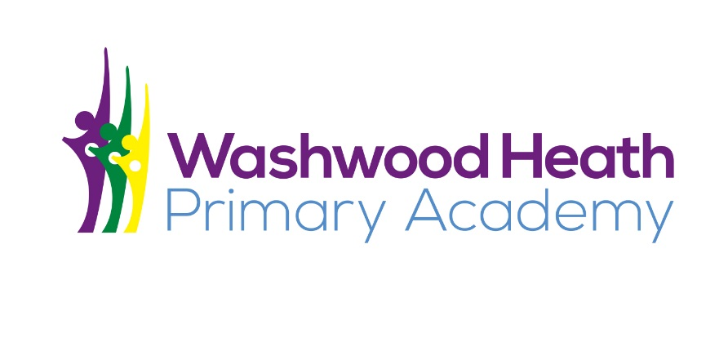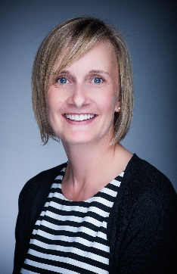

Washwood Heath Primary - an exciting new chapter in the development of Washwood Heath Multi Academy Trust . WHP presents a wonderful opportunity for us to develop and inspire children from the age of 4 onwards to post 16. Our aim is to instil the values and ethos that are at the very heart of the MAT ensuring that we provide our pupils with experiences that are rich and diverse equipping them with skills for life as an adult. WHP is set to be a vibrant school where our children are enthusiastic and motivated to achieve endless possibilities. Our children will be at the heart of every decision we make to ensure that they are happy, confident and the opportunities that are provided for them are relevant to their needs both now and in the future. The school has a dedicated team that works hard to reach high standards in everything we do and this is further embedded through our successful relationships with parents, the local community and the other schools in the WHMAT. We firmly believe that education is a partnership between home and school and regard you as an active partner in your child's education and value your interest and support.