Applicant user GUIDE

e-recruit CLASSROOM TEACHER recruitment drive

- Go to the Northern Territory Government Employment Opportunities Online website. https://jobs.nt.gov.au/Home/Search

- Search for the generic Classroom Teacher vacancy using position number 17937 in the Vacancy Number.

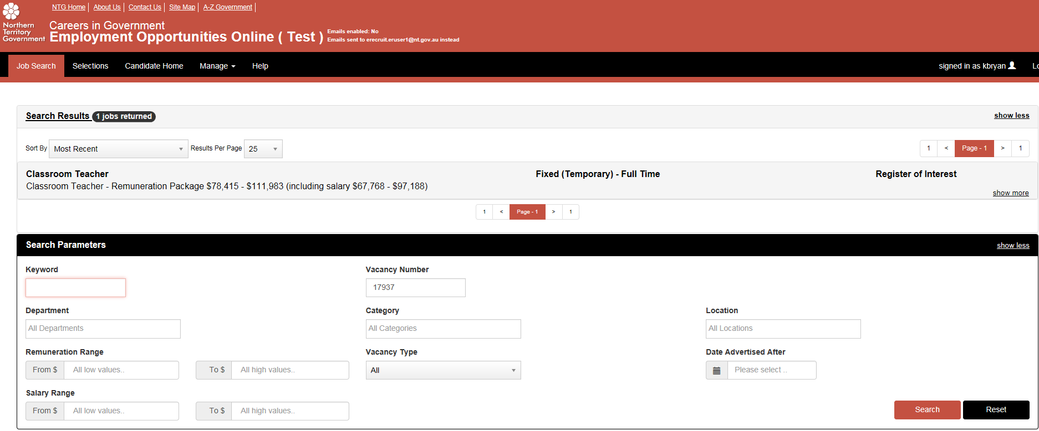

- Click on the Classroom Teacher vacancy for the details and click Apply Online.
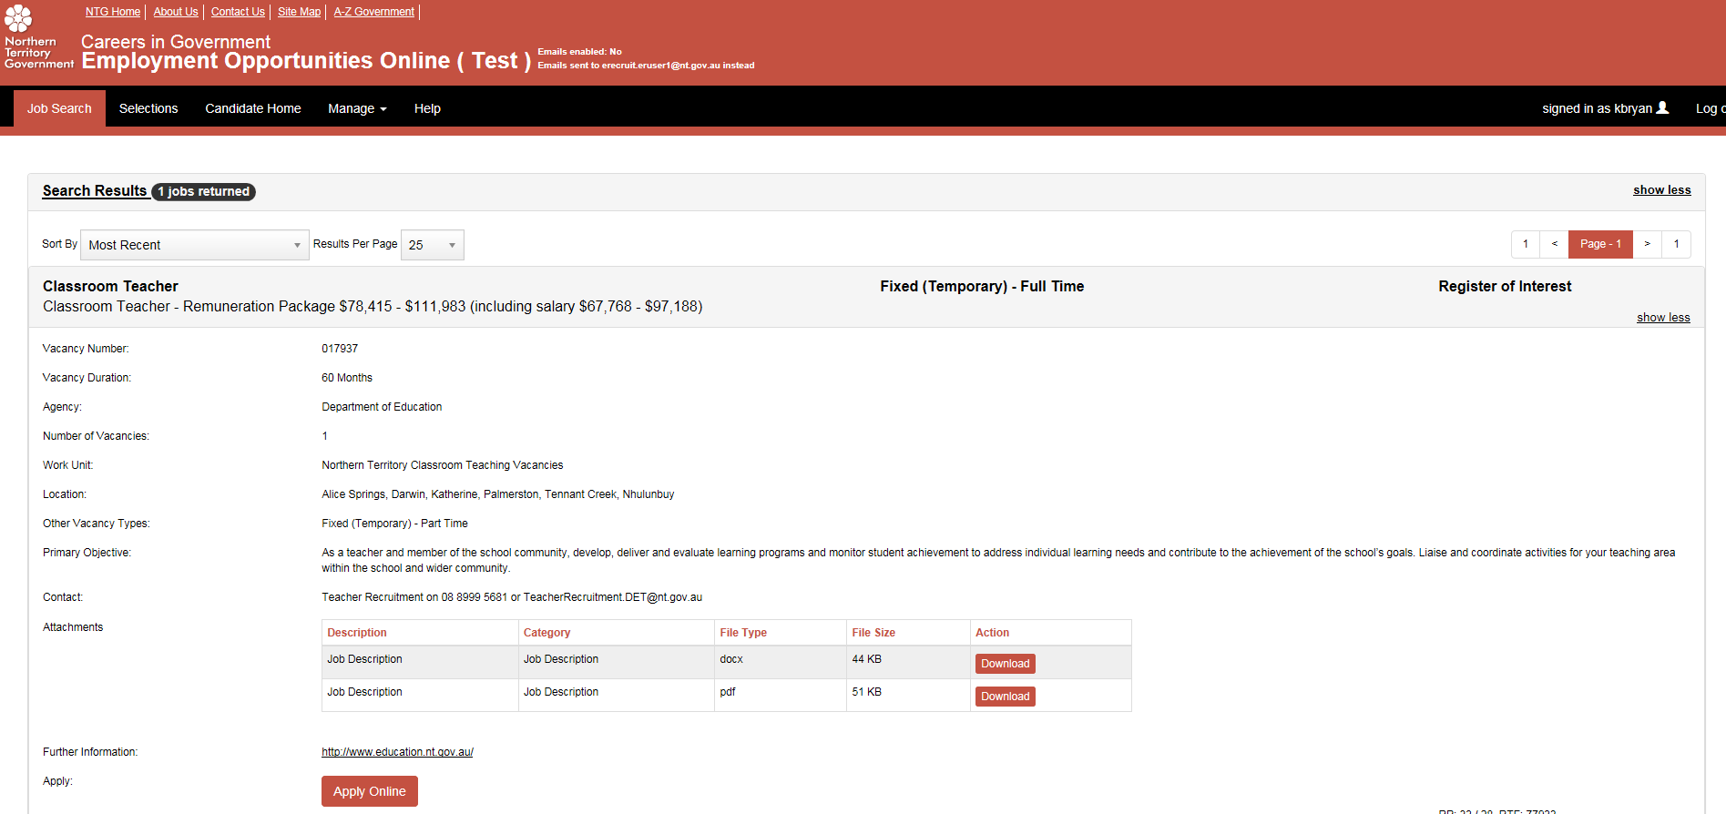

- Click next to the Privacy Declaration.

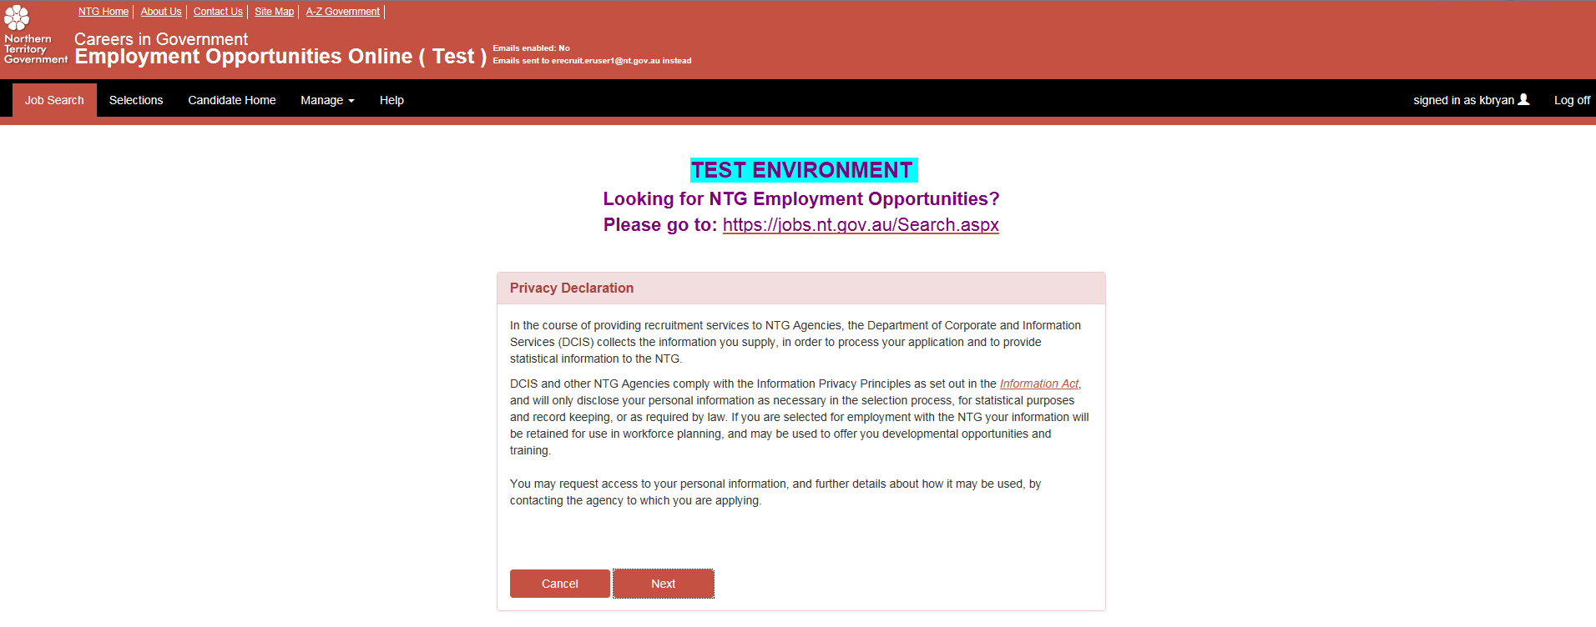

- For new users, click the black Register button to create an account.

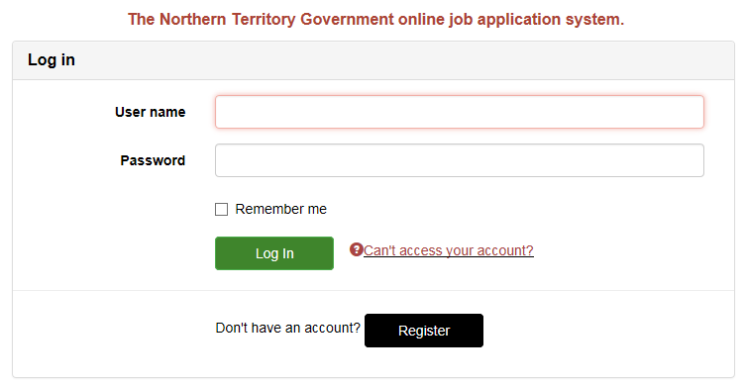

- Update the profile with your all of your details and click next to fill in your application. If you are not an Australian Citizen please upload identification in the supporting documentation under other.

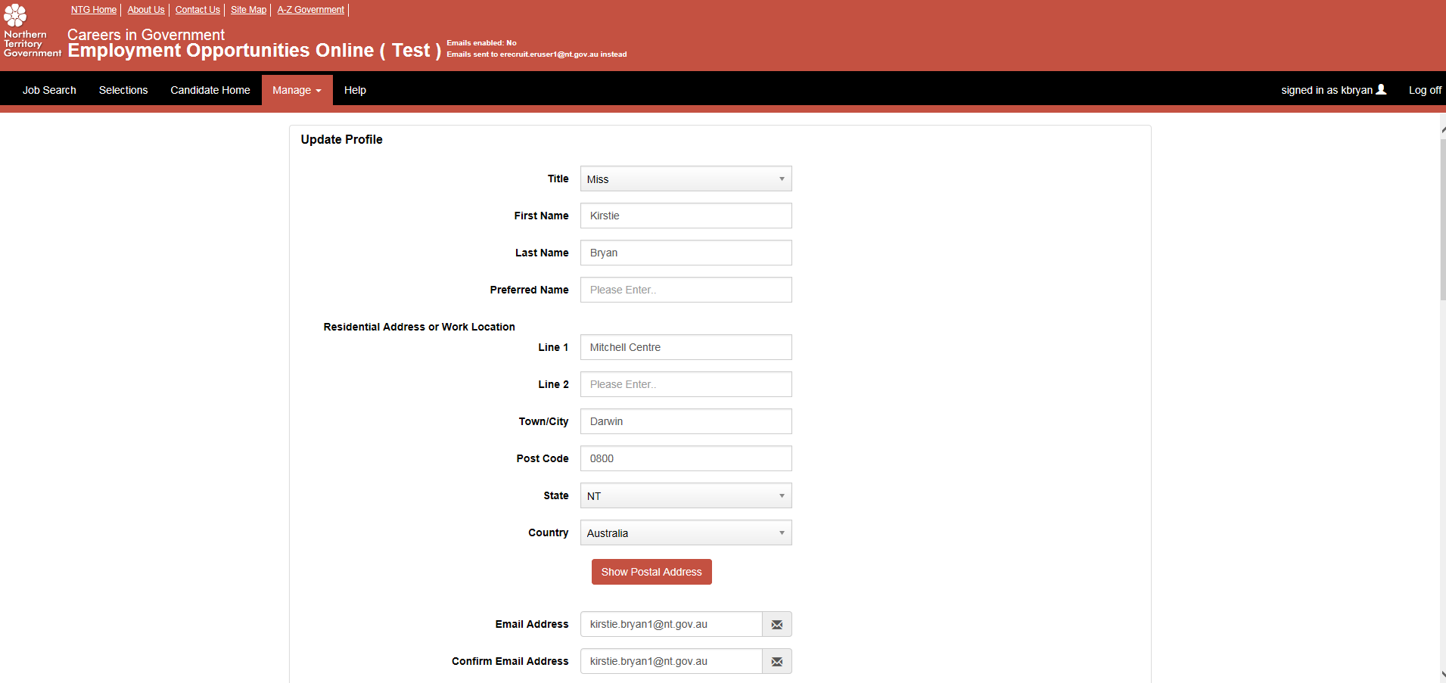

- Fill in the information for each section of the online application form (you are able to log back in to your account at any time to update the information, even after submitting).

Please note the Teacher Registration Board, as the regulatory authority, operates as a separate entity to the Department of Education and as such it is necessary to provide similar documentation to both bodies.

Please note an OCHRE card is a Northern Territory specific working with children check and is mandatory for all child related employment in the Northern Territory. Applications can be made online at SafeNT (NT Police).

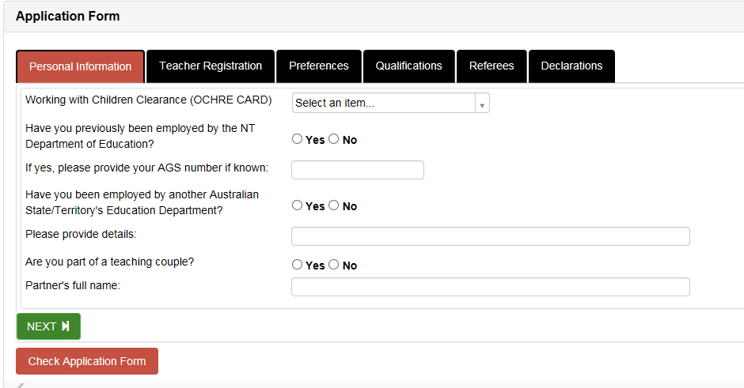

- Click ‘Check Application Form’ button. If there is any section incomplete a notification will prompt you to this.
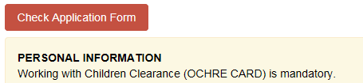

- Upload a copy of your CV, Qualifications, Statements of Services, Prac Reports/Exist Interview and VISA details if required.

Please note statements of service for the purpose of a salary assessment are accepted from relevant government payroll departments or on official school letterhead clearly stating full time or part time classroom teacher employment with commencement and cessation dates; and/or a total number of casual relief teaching days. Any leave without pay must also be noted.

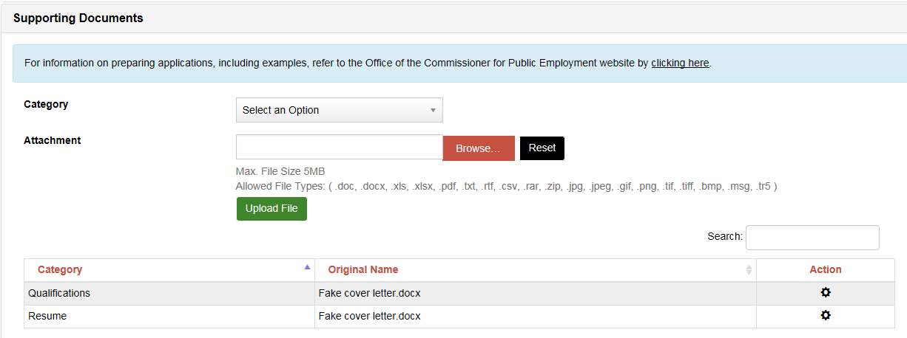

- If successfully validate, click ‘Submit’ at the bottom of the page.

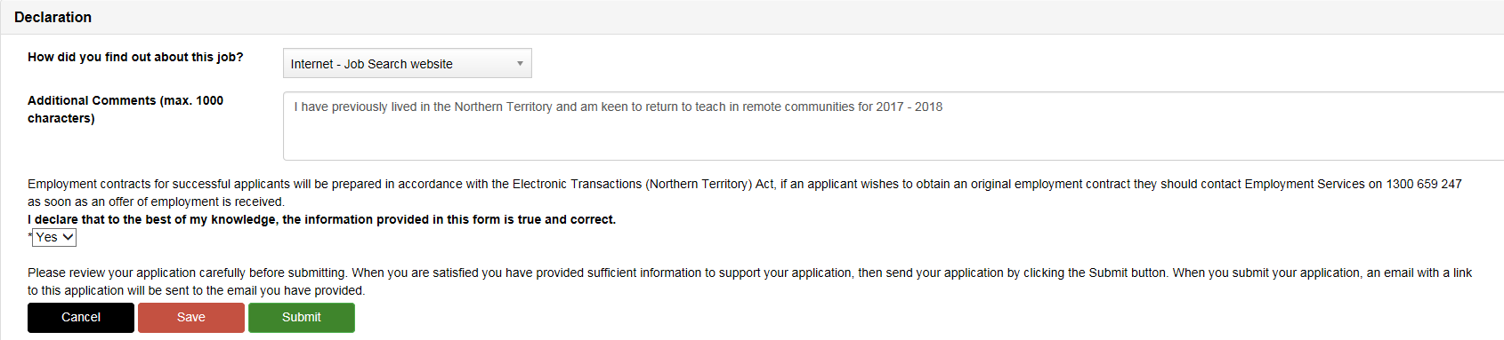

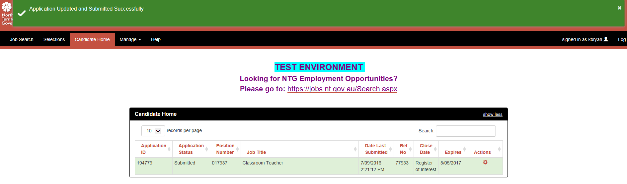
- A complete application for an ‘Eligible & Available’ status in order for schools to employ you as a relief teacher or on contract requires:

- Current Northern Territory Teacher Registration.
- Current Northern Territory OCHRE Card.
- Certified copy of identification if you are not an Australian citizen.
- Photocopy of relevant teaching Qualification certificate and transcripts
- Response from a Principal/Assistant Principal referee, against DoE reference template
You are able to submit without the specific NT teacher registration, Ochre card etc and log in at a later date to update as required.

