

JOB DESCRIPTION

JOB TITLE: Animal Centre Manager

REPORTS TO: Head of School for Animal Welfare and Veterinary Nursing

AREA: Animal Welfare and Veterinary Nursing

GRADE/SALARY: Lecturers Scale, points 6 to 14 £28,986 to £39,562 per annum
Level 5 Teaching Qualified up to £43,572 per annum

TEACHING: Up to 200 hours

POST NO: LB010M

CLOSING DATE: Sunday 11th August 2024

DBS: Enhanced DBS check with children’s barred list check

PURPOSE:

To manage the College’s animal facilities, which includes; the main Animal Centre, Dog Training Centre and Dog Grooming centre. To also manage and co-ordinate all practicals within the centres and teach as necessary. To work closely with other members of staff both within the area and across other College areas.

PRINCIPAL DUTIES:

- To manage the Animal Centre Team to be effective and supportive to colleagues as
appropriate.

- To maintain excellent animal health, welfare and standards within the centres, keeping in
line with current legislation and research.

- To ensure the centres provide an appropriate and safe environment for staff and
students with procedures in place to ensure compliance with Health and Safety legislation and that these are monitored effectively.

- To communicate with and support teachers and learners effectively.

- To manage and organise all practicals within the centres, including resources where
applicable.

- To manage and monitor animal records and records of fixed assets and stock.

- To manage the budget and stock for the centres effectively.

- To teach on a range of programmes within the specified area.

- To support a robust animal collection plan with clear vision for the future.

- To contribute to the curriculum development, marketing of programmes, recruitment and
interviewing.

- To play an active part in the development of the flexible curriculum and the learning
materials to support this including the College’s virtual offer.

- To develop external contacts and promote good relations with other animal
establishments/stakeholders, including industry-based work experience placements where applicable.

- To demonstrate commitment to professional development.

- To be proactive in maintaining and developing quality standards within the centres and
demonstrate a commitment to quality improvement.

- To embed sustainability within the centres and curriculum.

- To adhere to policies, procedures and values of Solihull College & University Centre.

- To undertake all mandatory training in a timely manner as required e.g. Safeguarding, Prevent.

- To actively promote equality, diversity & inclusion and to champion anti-racist practice.

- To support the college to become a Sustainable Net Zero organisation by 2030 and support the delivery of its Sustainability Strategy.

- To undertake necessary Health and Safety responsibilities, duties and training as required by this post.

- To undertake any necessary Data Protection responsibilities, duties and training as required by the post.

- Such other duties as required which are broadly consistent with the general functions and grading of this position.

EQUAL OPPORTUNITIES:

Solihull College & University Centre is committed to a comprehensive policy of Equal Opportunities. All employees are required to abide by this policy and ensure its compliance throughout the College.

SAFEGUARDING:

Solihull College & University Centre is committed to ensuring a safe environment for all students and expects all staff to engage fully with this commitment.

CORE VALUES:
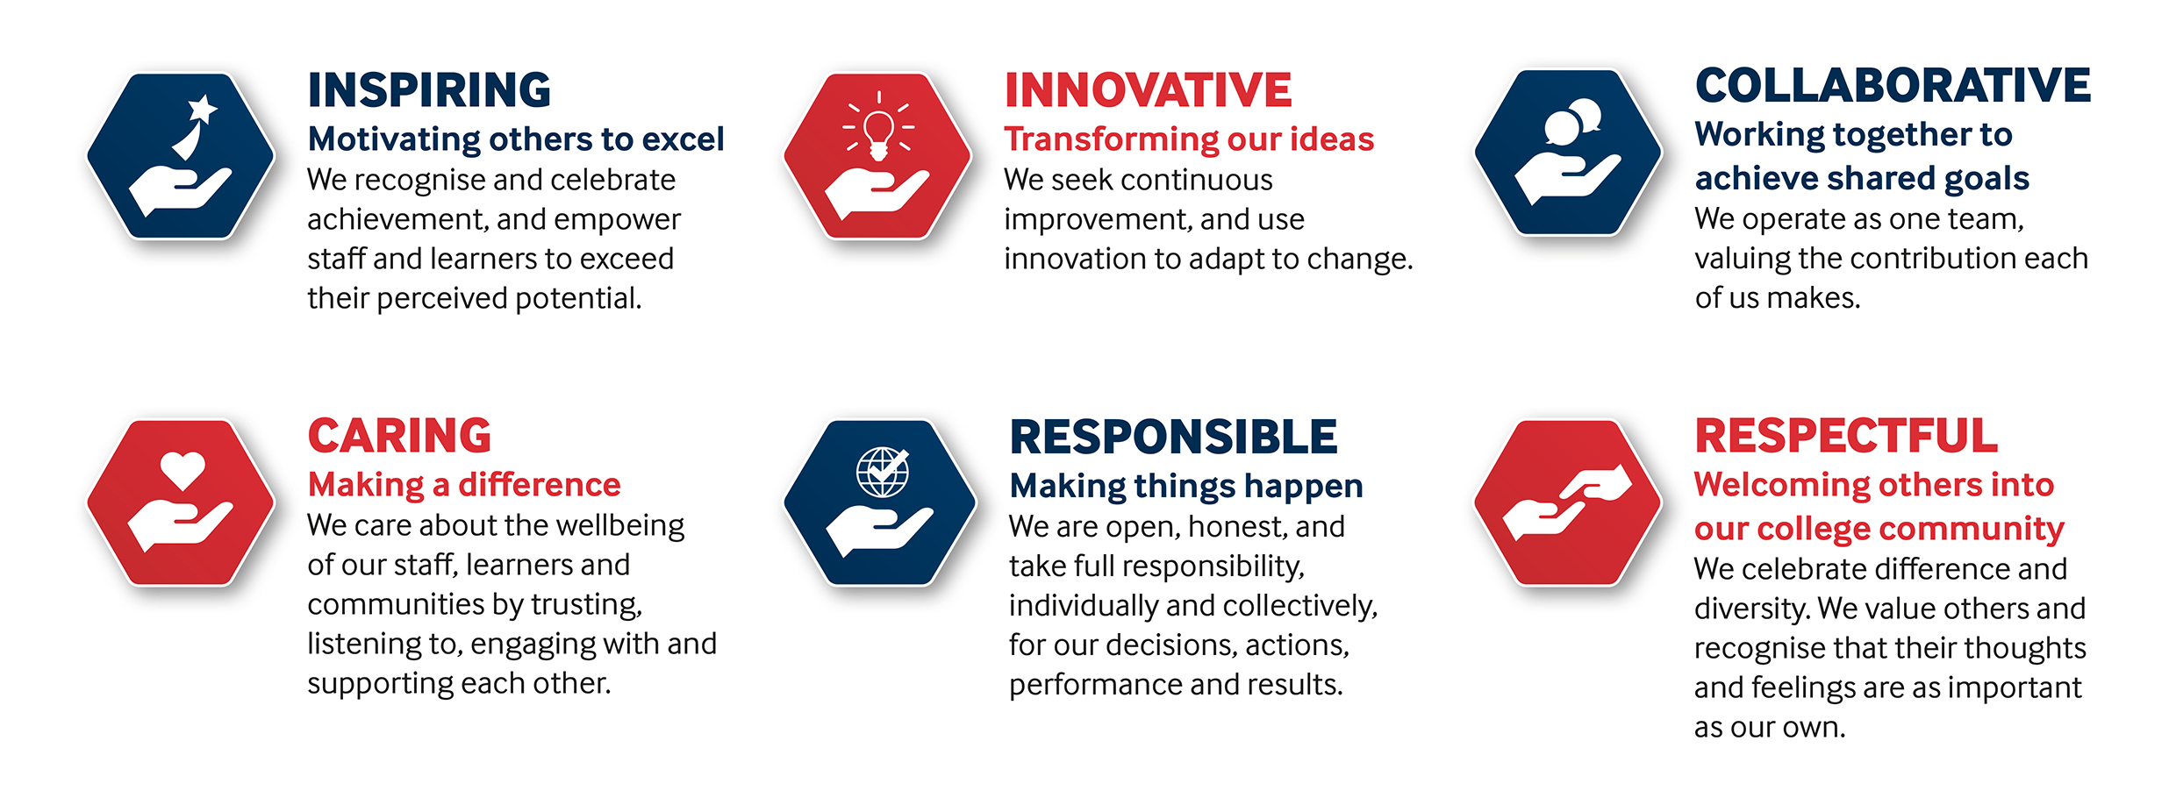

SOLIHULL COLLEGE & UNIVERSITY CENTRE
PERSON SPECIFICATION

JOB TITLE: Animal Centre Manager

SALARY: Lecturers Scale, points 6 to 14 £28,986 to £39,562 per annum

Level 5 Teaching Qualified up to £43,572 per annum

POST NO: LB010M

SPECIFICATION | ESSENTIAL | DESIRABLE
EDUCATION/  TRAINING | Hold an appropriate Degree or equivalent  Level 5 Teaching qualification (or committed to work towards in line with contractual requirements)  Level 2 qualification in English and Maths | Assessor Award
RELEVANT EXPERIENCE | Proven industry experience working with a range of animals, including in a supervisory capacity | Teaching experience on related programmes  Curriculum development experience
SKILLS / APTITUDES | Excellent communicator to liaise internally and externally to the organisation  Enthusiastic, flexible & dynamic to work out of hour and over weekends as required  Excellent administrator – well organised  IT literate  Ability to work as part of a team and lead a team.  Ability to embed English and Maths into practical teaching within the centre.  Ability to support research study  Able to work on own initiative  An awareness of sustainability and climate change and how it applies to FE and can be embedded into the curriculum
OTHER  REQUIREMENTS | Strong commitment to Equal Opportunities  An understanding of the needs and challenges of managing an animal centre in a busy educational setting  Commitment to CPD  A commitment to the Safeguarding of Young People and Vulnerable Adults and an awareness of the Government ‘Prevent’ strategy  Commitment to the College’s Values | General awareness of cultural diversity

