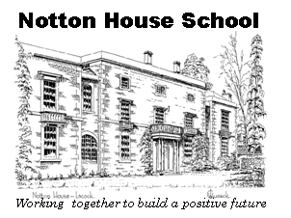

Working Together to Build a Positive Future

28 Notton
Lacock
Nr Chippenham
Wiltshire
SN15 2NF

Tel: 01249 730 407

Email: cath.neale@notton.learnmat.uk

Website: www.nottonhouse.bristol.sch.uk

Notton
House
Academy

Recruitment Pack
2017

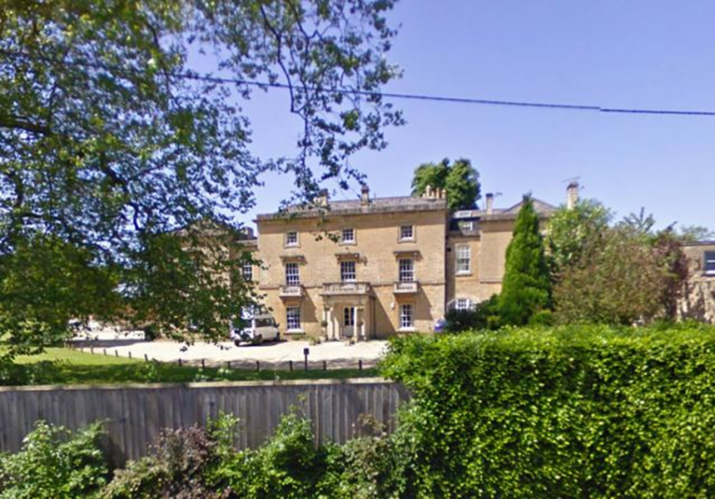
Contents Page
Introduction ….......……………………….………………………………………………………………………1
Letter from the Head Teacher and Chair of Governors ………………………………………………………………………………2
Statement of Purpose for Learn@MAT ………………………………………………………………………………………………..3
Lacock and Chippenham …………………………………………………………………………………………………………4
Visions and Aims ………………………………………………………………………………………………………….5

Introduction
Thank you for your interest in the position of Curriculum Lead – Creative Arts at Notton House Academy located in Lacock, near Chippenham.
We hope that this brochure will provide potential applicants with all the information and guidance that you need to apply.
If you need any further information please do not hesitate to contact Cath Neale, the Bursar or Lindsey Hull the Headteacher, who will be pleased to help you:
Email: cath.neale@notton.learnmat.uk
Tel: 01249 730 407
Map
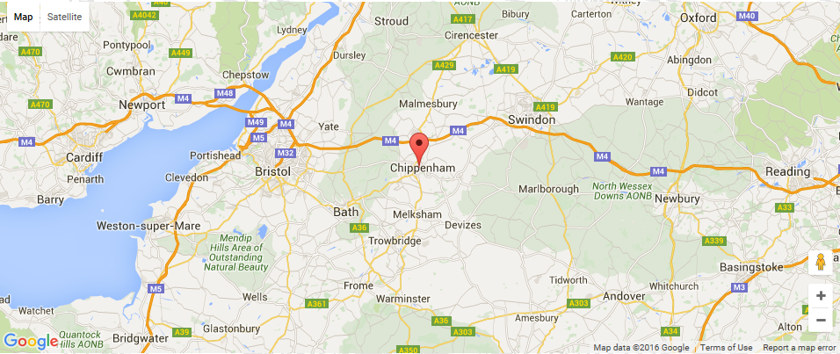
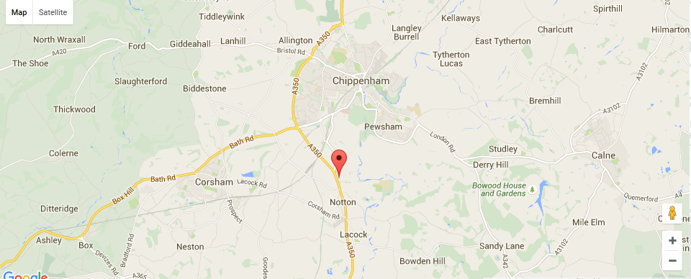

Letter from the Headteacher and Chair of the Academy Council

Dear Applicant,

We are delighted that you have expressed an interest in the post of Curriculum Lead – Creative Arts systems and develop to ensure that some of the most vulnerable young people in or society are given the best opportunities to succeed and achieve their potential. We aim to secure relevant qualifications for each of our students to allow them to move onto destinations that will enable them to be active members of society. We are looking for a creative and committed school leader to continue to drive school improvement in order for us to become an outstanding provision.

We are a residential Academy with a growing proportion of day students. Our pupils, who come from across Bristol and other local areas have an education, health and care plan. We believe that every young person, no matter their past experiences or the challenges they have faced, may succeed if they are provided with excellent teaching and learning opportunities, pastoral care and family support. We aim to be pillars of strength to our young people and provide them with strategies and skills to overcome barriers to learning.

As of the 1st September, we have become part of a new specialist multi academy trust. This will provide us with the ability to grow and develop our expertise further. As a school we are united and determined to improve. The focus for the Academy is on outstanding teaching and learning supported by robust systems and structures to enable all members of the school community to thrive. We are also committed to working in partnership with multi - agency teams and other professionals from social care and health, in order for our students and their families to thrive.

If you are passionate about playing a key part in the further success of our community and joining our team we look forward to receiving your application.

Yours faithfully,


Lindsey Hull - Headteacher


Dr Richard Riddell – Chair of the Academy Council.

Learn@ Multi-Academy Trust
Statement of Purpose
Learn@ is a partnership of schools that specialise in working with young people who have either SEMH (Social, Emotional Mental Health) or SLCN (Speech and Language Communication Needs). The Trust offers a range of provision including day school and residential school places, short-break care and Alternative Education courses. It has a range of specialised schools including a new “state of the art” purpose-built school in South Bristol; centrally based well-established sites in Central and East Bristol; and a charming country residential site in rural Wiltshire.
Learn@ offers places for young people across all ages from Key Stage 1 to its Post-16 provision, including a specific Sixth Form for ASC needs. Learn@ Academy Trust provides an inclusive ethos and approach in which each learner is central to what we offer and how we deliver it. We provide a more personalised learning programme across a very wide scope of areas, using modern facilities and offering a wide range of nationally recognised academic and vocational accreditation.
Learn@ is a holistic approach embracing the individual needs of each young person. As well as the Education Team, Learn@ provides a skilled staff of professionals, including, CAMHS, Educational Psychologists, Health Nurses, Practitioners, Learning Mentors, Social Workers, Counsellors and Therapists.

Ethos and Approach
Within the Learn@ Academy Trust we recognise that everyone is different. It is a positive thing that we are all different, it ensures our uniqueness in the world and it should be celebrated and cherished. Young people who have experienced trauma in their lives, or the feeling of failure often become insecure about themselves and have very poor self-esteem. They see their uniqueness as negative and may have become disaffected with education. We see it as our purpose to help them understand and appreciate themselves and recognise their strengths and potential. Through Learn@ we encourage their self-belief and confidence to use and develop their individual skills and personality to achieve the best they can.
Within the Learn@ Academy Trust we treat everyone equally. Through tolerance, respect and responsibility we promote and reflect equality across our whole community. Regardless of race, gender, faith, ability, aptitude or history we strive to offer every individual young person the support, structure, resources and style of approach they require to fulfil their hopes and aspirations. So all have an equal opportunity to succeed and achieve.
Within the Learn@ Academy Trust we hold central to our purpose that all young people have the right to learn. We promote discovery, exploration, investigation, research and experimentation. By better understanding How? What? Where? When? And who? Young people can better understand – Why?
We recognise that to understand the world young people often need to better understand themselves, and that social and emotional development is essential to growth and to the progress of our young people. Despite the many different challenges a young person may face, we believe that we are all born to learn and grow and our key role within Learn@ is to ensure each young person is given this opportunity.

“All different; all equal; all learning together”

Welcome to North Wiltshire
Lacock


Lacock village is near the town of Chippenham (3 miles) in North Wiltshire.
The village, which dates from the 13th century and has many lime washed half-timbered and stone houses, was used as a location in the TV and film productions of Pride and Prejudice, Moll Flanders and Emma. The Abbey also featured in the recent Harry Potter films.


Chippenham

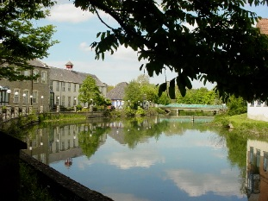


The historical market town of Chippenham is one of the West Country’s most vibrant towns. Nestled on the banks of the River Avon and a little over an hour’s journey from central London, Chippenham offers an ideal centre for exploration of rural Wiltshire, Bath and the Cotswolds. Chippenham is 4 miles south of the M4 and on the mainline rail route from London Paddington to the West Country and just 10 minutes by train to Bath.
Chippenham enjoys a reputation as a flourishing and lively market town, with a compact centre and thriving commercial life. The main shopping areas are on and adjacent to the High Street, Market Place and The Causeway and The Bridge, New Road and Hathaway retail Park. The enclosed Emery Gate Shopping Centre and open air Borough Parade Shopping Centre lie on either side of the High Street. There are a number of out of town shopping areas including Hathaway Retail Park, and Methuen Park.
Chippenham’s colourful and booming street markets are held on Fridays and Saturdays in the High Street and offer a variety of traditional and modern stalls.
Chippenham has a wealth of beautifully maintained parks, play areas and open spaces notably John Coles Park with its mature trees, flower beds and Victorian Bandstand and Monkton Park which sits on the banks of the River Avon.

Notton House Academy
Candidate Information

Vision and Aims
Vision – We want to develop quality provision that enables young people with social, emotional and mental health needs to excel in their achievement providing them with the very best in life opportunities; provision that provides excellence in teaching, learning and academic ambition alongside excellence in pastoral care, support and guidance.
Aims:
At Notton House Academy we aim for our young people to be:
- have the opportunity to achieve qualifications that reflect their potential.
- learn to take responsibility for their own learning and be successful in further education, training or employment.
- be able to take their place within society as responsible citizens, to respect themselves, others and their environment.
Closing date: 19th January 2018 at 12 noon
Interviews; To be confirmed

To arrange a visit please contact: Cath Neale, Bursar email: cath.neale@notton.learnmat.uk

