Tanfield Lea Road
Stanley
Co. Durham
DH9 8AY

Tel. 01207 232881
Fax. 01207 282922
TANFIELD SCHOOL
Specialist College of Science and Engineering
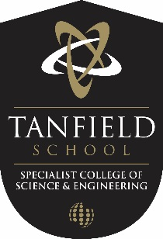

Headteacher
Mr S Clough BSC (Hons).

Dear Applicant,
Re: Post of Science Technician
Thank you for your interest in this post.
Tanfield School has an uncompromising ambition for the progress of all pupils. We are developing a curriculum that facilitates mastery in all academic skills alongside preparing our young people socially and as thoughtful citizens for the next stages of their lives.
Relationships between staff and pupils are exemplary so that pupils feel listened to, are safe and are inspired to learn. Tanfield’s pupils are thoughtful and caring. We respect and trust each other.
We always aim to recruit someone who will support us in this ambition and culture, so that all staff are consistent. We give a lot of attention to appointing the right person as our staff are our most valuable asset.
Your application is welcomed and, if successful, you will play a key part in the next stage of our school’s development. We aim to recruit people who:
- Are excited by their role and the prospect of working with young people, including those who may be less well motivated;
- Are keen to develop their own skills further;
- Support the ethos and vision of the school and are prepared to give time and commitment to help young people to be their very best version of themselves.
Please do not hesitate to contact us should you require any further details or if you wish to visit the school. The closing date for applications is 11th October 2017.
Yours sincerely,

Mr Steven Clough
Head teacher

