Bishop Ramsey CE School

Teacher of Mathematics

Job Description

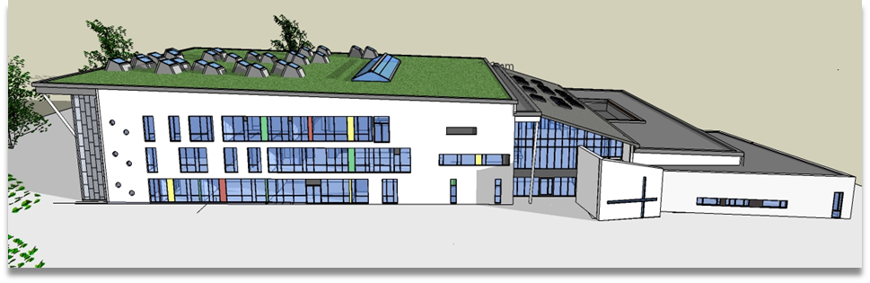
Job Title | Teacher of Mathematics
Grade | MPS
Immediate Supervisor | Head of Mathematics Faculty
Contacts | Internal | All teaching and support staff
 | External | Parents
Main Purpose of the Post
To teach a range of subject areas and classes as required by the Head of Faculty and the Head Teacher in accordance with the Teacher Regulations currently in force.

To ensure that your work within the faculty follows the strategic direction and developments published for the faculty

To manage the teaching and learning of all the students in your teaching groups by ensuring that their curriculum needs are catered for and that those students can make effective progress with their studies and achieve their full potential.

To ensure that the teaching delivered by you is of the highest possible standard.

To provide quality assurance by evaluating the quality of the teaching and learning of all students you teach by using the effective monitoring processes developed within the faculty.

Accountabilities
As a teacher in the Mathematics Faculty, you are accountable for the standards achieved and the progress made by the students taught by you; for the quality of your teaching in the faculty and the Pastoral Care offered to the students in your role as a form tutor

KEY TASKS
To uphold the ethos, aims and administration of the school.

To act as a role model for the department.

To become involved in and to initiate activities which help the school to improve the teaching and learning of its students.

Strategic Direction and Development
To assist in developing a well designed and well resourced curriculum consistent with the school’s aims and objectives and the requirements of the National Curriculum and Examination Boards which meets the needs of all the students taught by the faculty.

To evaluate and review programmes of study on an annual basis, taking responsibility for the development of schemes of work as requested by the Head of Faculty.

To show enthusiasm, motivation and a commitment to achieve the highest possible standards for the benefit of the students, the school and one’s self esteem.

To participate fully in the Professional Review Process as detailed in the Performance Management Policy.

To discuss with the Head of Faculty and Year Director to ascertain suitable staff development activities.

To treat all colleagues and students with respect with the aim of enjoying good working relationships with all members of the school community.
.

Management of Teaching and Learning
To be aware of school and faculty policies and act on them.

To act on current good practice in the delivery of the curriculum.

To be aware of, and develop teaching and learning strategies that meet the needs of each student. This will involve an awareness of how individual students learn, the use of appropriate language which is clear and precise and by creating a stimulating learning experience.

To encourage the sharing of good practice by taking part in a programme of classroom observations for all members of the department each year as per the Faculty Monitoring Programme.

To make use of the student data and learning styles of each teaching group provided, to develop appropriate teaching and learning strategies.

To make full use of the Teaching Assistant so that the teaching and learning of the students in the teaching group is enhanced.

To ensure that cross curricular themes are taught within your subject area as required.

To design relevant assessments, consistent with the demands of the National Curriculum and Examination Boards.

To develop an understanding of the aims and objectives underlying the schemes of work/programmes of study.

Leading and Managing Staff
To support the induction of students into each year within the context of a caring Christian community.

To ensure that students in your teaching groups are aware of the standard of their work and what they need to do to progress to the next level or grade

To ensure that all students are aware of the standards of behaviour expected from them, both inside and outside the classroom.

To monitor the attendance of individual students by checking subject registers on a weekly basis and provide data as required.

To promote good behaviour among the students you teach and all those you come into contact with in line with the school’s Behaviour Policy

Efficient and Effective Deployment of Staff and Resources
To maintain an attractive learning environment and displays of students work in a designated area.

To act as a mentor, responsible for the support and guidance of NQTs, Schools Direct Trainees, PGCE Trainees working within the department as requested.

To ensure that the reports written by you are detailed, accurate and are available according to the published timetable.

To be part of a duty team as per duty roster.

To ensure that the required materials are ready for each lesson.

To keep the Head of Faculty/Department and the Director of Learning and Achievement informed of all developments within each teaching group and within the form group.

To ensure that you carry out your duties and responsibilities under Health and Safety Regulations

To show a willingness to work as part of a team.

Leading and Managing Students
To support the induction of students into each year within the context of a caring Christian community.

To ensure that students in your teaching groups are aware of the standard of their work and what they need to do to progress to the next level or grade

To ensure that all students are aware of the standards of behaviour expected from them both inside and outside the classroom.

To monitor the attendance of individual students by checking subject registers on a weekly basis and provide data as required.

To promote good behaviour among the students you teach and all those you come into contact with in line with the school’s Behaviour Policy

Quality Assurance
To ensure that relevant and differentiated homework is given according to the published timetable.

To ensure that the marking of student’s work is in line with the school’s common marking policy and it’s Assessment Policy

To take part in any procedures required to monitor and moderate the marking of students work for internal and external purposes as per the Faculty Monitoring Programme.

To liaise with the Inclusion Faculty and the Co-ordinator for Gifted and Talented Students regarding the progress of students on the SEN and Gifted and Talented register.

To keep accurate and meaningful records of student’s progress.

To monitor the academic progress of all students taught, so that challenging but realistic targets can be set for each student.

To keep accurate and meaningful records of assessments carried out as part of the requirements of the National Curriculum and Examination Board.

To develop good relations with parents, students and other colleagues within the school.

To complete students’ reports in line with school policy.

School Responsibilities
To attend all meetings in line with the school’s calendar within your allocation of directed time e.g. faculty, year team, staff meetings, consultation evenings.

To ensure that the administration of the faculty, and the school is carried out efficiently, as laid down in the Staff Handbook and Faculty Handbook.

To act as a form tutor and carry out the functions as described in the document ‘The Role of the Form Tutor’.

To be aware of the professional and legal responsibilities required of a teacher at Bishop Ramsey School.

To be punctual for classes and duties etc.

Other Tasks
To undertake such teaching duties as required by the Headteacher in accordance with teacher regulations currently in force.

PERSON SPECIFICATION
CRITERIA | Essential / Desirable |  |  | Assessed by application / interview process
 | E | D |  | A | I
QUALIFICATIONS AND REQUIREMENTS
Honours Degree or equivalent. | √ |  |  | √
Qualified Teacher Status. | √ |  |  | √
Attendance at relevant Staff Development | √
EXPERIENCE
A proven record of successful classroom teaching | √ |  |  |  | √
Some evidence of interests outside your main teaching area |  | √ |  | √ | √
Experience of teaching across the full age and ability range | √ |  |  | √
Experience of school responsibilities, which have provided a thorough preparation for this post. | √ |  |  | √ | √
Experience of school responsibilities across a range of extra curricular areas. |  | √ |  | √ | √
KNOWLEDGE AND SKILLS
Knowledge of current educational issues to promote your development as a classroom teacher. | √ |  |  |  | √
To be able to use student data effectively to monitor the progress of individual students | √ |  |  | √ | √
A knowledge of Information Technology to carry out the key tasks outlined | √ |  |  |  | √
Administrative and time management skills to support the work of the staff | √ |  |  |  | √
The ability to communicate effectively with students and adults | √ |  |  |  | √
PERSONAL QUALITIES
Commitment to the best interests of students | √ |  |  |  | √
Willing and able to take responsibility | √ |  |  | √ | √
Enthusiasm and sense of humour | √ |  |  |  | √
The ability to motivate, guide and support colleague |  | √
An ability to co-operate with colleagues | √ |  |  |  | √
Reliability and integrity | √ |  |  |  | √
SPECIAL REQUIREMENTS
Sympathy with the aims of a Church school and support for the ethos and mission statement of Bishop Ramsey Church of England School | √ |  |  | √ | √

Bishop Ramsey CE School is committed to safeguarding and promoting the welfare and safety of children and young people. The successful applicant will be required to undergo an Enhanced DBS check. This commitment extends to organisations providing services to the school.

