THOMAS BECKET CATHOLIC SCHOOL

TEACHERS IN PERFORMING ARTS, DANCE,
PE AND ENGLISH

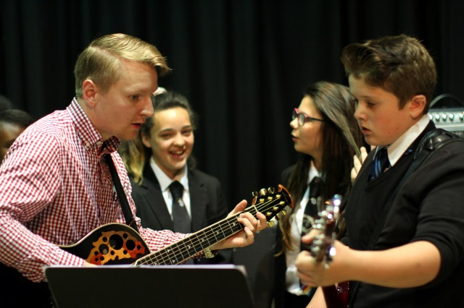
Due to an increasing demand in pupil numbers and the growing success
of Thomas Becket Catholic school, the Directors of this successful, popular, up and
coming Catholic Secondary School are looking to continue the recruitment of good quality enthusiastic teachers in the following subjects :
Performing Arts, Dance, PE and English
NQTs will be considered

Thomas Becket Catholic School is a successful, comprehensive 11-18 secondary school in Northampton. We are committed to continuous improvement and driving up standards of attainment and we are ambitious for our students and our staff.

We all strive at Thomas Becket for our pupils to achieve their very best. We are a Catholic, learning, listening school where it is not enough that children know they are loved, we show them. If you enjoy the challenge that a new role brings and are enthusiastic to come with us on our journey, then please do not hesitate to contact us.

Visits to the school are most welcomed where you will then see first-hand how special our school is. Please contact Jan Hayes at HayesJ@thomasbecket.org.uk or on 01604 493211, who will be more than happy to arrange a school visit.

All our staff uphold the core values and Catholic ethos of the school. All appointments will be subject to an enhanced DBS clearance in line with our Safer Recruitment Policy. Further details and an application form are available from Miss Jan Hayes at HayesJ@thomasbecket.org.uk or from the school website at www.thomasbecket.org.uk or the Catholic Education Service website.

Closing Date: 5th July 201 Interviews: Week commencing Monday 8th July 2019

About Us

Thomas Becket Catholic School is a successful, comprehensive 11-18 secondary school in Northampton. We are committed to continuous improvement and driving up standards of attainment and we are ambitious for our students and our staff. We are a Catholic, learning, listening school where it is not enough that children know they are loved, we show them.

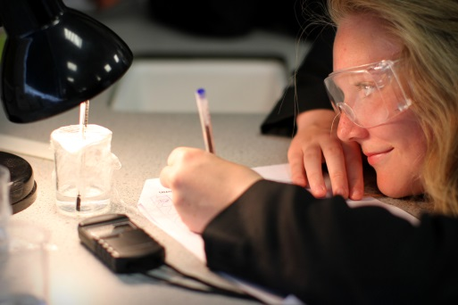
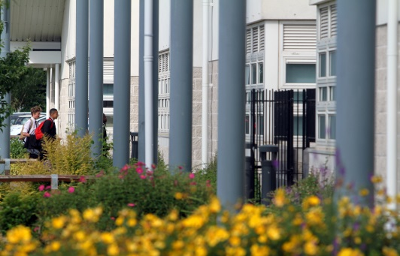

Thomas Becket Catholic School - www.thomasbecket.org.uk | Telephone 01604 493211 | Fax 01604 497300

