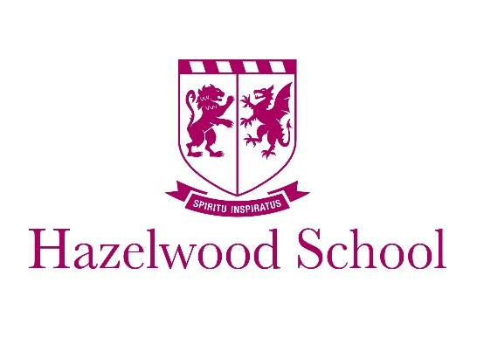

Wolfs Hill, Limpsfield, Oxted, Surrey RH8 0QU
www.hazelwoodschool.co.uk

Specialist Teaching Assistant

Established in 1890 the school is vibrant and thriving, valuing the traditions of the past whilst embracing the best of modern education. Hazelwood is set amongst 25 acres of glorious woodlands on the Surrey Kent border, within easy reach of London and Gatwick.

We are currently looking for a dynamic and innovative individual, keen to work as part of an enthusiastic team of teachers and support staff. The role involves mainly in class support, with specific children and literacy based support for children across the year groups.

Qualifications and experience are desirable, but not essential. You will have excellent communication skills, a willingness to learn and the desire to be part of a high performing team.

More information, including a detailed job description, is available via the TES website, where you can also apply for the role.

Tel: 01883 733885 (Direct)
E-mail: ashlinl@hazelwoodschool.com

Hazelwood School is committed to Child Protection and the successful candidate will be required to obtain an enhanced DBS Certificate through Hazelwood, prior to starting work. Hazelwood upholds and promotes British values.
Closing date: Thursday 14th May 2021
We reverse the right to interview and appoint before the closing date and we therefore recommend that candidates apply early.

