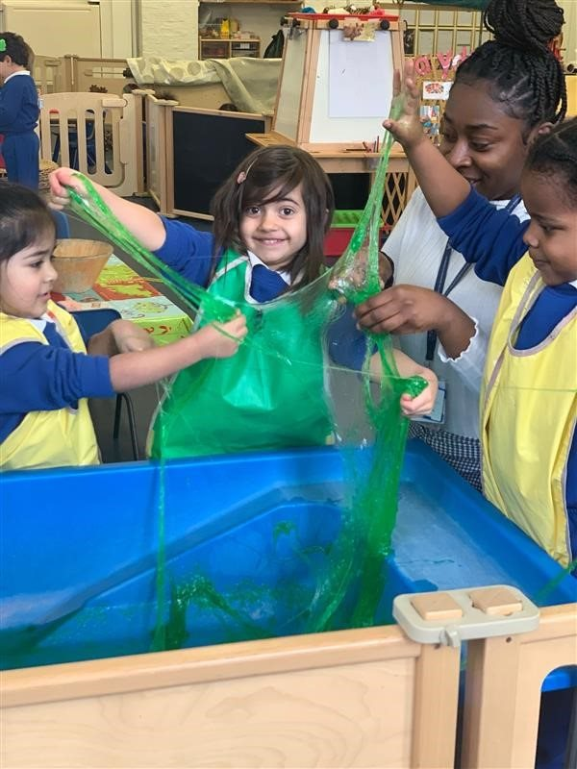 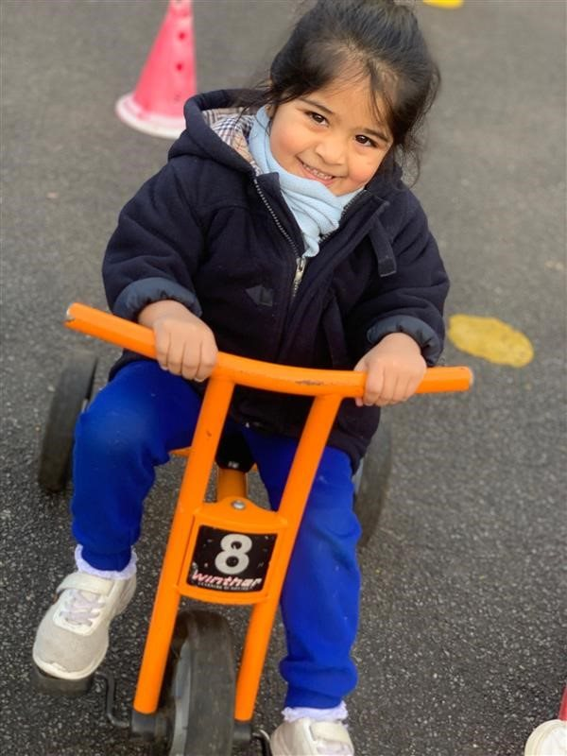

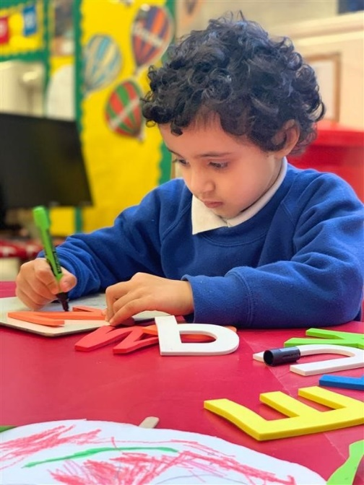****

Lead Teacher of Nursery ager

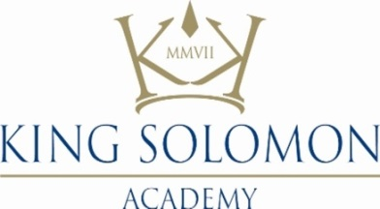



**February 2021**

Dear candidate,

Thank you for taking the time to find out more about King Solomon Academy and the possibility of joining us. Included in this information pack is information about the academy and the role of Lead Teacher of Nursery.

We seek **an experienced EYFS teacher and leader** in the Nursery setting, bringing expertise and experience working with young children to provide excellent support and teaching to our pupils. We want to invest in a member of staff for the **long term**, and support in their development and impact as they lead our nursery provision, working closely with our experienced Assistant Principal / Head of EYFS.

KSA is rare in that it is a genuine all-through school – our pupils can go from 2 years to university in our school. We have a brand new nursery building for over 100 pupils for 2-4 year olds on track to open in April 2021, to expand our existing nursery provision from 65 up to 90 pupils.

In this role you will be the key person leading the curriculum and the quality of teaching and learning in Nursery with a team of experienced and dedicated support staff.

We have a great team in Early Years and are looking for a Lead Teacher who is passionate about helping children love learning and playing in a warm and inclusive environment. We are proud of our woodland garden and are building a Forest School provision with a qualified teacher appointed and trained to lead this provision full time.

We hire on values. This means that our teams are made up of like-minded people who share real passion for our mission. We are an inclusive team and we are actively seeking to enhance the diversity of our team. We welcome team members from all backgrounds. We look after our staff with enhanced benefits and ongoing professional and personal development. We’re a school nursery setting which is serving our local community with ambition and passion.

We are looking for a qualified and experienced Lead Teacher of Nursery with strong leadership skills to join our growing team.

Whilst we always take great care in finding the right people for every role in our school, it feels even more important than usual to find the right person for this new role, working so closely with children and their families as they first begin their journey through our school. We would be delighted to hear from applicants who are already leading in an EYFS setting in some capacity and looking for a new challenge. We are also interested in meeting ambitious applicants who have proven themselves as excellent EYFS practitioners and are now looking for a next step in leadership. We know we can commit the time, energy and resources into developing the right person into an excellent Early Years leader. We have a deep commitment to development at our school and within the wider network with protected time each week for team training, co-planning, real-time coaching and one to one feedback and development.

Our pupils will now join at 2 or 3 years old and stay with us until they are 18. By joining King Solomon Academy in this role, you would play a part in showing what is possible when children’s education is seen as a long term commitment. Professionally, it also provides teachers and leaders with a unique opportunity to have impact across all phases of education: we are committed to investing in EYFS to ensure all our pupils get the very best start on this journey.

We are growing a team of exceptionally committed teachers and leaders who value each and every year of a child’s education equally. If you too are motivated to redress educational disadvantage in the UK, King Solomon Academy is beginning to show what is possible and you could be part of defining the future of education in our country.

To apply, and to see more information about the school and this role please visit: <http://kingsolomonacademy.org/current-vacancies>.

The deadline is **11am** on **Monday 1 March 2021**.

To discuss the role, please feel free to email the Principal’s PA, Shaheen Riaz ([s.riaz@kingsolomonacademy.org](mailto:s.riaz@kingsolomonacademy.org)) or phone on 0207 563 6901.

We wish you the best with your application.

Yours sincerely,



**Max Haimendorf**Principal

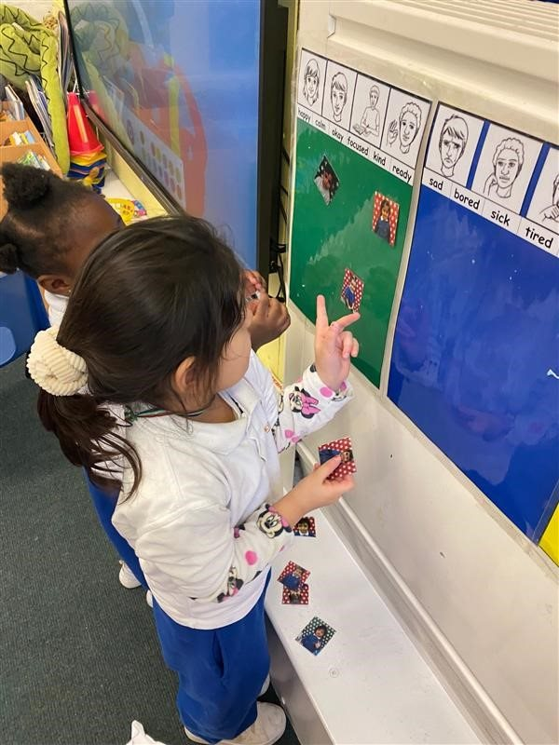

**Job Description: Lead Teacher of Nursery**

**Reports to**: Assistant Principal, Head of EYFS

**Start date:** September 2021 (or earlier by agreement)

**Salary:** Competitive:Ark Main Scale Inner London or Upper Pay Scale and an additional Teaching and Learning Responsibility payment (scale of TLR dependent on experience)

**The Role**

To develop a Nursery provision that is safe, joyful and has at its heart the highest possible expectations of each and every child, working closely to develop a team of teachers and practitioners to develop excellent practice across the setting.

The role will include class teaching as well as coaching and development of other members of the Nursery team.

**Key Responsibilities**

* From appointment, play an active role in the planning of new indoor and outdoor environments in Nursery including the design and layout of the environment to create a rich, stimulating and enabling provision;
* Plan, evaluate and refine the curriculum;
* Role model excellent teaching in EYFS;
* Line manage and coach
* Create, maintain and foster excellent relationships with parents which define the long term and all-through relationships we will have with our families;
* Work alongside Senior Leadership Team to create a strong staff team who are passionate about Early Years and dedicated to ensuring every child makes rapid and sustained progress.

**Outcomes and Activities**

**Management of Nursery**

* Lead by example, have high expectations of yourself, embracing and personally demonstrating the school’s ethos, vision and values, and expecting the same of all staff and pupils.
* Demonstrate and ensure in the team that there is detailed and thorough knowledge of the Early Years Curriculum, including detailed knowledge of Early Years Assessment and child development;
* Plan and deliver assemblies, trips, events and parent workshops;
* Perform leadership duties including monitoring and evaluation, strategic planning, timetabling and duties;

**Teaching and Learning**

* Meticulously plan and teach engaging and challenging learning for all pupils that pave the way for success in school and life;
* Meet the needs of all learners by adapting teaching ‘in the moment’ and using this assessment to inform future planning
* Role model good communication through an excellent command of English.
* Set and maintain expectations of classroom organization and displays;
* Meet deadlines;
* Closely monitor progress and attainment of pupils and use it to inform their teaching;
* Provide content for, and where necessary deliver, high quality pupil interventions with direction from SENDCO;
* Organize and participate in exciting and motivating trips and events.

**Character and culture**

* Through observation and feedback, mentor year group practitioners to ensure excellent positive culture in all lessons;
* Analyse behaviour and attendance data to identify trends and act to address any issues;
* Be held to account on attendance levels in Nursery and hold the rest of the team to account to ensure attendance and punctuality are maximized;
* Set and maintain high standards of behaviour through a restorative approach and in line with our behaviour policy;
* Model precise and consistent use of systems and routines to all practitioners in their year group;
* Drive excellent culture and organisation to ensure the effective running of the school day, including communal times (e.g. eating lunch, use of toilets)

**Leadership of staff**

* Line manage staff in the Nursery team, including day to day tasks and processes;
* Provide feedback to Nursery practitioners that is supportive and leads to their rapid and sustained development;
* Act as a role model in terms of professionalism and positivity in the staff body

**Relationship management with parents**

* Recruit and induct pupils by providing a warm and welcoming, personalised experience of starting in the nursery
* Maintain regular and productive communication with parents about their child’s progress, behaviour and development, including attending after school parent meetings as required;
* Be held to account on attendance of parents to meetings/workshops;
* Be a figurehead of communication and trust with parents;
* Pro-actively share positive news about the pupil and the school with parents;
* Seek out and act on feedback from parents;
* Ensure parents are happy about and aware of how their child is doing in school

**Other**

* Perform additional duties and tasks required for the effective operation of the school, including: attending home visits, eating lunch with pupils, break supervision and other duties
* Undertake other various responsibilities as directed by the Principal or the line manager

**Person Specification:**

**Lead Teacher of Nursery**

**Qualification criteria**

* Right to work in the UK
* Qualified Teacher Status

**Experience**

* Experience of working and leading in a high-quality EYFS / nursery setting, ideally including 2 year old provision
* A genuine passion for education and making a difference to the lives of children
* Experience of leading and coaching other staff to success

**Skills and attributes**

We are looking for these skills and attributes or at the very least, a clear, demonstrable capacity to develop them organised around our four school values:

**“Aiming high”**

* Prepares for success with excellent organisational skills
* Works hard to achieve goals
* Never gives up on ourselves, our teammates or our mission
* Willingness to play a full part in school life and go above and beyond to ensure success
* High energy and driven by a ‘whatever it takes’ attitude.

**“Working together”**

* Works effectively as part of a team
* Seeks out opportunities to build on own and others’ strengths and helps others to be better through a culture of clear, kind feedback
* Makes a strong contribution to assessments and child-led planning

**“Being kind”**

* Able to create a safe, happy and successful environment for everyone in our community
* Shows gratitude
* Takes care of others
* Exhibits pride in achievements of self and others

**“Leading the way”**

* Has a passion for working with children
* Is a positive role model to others
* Is brave
* Shows initiative
* Feels passionate about creating a better future.

**Other**

* This post is subject to an enhanced DBS disclosure.

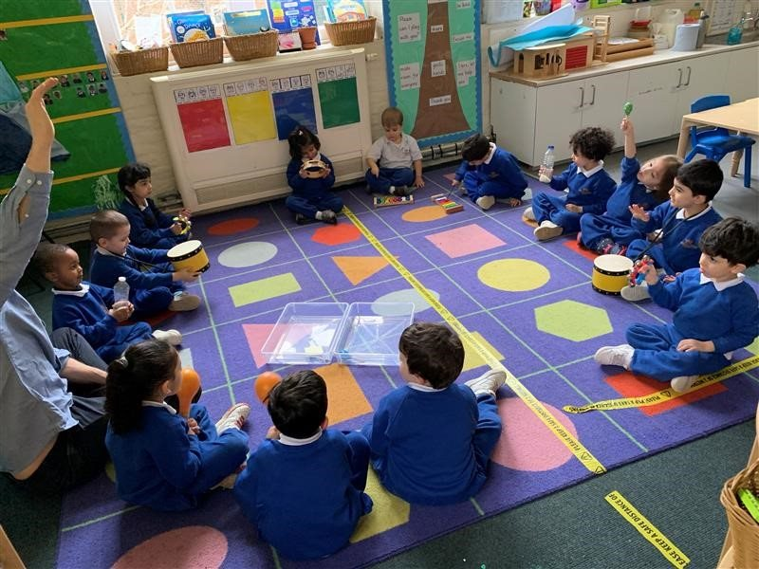

**Principal

Max Haimendorf graduated from Oxford and joined the first cohort of the Teach First programme, teaching Science in West London. Following work at Teach First central office he joined the consultants Oliver Wyman where he worked in finance strategy. Whilst there he wrote about the importance of small schools in Teach First’s first Policy Paper, Lessons from the Front. In 2008 he was appointed as Secondary Headteacher of King Solomon Academy, starting the Secondary part of the school in September 2009. He has now led KSA through two outstanding Ofsted inspections and to achieve the highest GCSE results in the country for a non-selective school in 2015. He became all-through Principal of KSA and Executive Principal of Ark Paddington Green Primary Academy in September 2016. He was awarded an OBE for services to education in the Queen’s Birthday Honours of 2020

Max is a father of a 2 and 5 year old and is passionate about surpassing the provision his own children have received, and building an exceptional nursery.

*“We are dedicated to doing whatever it takes to ensure each of our pupils has the chance to attend an academically rigorous university.”*



Head of KSA Primary and Leader of Curriculum (currently on Maternity Leave)

– Beth Humphreys

Ms Humphreys graduated from the University of Edinburgh with an MA in English Literature and French and then completed a second Masters’ degree in Educational Leadership at The Institute of Education. She joined KSA in 2012 and was formerly Deputy Head of Secondary, leading on curriculum and professional development. She is a passionate teacher of English and loves nothing better than seeing young people reading, writing and talking about brilliant texts.  Ms Humphreys took on the role of All-through Vice Principal in September 2016, Head of Primary in January 2017 and Associate Principal in January 2019.

Head of School

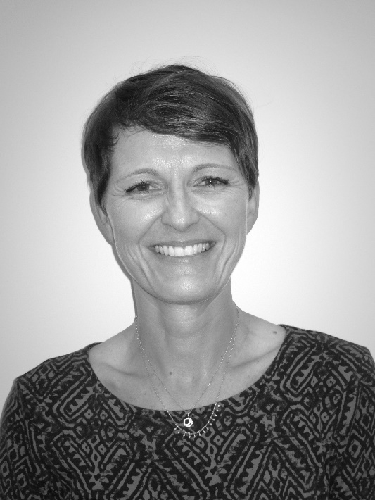Katarine Deeks has been a primary school teacher in disadvantaged inner London communities for twenty years. The thirteen years in senior leadership positions have been dedicated to moving underperforming schools out of Ofsted categories and creating learning environments and cultures that are safe and inclusive with increased aspirations. She joined Paddington Green in 2009 as a Deputy Headteacher; a member of the team securing a move to a good Ofsted inspection in 2012. Katarine was the Acting Headteacher from September 2014 and was appointed Head of School when the school became Ark Paddington Green in September 2016. She is proud to be a leader in a school with a strong collaborative team commitment and a consistently positive vision.

*“Transforming our school to realise the potential and drive the prospects of our children is at the heart of everything we do, every day.*

**About the nursery at KSA**

***King Solomon Academy is focused on providing a high quality a life transforming education to all our pupils – this starts with our new nursery.***

We believe that the foundations of our school are built in our Early Years and throughout Primary. As an all-through school we know that the successes here echo through a child’s whole education. If we can help pupils to be confident and engaged learners in these early years, we can set them up for success in their futures.

We want candidates to be excited about our nursery - detailed information is available on our website. <https://kingsolomonacademy.org/nursery/nursery-provision>

As a genuine all-through school, with our pupils staying with us from nursery all the way until they apply to university aged 18, we have a unique opportunity to have a long term and dramatic impact on our pupils’ lives. We therefore have to prioritise pupils’ personal, social and emotional development as well as their communication and language skills. As our children start with us, we are passionate about creating mastery of all aspects of reading (including phonics) writing and maths, as well as creating the classroom culture which fosters rapid and significant character growth. In this way we believe our classrooms have vital importance in our ability as a school to affect change in the lives of our pupils.

Our EYFS environment is characterised by the formation of extremely positive and influential relationships between the school, pupils and their parents. We aim to support the development of the whole child, including their upbringing at home. Our curriculum is rich and varied teachers are encouraged to dream big in their curriculum choices to inspire and engage pupils. In preparation for learning musical instruments in Year 3, we invest in specialist music learning throughout the school – sport, drama and other enrichment activities benefit from our all-through setting.

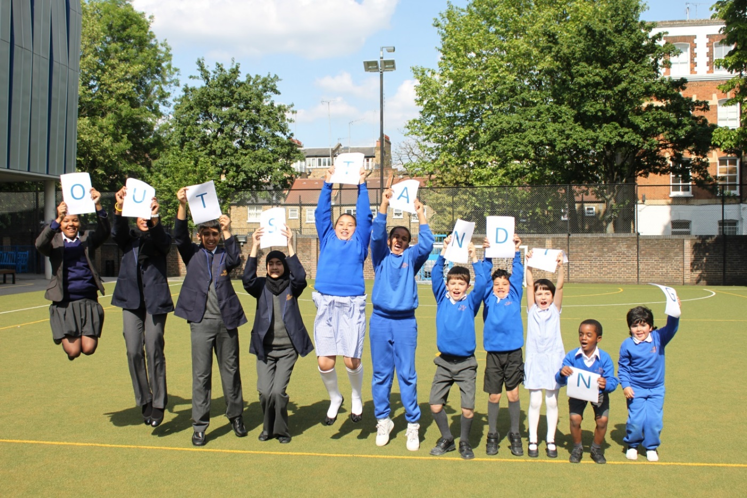

**Positive Action and inclusive recruitment at KSA**

We are keen to bring new perspectives and backgrounds into our school to build a diversity of thinking so that we can build the best school possible. Following and analysis of our teaching body, we are actively welcoming qualified candidates from Black and Ethnic Minorities, as they are currently under-represented amongst our teachers. This is particularly important given the diverse community we serve.

We want to make applying to and working at King Solomon Academy as inclusive as possible, and have a variety of systems in place to ensure that our approach is as fair and open as possible:

* Transparent application procedure, including a well signposted interview day, which tells candidates how they will be assessed and how they can prepare
* ‘Blind’ screening of applications, discounting identifying characteristics when shortlisting, in pairs
* Diversity and Inclusion training for senior leaders involved in recruitment
* Interview processes which include a range of leaders to avoid any individual bias
* Discussion with the Staff Working Group (staff consultative body) to ensure the recruitment process is inclusive.

**Being part of the Ark network**

Ark is an international charity, transforming lives through education. We exist to make sure that every child, regardless of background, has access to a great education and real choices in life.

We know that great schools need great teachers, which is why we offer you the very best training and support at every stage of your career - from starting out as a trainee to running your own school.

Our highly-successful network of 37 schools educates over 20,000 students across Birmingham, Hastings, London and Portsmouth. They are achieving some of the best results in the country despite being largely in areas of historic academic underachievement.

Ark schools prioritise six key principles: high expectations; excellent teaching; exemplary behaviour; depth before breadth; more time for learning; knowing every child.

Ark invests significantly in a number of professional development programmes which complement academy level training:

* The Ark training menu: we have developed a bespoke training menu, which is accessible by all staff in the network offering a wide range of training modules to staff in all roles
* Network support: schools share CPD, allowing us to share best practice and role specific training across the network, facilitated by in-school and central staff
* Ark staff receive 10 training days each year rather than five.

Ark is at the forefront of changing education society through education. We run Initial Teacher Training through School Direct and we co-founded the Future Leaders and Teaching Leaders development programmes and offers teachers and support staff a comprehensive range of school-based first class professional development opportunities.

**Ark Safe Recruitment Procedure**

Ark is committed to safeguarding and promoting the welfare of children and young people in its academies. In order to meet this responsibility, its academies follow a rigorous selection process to discourage and screen out unsuitable applicants.

**Disclosure**

This post is classified as having substantial access to children, and appointment is subject to an enhanced police check of previous criminal convictions (DBS). Applicants are required, before appointment, to disclose any conviction, caution or binding over including ‘spent convictions’ under the Rehabilitation of Offenders Act 1974 (Exemptions) Order 1975. Non-disclosure may lead to termination of employment. However, disclosure of a criminal background will not necessarily debar individuals from employment – this will depend upon the nature of the offence(s) and when they occurred.

**Reference checking**

References from the previous and current employer will be taken up for shortlisted candidates, and where necessary employers may be contacted to gather further information.

**Probation**

All new staff will be subject to a probation period of six months (which may, in certain circumstances, be extended by up to 10 weeks). The probation period is a trial period, to enable the assessment of an employee’s suitability for the job for which they have been employed. It provides the academy with the opportunity to monitor and review the performance of new staff in relation to various areas, but also in terms of their commitment to safe guarding and relationships with pupils.