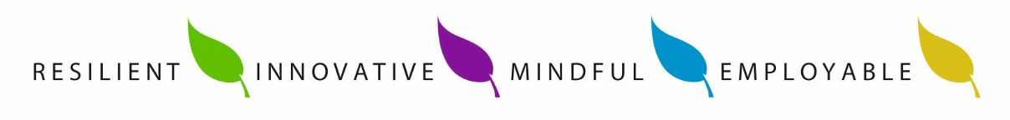

Kingsmead School

Geography Department

The Kingsmead Geography department at is a strong, committed and innovative department, which is forward thinking and dynamic. The department consists of two full-time specialists and sits within the Ebacc Faculty.

The Geography department delivers KS3, KS4 and KS5 courses, following AQA Specifications for both GCSE and A Level. KS3 is a three-year course, reflecting the need to build important skills and a strong foundation before specialising and KS4 and KS5 are both two-year linear courses. At KS4 mixed ability classes are taught. Outcomes in KS4 and 5 are strong and the average grade achieved for KS5 is B+.

The team works collaboratively to create exciting and innovative schemes of learning that meet the needs of our students. Research from the EEF informs our lesson planning so that our delivery is effective. Staff are encouraged to be imaginative and focussed on outstanding student outcomes when they work towards the curriculum aims of developing ‘earth readers’. Students at Kingsmead are taught the knowledge and skills to read the world in which they live and understand how physical and human processes work together to create the living environment.

The GCSE course followed is AQA, which covers both Physical and Human issues. We chose to follow the AQA A level course and so provide continuity in content and assessment styles. Both courses provide opportunities to undertake fieldwork. Indeed, as a department we seek to develop and offer opportunities for fieldwork across all Key Stages and are always looking for new ways to make Geography come alive.

Kingsmead staff are encouraged to be involved in the strategic direction of the school through understanding the school systems and plans. There are hundreds of opportunities for ambitious staff to grow and develop including extended leadership, shadowing and coaching. Staff in all roles are encouraged to get involved in any cross curricular projects and activities that they find of interest.

If you are determined to be the best teacher that you can be, mindful in your approach to others as well as yourself; If you are the type of teacher who never stops trying to find a way of helping children to understand, is innovative and resilient in your teaching; If your expectations for children to succeed is forever rising and you have a restless desire to work in an outstanding school that never says ‘enough is enough’; if you think that the most important job in a school is what happens in the classroom; If you would like to be part of a vibrant and valued subject team, then we would love to hear from you.