

Appointment of
Head of Boarding
January 2020

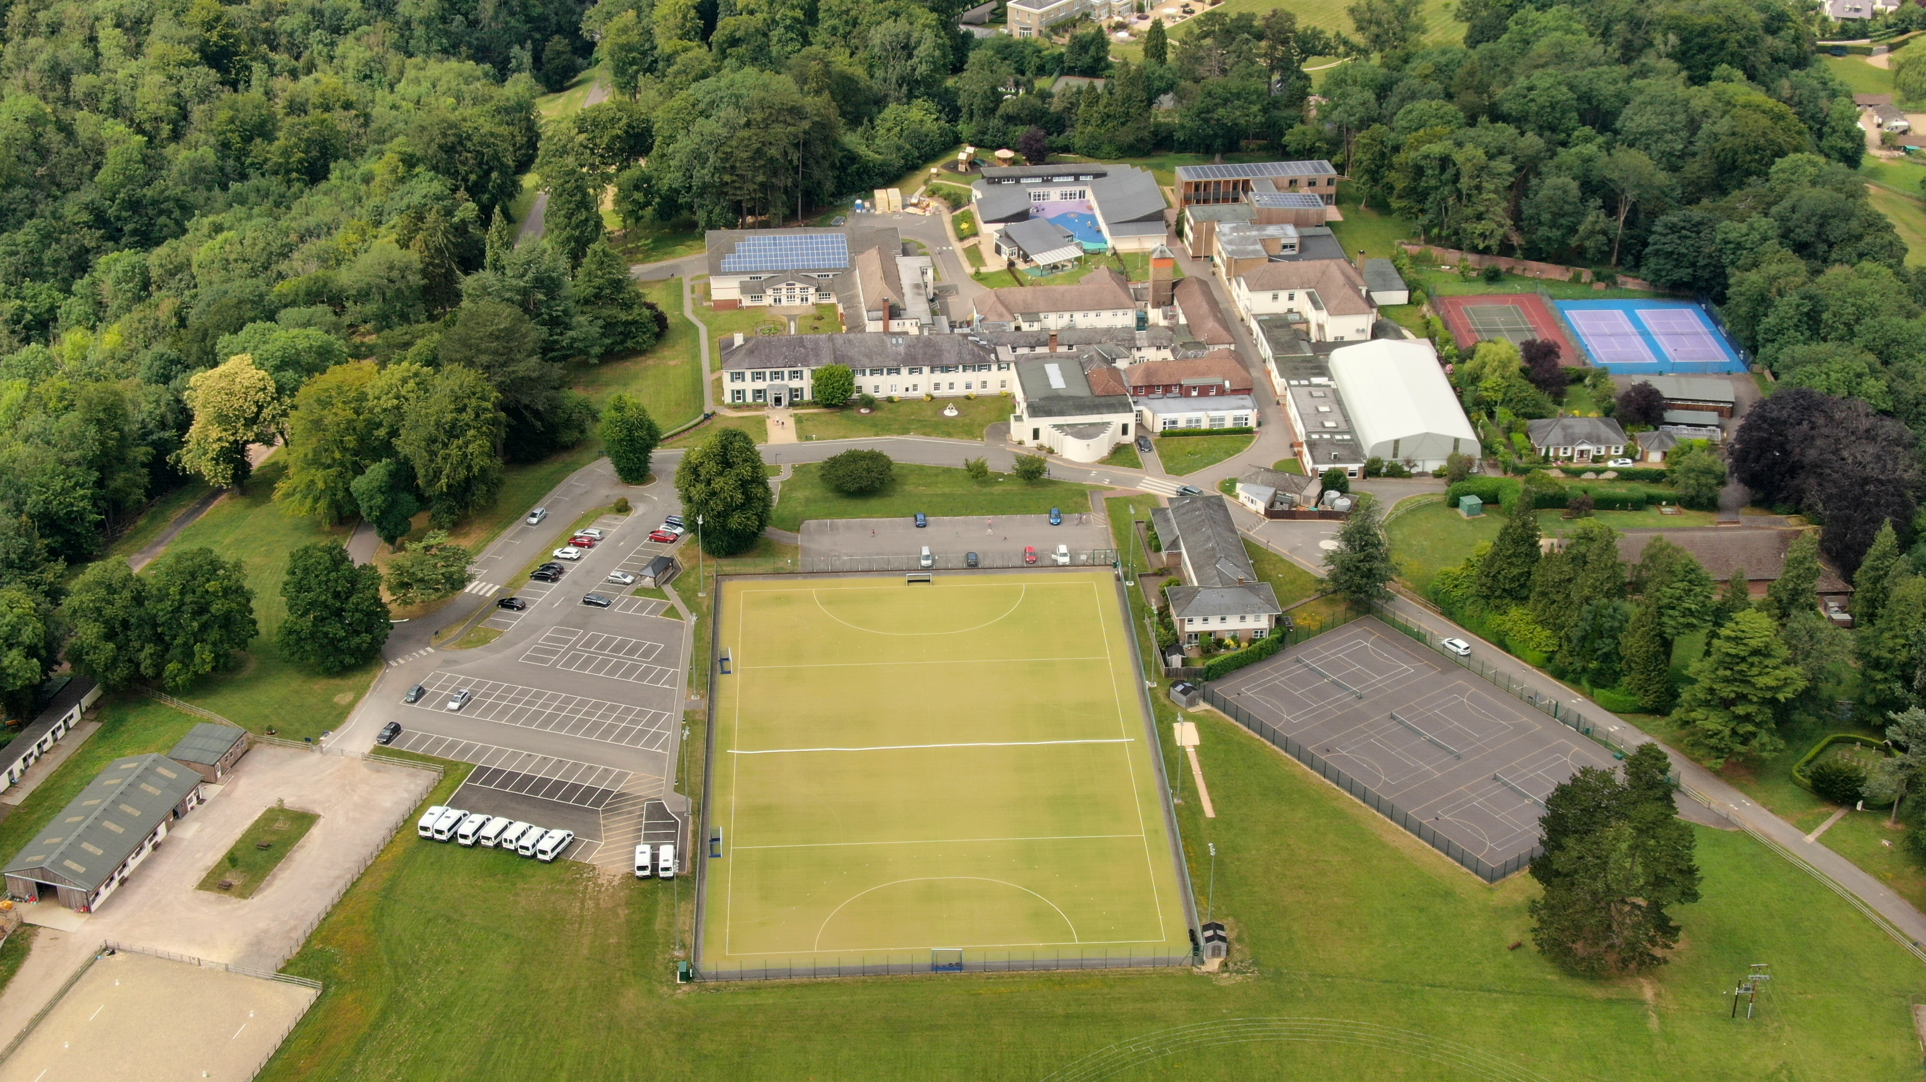

The Role
St Teresa’s Effingham (part of the Effingham Schools Trust) is looking to appoint a Head of Boarding.This is an exciting opportunity for someone to join a highly successful department, we are looking for an energetic and enthusiastic person to manage the day-to-day care of our boarders and to contribute to life in a busy boarding community of girls aged 10 - 18.

The School

The Effingham Schools Trust is a newly created partnership of neighbouring schools St Teresa’s and Cranmore. The partnership forms a diamond model school, a powerful and exciting educational proposition, delivering all the advantages of both single sex and co-education to girls and boys. A diamond school is, quite simply, the best of both worlds, leading to an outstanding experience. It is an approach that not only elicits excellence from pupils, but also from teaching staff who are able to tailor their professional techniques to age, stage and gender.

The Effingham Schools Trust has a school population of over 1,000 including over 80 boarders, and a healthy Sixth Form. The schools have their own Preparatory School and Pre-prep. The schools sit in 80 acres of beautiful countryside and benefit from excellent facilities. In recent years the schools have carried out a significant development programme and further exciting projects are in the pipeline.

The Effingham Trust offers a strong, caring community based on its Catholic traditions, but remains an inclusive environment that welcomes pupils and staff from all backgrounds. With recognised strengths spanning academia, sport and the creative and performing arts, we focus on the individual, allowing the students to achieve their best and enabling them to follow their own unique path to happiness and success.

Location

St Teresa’s stands in grounds of 55 acres in an area of outstanding natural beauty between Dorking and Effingham in Surrey. Cranmore School stands in the grounds of 25 acres in the village of West Horsley, between Guildford and Leatherhead in Surrey. There is easy access to London by road or rail; both Gatwick and Heathrow are within 45 minutes’ drive.

Facilities

St Teresa’s is centred around the original 19th Century Manor House and has evolved over the years and now proudly boasts some outstanding facilities.

A number of new facilities have been provided to meet the needs of a modern education. These include a brand new Sixth Form Centre, Equestrian Centre, Tennis Academy, and a Performing Arts Centre comprising a large theatre, drama studios, music classrooms, practice rooms and recording suite, impressive playing fields at both sites.

Main Duties and Responsibilities:

- The Head of Boarding is responsible to the Headmistress for the welfare and care of the Boarders and Boarding Staff, and the smooth running of the Boarding Houses.

- To work with the Headmistress to effectively lead and develop a team of Boarding Staff and create of a happy, homely Boarding House.

- To set a good example to the students at all times, including in matters such as dress code and moral conduct.

- To develop a vision for Boarding that promotes and supports a culture where the school’s values of Faith, Character, Intellect, Compassion and Community are evident, and promote this vision through the creation and implementation of the annual Boarding Development Plan.

- To be resident overnight in accommodation provided during term-time, other than evenings off, in order to ensure security of the students and to assist with emergencies/evacuations that happen at night.

The Appointment

The remuneration paid to the person appointed will be commensurate with the importance of the post and with the experience and qualities of that person. As part of St. Teresa’s commitment to safeguarding and promoting the welfare of children, any offer of employment to this post will be subject to receipt of a satisfactory Disclosure and Barring Service check, along with qualifications, satisfactory references and a satisfactory response to a Health Questionnaire.

Please complete the Application Form in full accompanied with your letter of application and CV.
The letter should indicate your suitability for the post and your motivation for submitting the application. Further information including examination results and the Independent Schools’ Inspection Report can be found on the School’s website www.st-teresas.com

Please note: Closing date for applications is Monday 14 October 2019.

Applications should be sent to:
Mrs Natacha Menzies
n.menzies@st-teresas.com
PA to the Headmistress
St Teresa’s
Effingham
Surrey RH5 6ST

St Teresa’s reserve the right to interview at any stage of the selection process.

