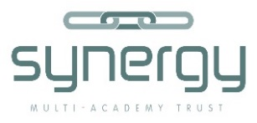

Synergy Multi Academy Trust

Synergy Trust is made up of a group of local schools that work collaboratively to raise standards and to provide the best of opportunities for all pupils in our part of north Norfolk. Partner schools serve children between the ages of 4 and 18.

Synergy believes that all partner schools will have strengths and areas to develop and that all can all improve through learning together and sharing expertise and wisdom. The trust understands that there will be excellent practice in each partner school and that every partner school will be able to contribute to the development of the trust and learn from its partners.

The principles of Synergy Multi-Academy Trust

1. Excellence: education must be of the very highest standard.
2. Comprehensive: education must be for all types and abilities of pupils.
3. Partnership: member schools work together for their mutual benefit.

The aims of Synergy Multi-Academy Trust

1. To ensure every pupil achieves to his or her full academic potential.
2. To ensure every pupil develops the skills and attributes that will help them succeed in the world of work.
3. To ensure every pupil develops into a good citizen and a kind person.

Synergy Multi-Academy trust was established by Reepham High School and College. The current partners within the trust and their dates of joining are:

Reepham High School and College (October 2015)
Reepham Primary School (August 2016)
Bawdeswell Primary School (February 2017)
Mattishall Primary School (April 2017)
Foulsham Primary School (May 2017)
Astley Primary School (July 2017)
Corpusty Primary School (January 2018)

