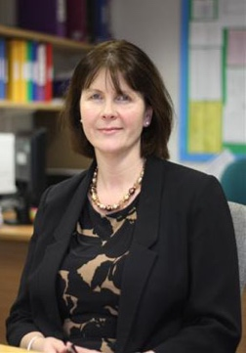



**DONCASTER UTC**

**THE APPOINTMENT OF A PART TIME TEACHER OF MATHEMATICS FOR BRIGHTER FUTURES LEARNING PARTNERSHIP TRUST FROM JANUARY 2023**

**1. General Information about** **Doncaster UTC**

Doncaster UTC opened in September 2020 as part of the Brighter Futures Learning

Partnership trust and specialises in Engineering and Creative and Digital Technologies (with a third specialism, Medical Science, being offered from September 2021), providing a high-quality curriculum in collaboration with industry partners to the first intake of Years 9 and 12 students. The school will work closely with a number of external bodies such as the University of Sheffield, Polypipe and VolkerRail. This is intended to ensure that students are able to maximise their employability and be successful in the modern workplace. Doncaster UTC will offer both academic and National pathways in STEAM subjects, but students will also be able to access subjects such as Geography and Business Studies.

**2.**  **The Department**

The maths team will deliver Edexcel GCSE Maths, Edexcel Level 3 Core Maths and Edexcel A Level Maths, with A Level Further Maths to be delivered in future. In addition, the team supports with the delivery of the maths element within our engineering courses. We have an experienced strong team in place who is supported by the Director of Maths for the BFLP Trust. The department has ongoing subject specific CPD led by Specialist Leaders of Education for Mathematics.

**3.** **The Appointment**

This appointment offers an opportunity to join a successful and ambitious team. We are looking for a highly motivated teacher who is committed to working as part of a team to build on and develop the maths department. We are looking for an inspirational teacher who will be an excellent role model for our students.

**DONCASTER UTC IS COMMITTED TO SAFEGUARDING AND PROMOTING THE WELFARE OF CHILDREN AND YOUNG PEOPLE AND EXPECTS ALL STAFF AND VOLUNTEERS TO SHARE THIS COMMITMENT. THIS POST IS SUBJECT TO AN ENHANCED DBS CHECK.**

**COMPLETED FORMS AND LETTERS OF APPLICATION SHOULD BE RETURNED TO THE PRINCIPAL VIA vaccancies@doncasterutc.co.uk.**