

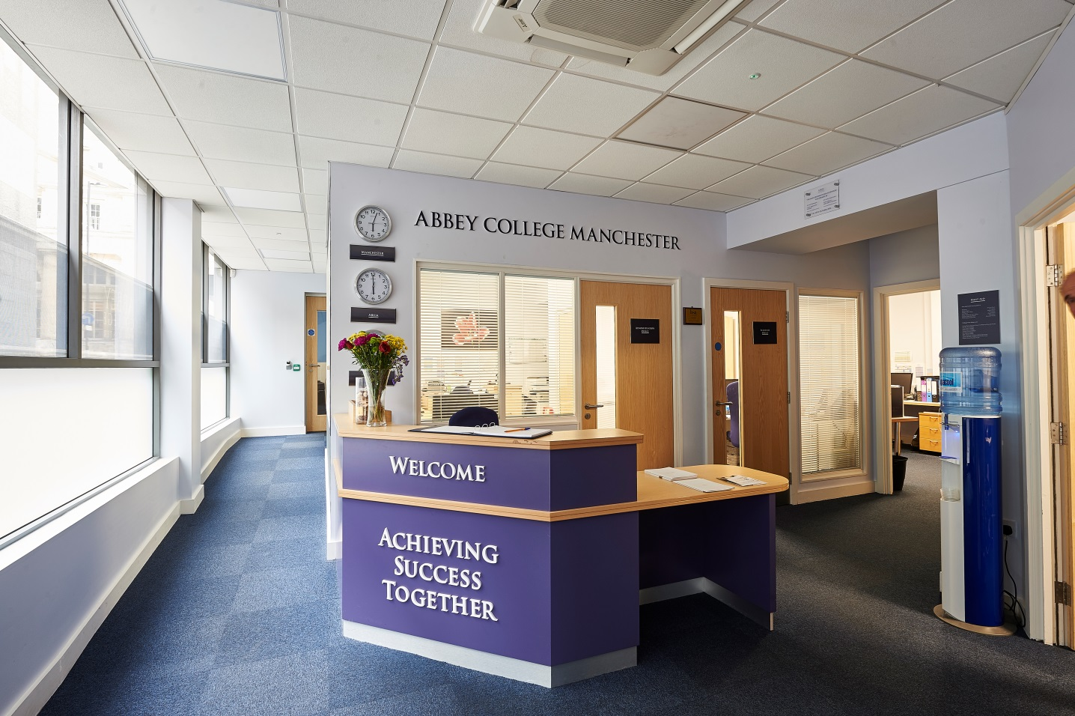

Information Pack:

Clydesdale House Kitchen Assistant

September 2023

About Abbey College Manchester

Abbey College Manchester was founded in 1990 and over the past thirty plus years has become one of the leading providers of independent sixth form education in Greater Manchester. There are approximately 200 students in the college. Within this, there are approximately 70 students from the UK with the remainder coming from 40 different countries.

We aim to:

- guide our students to achieve academic success and fulfil their aspirations
- respect and value each student providing a friendly, safe, supportive environment, where students are happy and grow in confidence
- show a sensitive understanding of the challenges facing young people in the 21st Century by empowering students to make informed decisions and have the determination to achieve their goals
- prepare our students for university, their future careers and to make a positive contribution to the community.

We are a dynamic, exciting college, situated in the heart of Manchester providing high quality, flexible A Level, International Foundation, Combined Studies, and GCSE programmes. Our modern building provides an environment conducive to study and in our small classes each student can develop their individual aptitudes aided by a strong system of tutorial guidance.

Teaching and learning is rigorous whilst being creative and responsive to individual need. Our enrichment activities include sport, voluntary work, charity events and many other opportunities led by the students and staff. We encourage students to raise their own expectations and standards to the highest possible level. Staff, students and families get to know each other well and enjoy working together.

At Abbey College Manchester we offer a unique alternative to the traditional school whilst maintaining a strong academic ethos. Everyone contributes, everyone is appreciated; our committed teachers love their subjects and seek to inspire their students, in their turn, to love learning and value the acquisition of knowledge.

Boarding Accommodation

Abbey College Manchester has approximately 100 students living in our boarding accommodation. About 30 students reside with our homestay families and 70 live in our Senior Boarding House (Clydesdale House) which we moved into in September 2021. Clydesdale House is a 5-10 minute walk from the main college building. Only students aged 16+ reside in this boarding house. The post holder would be taking responsibility for the students at Clydesdale House as described in the job description in conjunction with the Assistant Principal Pastoral and Boarding, Heads of House, Day Manager and Residential House Parents. The students live in clusters over four floors at Clydesdale House which are accessed only by Abbey College Manchester students and boarding staff.

Description of the post

The role of the Kitchen Assistant is to provide support to the Clydesdale House cook on 4 days and cook the evening meal on Saturdays. The duty is five days per week from 4-7pm during the week and 3-8pm on Saturdays. The normal days of working will Tuesday to Saturday

Responsibilities:

- Support the cook in her developing and establishing new menus and ensure these are displayed for students
- Ensure correct ingredients ordered/purchased in accordance with the menu from trusted outlets.
- Highlight any potential allergens/intolerances within the food to students via information board
- Check food condition and best before dates daily and ensure any “bad” food is disposed of correctly
- Ensure stock rotation so oldest food used first and menu to incorporate this
- Check fridge temperature as per guidelines
- Check freezer temperature as per guidelines
- Ensure kitchen area clean prior to commencing food preparation (daily)
- Support the cook with the preparation of food for the menu
- Ensure work surfaces and equipment is cleaned throughout preparation and serving
- Ensure food core temperature is checked and maintained to guidelines throughout serving period
- Ensure kitchen area/oven cleaned after food service
- Prepare and cook the evening meal on Saturdays on a weekly basis according to the published menu

Note: This job description is indicative of the duties and responsibilities of the post but does not form part of any contract of employment. All jobs within the college evolve over time and their features vary from year to year.

Person specification

1. Personal skills and qualities

- High levels of personal and professional integrity
- Personal warmth, good rapport with students and colleagues
- Ability to cook nutritious food and provide an interesting and appropriate menu
- Honesty and integrity
- Approachability and flexibility are key to this role
- Be suitable to work with young people (DBS clearance)

2. Knowledge and experience

- Hygiene certificate level 2 or higher
- Experience of cooking in this type of environment i.e. a school canteen or equivalent

Philosophy and Ethos
- High expectations for student attainment, personal development and conduct

Reporting to:

Cook/Senior Houseparent

The selection process

Job title: Clydesdale House Cook

Activity | Date
Deadline for receipt of applications | 20th October 2023
Shortlisting of candidates | 20th October 2023
Interview dates | w/c 30th October
Start date | ASAP by mutual agreement

Applications will only be accepted from candidates completing the Abbey College Manchester Application Form and Equal Opportunities Monitoring Form.

We reserve the right to close this advertisement early and appoint at any point in this process or not appoint

Safeguarding Statement
Candidates should be aware that all posts in the college involve responsibility for safeguarding children. The Abbey College Manchester Safeguarding Statement is as follows: “We recognise our moral and statutory responsibility to safeguard and promote the welfare of all students. We endeavour to provide a safe and welcoming environment where children and young people are respected and valued. We are alert to the signs of abuse and neglect and follow our procedures to ensure that children and young people receive effective support, protection and justice”.

Rehabilitation of Offenders Act, 1974
This post is exempt from the Rehabilitation of Offenders Act 1974 and therefore all convictions, cautions and bind-overs, including those regarded as ‘spent’ must be declared. Please provide full details in a sealed envelope marked ‘Confidential’. The letter will be opened after shortlisting, prior to interview.

References
These will be taken up after interview. As part of this your referees will be asked about your suitability to work with children and whether they know of any disciplinary offences relating to children or young persons (whether the disciplinary sanction is current or time expired) and whether you have been the subject of any child protection allegations or concerns and if so the outcome of any enquiry or disciplinary procedure.

Interview
If you are invited to attend an interview this will be conducted in person and will include questioning on your suitability to work with children. All candidates must bring original documents confirming any educational and professional qualifications that are necessary or relevant for the post (e.g. the original or certified copy of certificates, diplomas, etc.). All candidates invited to interview must also bring their passport or photo ID and proof of the right to work in the UK (if applicable).

Terms and conditions

Remuneration
- The hourly rate is £11.50

Hours of work
- The post is 17 hours per week; evenings 4-7pm Tuesday to Saturday. Additional hours maybe required if cover is needed.

Holidays
- The college summer holidays (July/August) and Christmas holidays (three weeks)

Pension provision
Abbey College Manchester is part of the Abbey DLD Colleges Ltd and automatically enrol all new employees (unless requested not to by the employee) onto the company pension scheme. Notification of the pension plan (and all further details including opt out / opt in rights) will be provided.

Offer of appointment
Any offer of appointment is conditional on receipt of satisfactory references, an enhanced DBS clearance, the interrogation of qualifications and proof of the right to work in the UK.

We are committed to safeguarding and promoting the welfare of children and young people.

We expect all staff to share this commitment and to undergo appropriate checks, including enhanced DBS checks.

