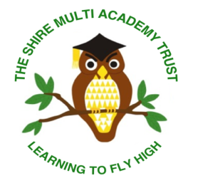
Prospective Candidates Information
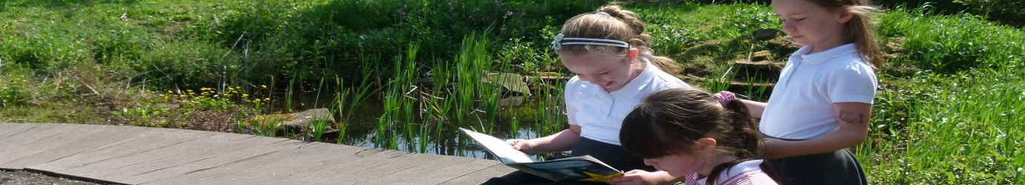
Thank you for showing an interest in our advertised position.
The following information aims to give you a brief insight into the ethos and vision of the Trust and how we work together collaboratively across our schools. We welcome visits to our school for any prospective candidates. We look forward to your application if you feel you would like to join our team and make our vision a reality.
Sandhill Primary School- School Specific Information
Early Years Leader Position
Sandhill Primary School is a 10 class school including nursery in the village of Great Houghton in the town of Barnsley.
The Early Years Foundation Stage offers 52 places for FS1 aged children and 40 places for FS2. Our FS1 sessions are 3 hour in duration and run in the mornings and in the afternoons in line with the school day. We are a popular choice for nursery education in the village and we are full. Our FS2 children attend school in line with the school day from 8.45 till 15.10. Due to the number of FS2 children we can accept some of our FS2 pupils are placed in a mixed Year1/FS2 class. The FS1, FS2 and Year1/FS2 classrooms all have access to the early year’s outdoor area which enables learning together.
Our children are enthusiastic, curious and enjoy coming to school. At first they need help to learn to play together and improve their independence. Once this is sorted they are ready for learning the more specific skill of Literacy and Number. We place an emphasis on daily teaching of phonics and maths and our curriculum is based around the experiences and interest of the children and a text driver approach. They all like a good Story!
Our EYFS team vary in their experience; however they are all motivated to ensure that the children achieve well, are safe and enjoy being at school.
and
About the Trust
At the Shire Multi Academy Trust our ethos is simple. We put children first; we provide them with opportunities and experiences via which they can excel creating a Trust-wide learning culture where children thrive.
There are currently 2 schools within the trust. Sandhill Primary and Laithes Primary, both situated in Barnsley, South Yorkshire. The Trust has established shared policy and procedures across the schools. Joint initiatives on school improvement are common place and teachers meet regularly to work together and learn from each other. Trust INSET days are planned annually and the investment in CPD is high. The leadership structure is similar at both schools meaning that our phase, subject and senior leaders support each other with development in our schools. Each school has its own SLT and the Trust has an Executive Leadership Group. The Executive Headteacher, Finance Director, Director of Strategic Improvement, Director of School Improvement and the Heads of School work together at a strategic level to support the development and underpin the collaborative intentions of the trust.
Our Vision
We believe in Leaders Leading. We believe in Teachers Teaching. We believe in Children Learning.
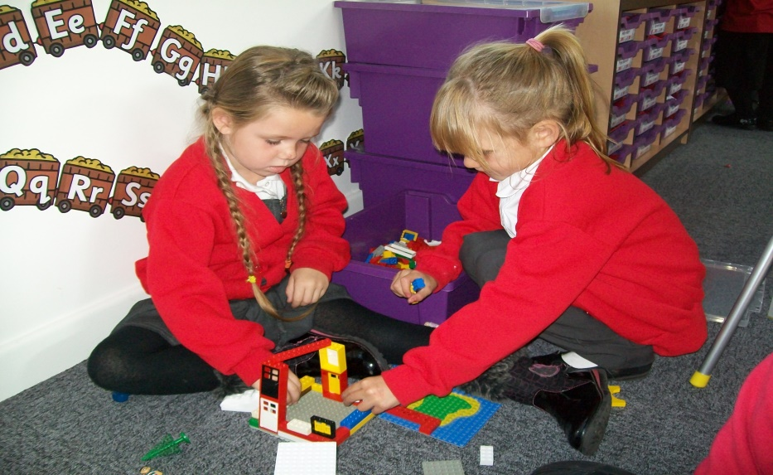
Our Trust aims for all its schools to collaborate sharing expertise and skills. We listen to, value and strategically utilise the experience and practice of all. We embrace each other’s strengths and openly support each other’s developments. Learning together makes us stronger.
Our Trust aims for inclusivity. We know that success in modern Britain depends upon respecting, understanding and celebrating difference. We welcome all. We endeavour to improve the lives and life chances for our children and their families. As a Trust we nurture, celebrate achievement and recognise success in order that all our children become confident citizens of the future.
As a Trust we innovate. In the fast paced world of education in the 21st century we welcome challenge and provide an environment that encourages staff reflection and debate about the way they teach. We want our schools to create a climate in which teachers are motivated and trusted to take risks, to be inventive, to ‘think out of the box’ in ways that suit the uniqueness of our schools.
Our Trust has a culture amongst all stakeholders that makes it unequivocally clear there are no excuses for children not achieving high standards in their learning and behaviour. Rigorous quality assurance is ensured through strong governance and a framework of accountability and responsibility by all.
‘Learning to fly high’ is our motto. Our children engage with exciting learning journeys that provide a wealth of experiences fostering future aspirations. From jumping in puddles to playing a tuned instrument we aspire to be the best that we can be.
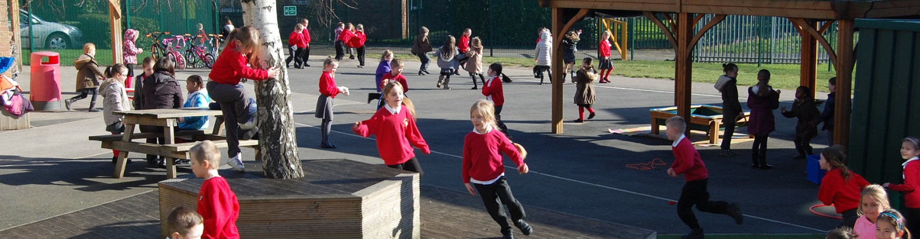
We hope this has given you a flavour of what we are about at the Shire Multi Academy Trust and look forward to hearing from you in the future. If you require any further information please do not hesitate to contact us using the contact details on the Job Advertisement.

