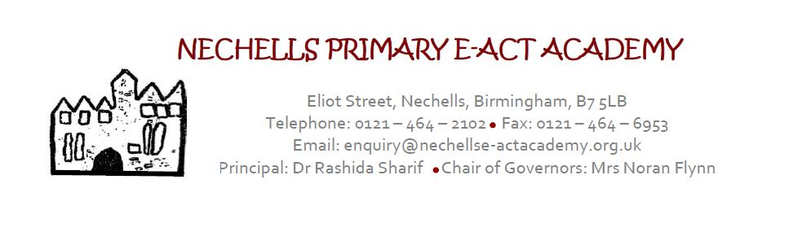
JOB DESCRIPTION
PPA /Music Creative Art Teacher Full Time

Person to whom Class teacher is responsible: Principal

Class teacher line manages: Teaching Assistants.

Terms and Conditions

The appointment is subject to the current conditions of service for Teachers other than Principal’s contained in the current Academy Teachers' Pay and Conditions document and other education and employment legislation.

The duties outlined in this job description are in addition to those covered by the latest Teachers’ Pay and Conditions Document. This job description may be amended at any time, following consultation with the Principal to reflect or anticipate changes in the job, commensurate with the salary and job title and will be reviewed annually. Priorities for the year will be negotiated and highlighted. To lead whole school PPA/Management cover to plan and deliver
Nechells Primary E-ACT Academy expects all teachers to:

- Be committed to and actively support, develop and enhance the academy’s aims and ethos.
- Contribute to a culture of teamwork, collaboration, collegiality and shared responsibility for excellent behaviour, high standards and performance.
- Have a commitment to the development of themselves and others.
- Develop a whole academy approach to planning, delivery and monitoring of the curriculum.

Standards and Quality Assurance
- Support the aims and ethos of the academy.
- Set a good example in terms of dress, punctuality and attendance.
- Attend and participate in open evenings and student performances.
- Uphold the academy's behaviour code and uniform regulations.
- Participate in staff training.
- Attend staff meetings.
- Develop links with governors, the E-ACT Academy Trust and neighbouring schools

CORE PURPOSE OF JOB

- To carry out the duties of a schoolteacher as set out in the School Teachers Pay and Conditions Document.

- To meet the required standards for Qualified Teacher Status

- To lead, manage, support, evaluate and monitor the work of Teaching Assistants

- To support all staff in ensuring the safeguarding of all pupils

- To assist in the development of planning and assessment.

- To assist the Principal in establishing and developing the academy as a high achieving
academy through providing the highest standard of teaching and learning for all
pupils of all abilities and educational need.

- To work with the Principal and the Senior Leadership Team (SLT) to devise and
implement strategies to identify and remove barriers to learning to enable all
pupils to have full access to the curriculum.

KNOWLEDGE AND UNDERSTANDING

- To develop and implement the academy’s inclusion policy, communicating its philosophy and practice to all staff, parents/guardians and the wider academy community.

- To develop knowledge of and keep up-to-date with PSHE and Citizenship, the National Curriculum, and the Agreed Syllabus for Religious Education.

- To understand how children’s learning is affected by their physical, intellectual, emotional and social development and to support them to overcome any barriers to learning.

- To make good use of ICT skills for classroom and management support.

- To become familiar with the academy’s current systems and structures as outlined in policy documents including the Teaching and Learning, Monitoring and Feedback, Behaviour, Health, Safety and Welfare, Child Protection and Safeguarding Policies.

- To understand and know how academy data compares to national and local averages and use data and information on individuals and groups to set clear targets for children’s achievement.

- Be up to date with relevant research, national inspection evidence and legislation, including the SEN Code of Practice and equal opportunities legislation and how these apply to the pupils in the academy.

STRATEGIC DIRECTION AND DEVELOPMENT OF THE ACADEMY

To support the various events in the academy year ensuring the fostering and building of good
relationships amongst the staff of the academy and the promotion of effective and excellent
home – academy partnerships and the wider academy community.

To foster and develop a partnership with parents/carers to encourage their involvement in the
life of the whole academy.

To ensure the effective management of resources.

TEACHING AND LEARNING

- Ensure there is a positive, consistent learning environment, including in the classroom and shared areas.

- Ensure that improvements in English and Mathematics are priority targets for all
pupils taught, including those with special educational needs, Minority Ethnic, EAL
and Vulnerable and Looked After pupils.

- Monitor and evaluate the standards of learning and achievement of all children in the class, in order to set and meet challenging, realistic targets for improvement.

- To take an active role in influencing, developing, monitoring and updating policy and practice in class teaching to raise achievement for all pupils.

- To assist in ensuring equal access to the curriculum in the class.

- To support the work of colleagues in planning, classroom management and organisation, teaching methods and resources.

- To ensure the provision of an appropriately broad, balanced, relevant and differentiated curriculum for pupils in class.

- To monitor pupil progress and achievement against targets.

- To implement academy procedures and to ensure adherence to policy and practice.

- To assist in the management of Teaching Assistants performance within class.

- To be active in implementing agreed action plans, target setting and academy review.

CHILD PROTECTION AND SAFEGUARDING

To be aware of and comply with policies and procedures relating to child protection, health, safety and security, confidentiality and data protection, reporting all concerns to an appropriate person.

OTHER PROFESSIONAL REQUIREMENTS

- Establish and maintain effective working relationships with professional colleagues and parents.

- Participate as required in meetings with professional colleagues and parents in respect of the
- Duties and responsibilities of the post.

- Prioritise and manage own time effectively, particularly in relation to balancing the demands made by teaching and involvement in academy development.

- To be proactive in the implementation of the roles and responsibilities commensurate with this post.
- Keep up to date with recent developments in curriculum development and assessment.
- Ensure that the knowledge and information acquired on courses is disseminated to the appropriate staff and its impact monitored.
- Be aware of the need to take responsibility for and actively participate in your own professional development.
- To liaise with outside agencies where appropriate.
- To undertake other duties and tasks as directed by Principal that is within the purview of this post.

CLASSTEACHER
PERSON SPECIFICATION

 | Criteria all essential
Qualifications | - Qualified Teacher Status  - Degree  - Recent participation in a range of relevant CPD
Experience | Can provide evidence of:  - effective use of assessment and analysis in raising standards  - understand the importance of working with parents/community  - promoting pupils’ spiritual, moral, social and cultural development  - Understanding of monitoring, evaluation and assessment  - Extensive experience of working in the primary phase
Professional  Knowledge | Can demonstrate:  - a growing understanding of the new national curriculum  - good knowledge and understanding of the principles of effective personalised learning, teaching and assessment  - effective planning and preparation for children’s learning  - Knowledge of current developments in primary education
Professional Skills and Attributes | Can provide evidence of :  - Sustained good classroom practice  - high expectations and standards and provides a positive role model for pupils and staff  - good classroom organisation and behaviour management  - effective relationships, including with parents  - effective communication, orally and in writing, including ICT  - Listening to and reflecting on feedback  - Setting challenging and realistic targets for pupils  - Effective, planning, organisation and management of time  - Seeking advice and support when necessary  - A good knowledge of processes for ensuring pupils’ safety, welfare and well-being
Philosophy and Attitude | Can demonstrate:  - personal enthusiasm and commitment to excellent teaching  - Commitment to raising standards and raising the achievement of pupils  - commitment to equality, diversity and inclusion  - a clear understanding of the pastoral needs of pupils from a variety of social and cultural backgrounds  - Taking responsibility for one’s own professional development
Confidential References and Reports | - Professional references should provide a strong level of support for relevant professional and personal knowledge, skills and abilities referred to above  - Positive recommendation from current employer

