

www.nonsuchschool.org
www.nonsuchschool.org

Recruitment Pack
FEMALE PE SUPPORT ASSISTANT (Gap Year Opportunity)

July 2023

CONTENTS

Welcome from the Headteacher 3

Our Trust 4-5

Our School 6-7

Our Leadership Team 8-9

Our Department 10-11

Our Commitment to You 12

The Opportunity 13

Job Description 14-15

Person Specification 16

Application Process 17



WELCOME FROM THE HEADTEACHER

Dear Candidate

Thank you for your interest in the post of PE Support Assistant (Gap Year Opportunity) at Nonsuch High School for Girls (NHSG).

Nonsuch is a high performing selective school with a reputation for academic excellence, first class care, guidance and support as well outstanding extra-curricular provision.

We are an inclusive, happy and caring learning community and we are ambitious for all of our students, seeking to ensure that they are challenged to make the very best of their abilities and to achieve success in all they do. All of our staff, both teaching and support, play an important role in achieving this. The school is also part of the Girls’ Learning Trust (GLT) which provides excellent opportunities for staff collaboration and career development.

We provide a well-resourced and positive working environment with supportive colleagues and full access to training opportunities.

I hope you will find the information in this pack interesting and informative. We very much look forward to receiving your application.

Yours faithfully

 | Amy Cavilla  Headteacher



OUR TRUST

What is a Multi Academy Trust?
Multi-Academy Trusts (MATs) are where more than two schools have joined to form one organisation, governed by one Trust board. Our MAT is both a registered (exempt) charity and a company limited by guarantee, and since we operate within the state sector, we are regulated by the Education and Skills Funding Agency (ESFA). We receive our funding direct from the government on per pupil basis, and we also generate some income through various additional activities (including targeted capital funding bids, and out of hours lettings), which we invest directly into our educational activities.

What makes Multi Academy Trusts different?
The original academies programme started in 2010 and was intended initially to provide an alternative governance model for schools. Since this process started, many schools have now identified the significant benefits associated with forming partnerships with other schools – enabling cost savings across central services, alongside the ability to invest in strategic roles supporting schools to become more effective. By ‘clubbing together’, our three schools have access to resources and support that individually they would not be able to afford, and ultimately, we are able to collaborate to provide better outcomes for our pupils.

What is the history of the Girls’ Learning Trust?
In 2015, Nonsuch High School for Girls formed a multi-academy trust with Wallington High School for Girls, the Nonsuch & Wallington Education Trust. In 2018, the company changed its name to Girls’ Learning Trust (GLT) and later that year Carshalton High School for Girls joined the MAT.

Our schools share many characteristics and are held in high regard by the local community. They are high performing and deliver a broad, balanced and challenging curriculum setting high expectations. Students benefit from being taught by well-qualified, dedicated and committed staff who are experts in girls’ education. The Trust benefits from the expertise within an executive support staff team that provides shared services for schools, including Finance, Estates, IT, Procurement, Capital Development Projects, HR, Governance, Audit and Risk. This core team of professionals ensure consistent methods of operation, strong quality assurance and best value across the Trust.

Relationships in the Trust, between staff and students or between colleagues, are built on mutual trust and respect. These relationships drive school improvement and contribute to the wellbeing of everyone. Visitors often comment on the high levels of motivation and positive behaviour of the students, the commitment and professionalism of the staff and the well-equipped school buildings. Strong academic performance is complemented by highly effective pastoral care. We believe in offering a broad experience that goes well beyond the academic, and girls are encouraged to develop their confidence, independence and resilience across a wide range of enrichment and extra-curricular activities.

What makes the Girls’ Learning Trust special?
While we work across the Trust to support school performance and ensure value for public money, we believe in allowing our schools autonomy in developing approaches to pedagogy and the curriculum that will deliver the very best outcomes for their students. Nevertheless, our shared values and the many opportunities we have for collaboration across our schools mean that we learn lots from each other and that we remain outward-focussed.

What is it like working at the Girls’ Learning Trust?
All of our staff are located at offices in one of our schools, ensuring our shared services gain an understanding of the challenges and opportunities that face our pupils, teachers and school leaders. The environment is fun, fast paced and collegiate. Colleagues join us from all different walks of life and for a host of different reasons. But the one thing that we all share is a passion for education and a desire to make sure young people get the best education possible.

There are some common features to working in any role at the GLT:

- A passionate and dedicated staff team who believe in the transformative power of education and take pride in the positive impact their roles have both inside and outside of the classroom.
- A team of problem solvers who constantly figure out ways to help pupils achieve better outcomes, tackling challenges both big and small together.
- A fun and empathetic environment: staff who support and take care of each other, bringing a sense of humour to the workplace.
- A commitment to professional development: we are proud of our culture of promoting GLT staff within and across our trust and have an excellent record of developing outstanding staff and preparing them for senior leadership.
- A commitment to safeguarding and wellbeing: we operate a rigorous recruitment procedure that includes DBS, medical screening and confirmation of qualifications. And we are committed to ensuring this remains our top priority.

OUR SCHOOL

Our school
Nonsuch is a highly successful and selective grammar school for girls aged between 11 and 18 years. Opened in May 1938 and standing in 22 acres of beautiful grounds on the edge of Nonsuch Park, we aim to provide a caring, happy and stimulating environment in which students can attain the highest levels of academic and personal achievement. Teachers and support staff joining Nonsuch comment on the excellent behaviour and positive attitude to learning of our students and on the warm and co-operative relationships between staff.

Attainment and achievement at Nonsuch are excellent. Summer 2022 saw GCSE results
where 68.5% of grades were at 9-8 and 87% of all grades were 9-7. 99.1% of all grades attained grade 5 or above. At A-Level students achieved 34.5% A* and 64.9% A*-A grades - again placing the school amongst the highest performing schools nationally.

Our mission
The school’s aim is to empower our young women and enrich their lives to ensure they aspire to take their centre stage place in the world. We want students to enjoy learning, to become independent and effective learners and to achieve academic success in an atmosphere that fosters positive relationships and mental health, promotes equality and celebrates diversity. Our curriculum is broad and balanced; it provides intellectual challenge, develops creativity and curiosity and empowers our students to articulate their thinking confidently. The curriculum and extra-curricular opportunities promote social and cultural enrichment and a strong sense of community. The advice and guidance enables students to make wise, informed and ambitious choices. We promote the values of positivity, respect, integrity, courage and endeavour. We want our students to engage with the local and wider community in the belief that they can make a difference.

Our curriculum
On entry, all students follow an academic programme including a Modern Foreign Language (German, French or Spanish) and Latin. The range of subjects taken for GCSE is broadened by the opportunity to continue with a second language or start an additional language. Students study the three separate sciences and have the opportunity to take up Astronomy or Photography or to choose an appropriate Technology, Computer Science, Arts, Humanities or Modern Foreign Language course. Initially, students are taught in forms, with smaller groups for practical subjects.

The vast majority of students continue their studies in the large Sixth Form, for which external candidates may apply. Courses may be chosen from around 21 subjects. In addition, students take options from the elective menu: many Year 12 students take the Extended Project Qualification and some students opt for classes in dissection, Arts award or Sports Leader award accreditation among other options. Candidates are prepared for Oxbridge entry or for admissions tests, for example BMAT (for Medicine) and LNAT (for Law), as appropriate. The vast majority of students proceed to higher education or professional training.

A comprehensive tutorial programme (including citizenship, careers and health education) supports the curriculum for all students, who are encouraged to assume responsibility for their studies through regular homework and negotiated target setting. Opportunities for active citizenship abound: students in each year group take part in community outreach and fundraising for local, national and global charities. They assume leadership roles within school also representing their peers on the School Council and all Sixth form students belong to the Sixth Form Committee which holds regular Forum meetings. Sixth form students make an invaluable contribution to the community life of the School, serving as school officials and prefects, leading the house system and supporting younger students as mentors.

Artistic, dramatic, musical and sporting talents are fostered. Many students have instrumental lessons; choirs and orchestras flourish, together with many clubs and societies. All opportunities are taken for visits in this country and abroad to widen further the educational experience. Membership of a range of sports teams is encouraged and many Nonsuch students play sports at County and National level.

The School’s commitment to excellence in girls’ education is reflected in the breadth of the curriculum, the outstanding examination results and the number of extra-curricular activities on offer. Most importantly, of course, the School’s success is visible in the confidence and enjoyment of girls who leave us to continue their studies and to carve their niche in 21st century society, as well as the excellent alumni network which supports our Careers and Networking events.

Resources and school site
The School is fortunate in having exceptional and well-resourced accommodation for all subject areas. We have 11 fully resourced Science labs, 4 ICT rooms and an Astronomy Dome on the roof which is also used by astronomers in the local community. Our offer of 3 modern languages and Latin is supported by a bespoke language lab and GCSE and A level language students benefit from weekly meetings with Foreign Language Assistants. The Sixth Form Study Area and Learning Resource Centre further enhance the facilities available to students.
A skilled team of administrative staff, technicians and cover supervisors work closely with the teaching staff. This team includes pastoral administrators, an Emotional Literacy Support Assistant, first aiders and a librarian. Our cafeteria is used by students and staff at mid-morning and lunchbreak, supplemented by a concession in the sixth form area and outside provision called “The Lunch Box.” There is a private day care Nursery on the School site which is used by some staff. The school is adjacent to a David Lloyd Sports and Leisure Centre which staff are able to use free of charge during off peak hours in term time.



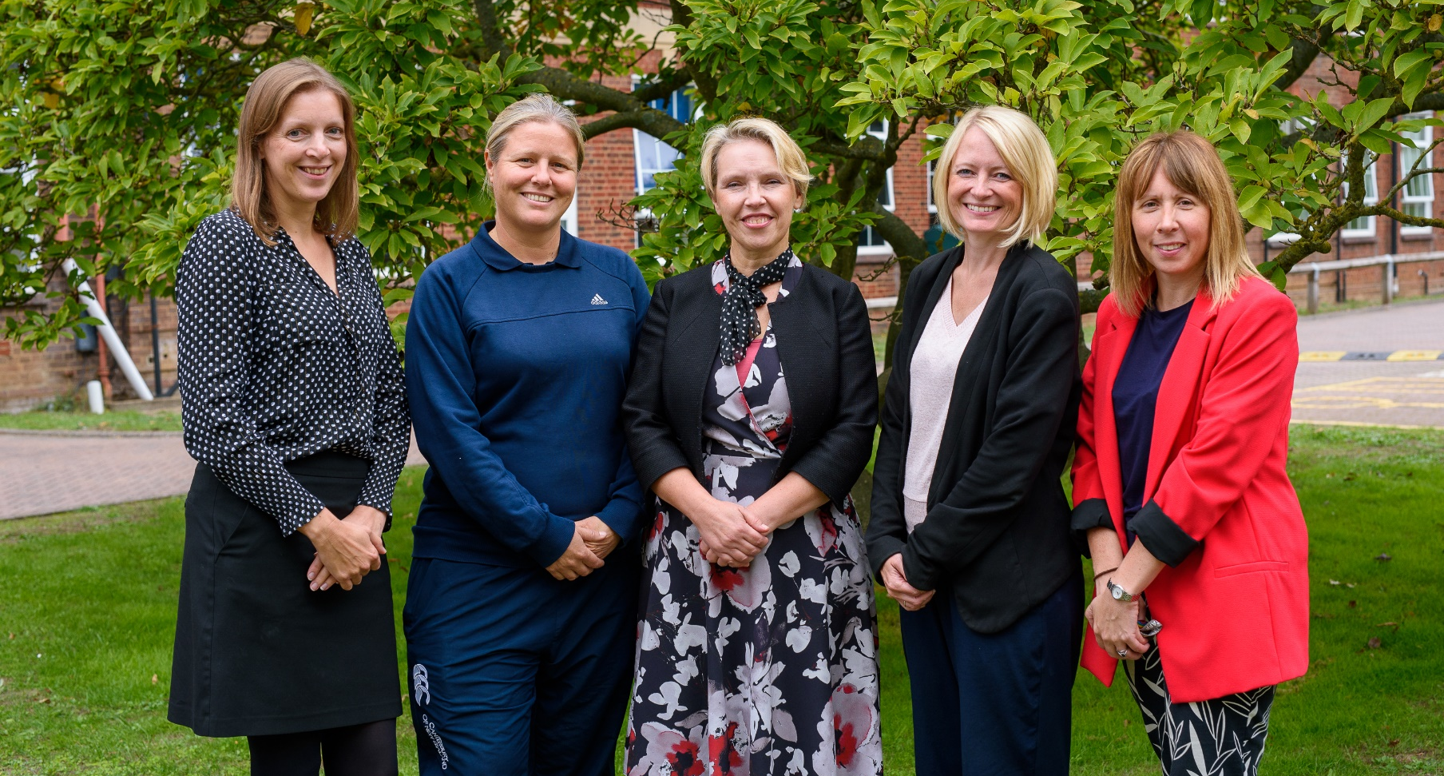

OUR LEADERSHIP TEAM

The Senior Leadership Team consists of two Deputy Heads, two Assistant Heads and Directors of School Improvement, who work closely and supportively to plan for the future development of our highly successful school. Collaborative and open working practices ensure coherence and clarity in the leadership and management of the school. The Local Governing Body is a strong and supportive team with considerable professional expertise.

Amy Cavilla (Headteacher)
Amy is in her 7th year of headship and has worked in all girls' state schools since 2003. The mission of Nonsuch High School for Girls is about empowering its students to take their rightful place centre stage as global change-makers. Amy is committed to the ethos and mission of girls' education and sits on the UK Regional Advisory Committee for the International Coalition of Girls' Schools comprising nearly 500 schools world-wide. Nonsuch is proud of its house traditions, school values and championing of a broad curriculum and participation in extra-curricular activities.

Helena Wright (Deputy Headteacher)
Helena joined Nonsuch High School for Girls in 2014 having taught and led in two highly successful schools in the comprehensive sector. She has taught for over 20 years Business and Economics and still loves being in the classroom. Helena remains passionate about Teaching & Learning and staff development and is committed to cultivating great teachers and middle leaders. Some of Helena’s key responsibilities include; staffing, all things curriculum, school admissions and quality assurance.

Alexis Williamson-Jones (Deputy Headteacher)
Alexis joined Nonsuch High School for Girls in 2021 having taught in the Independent Sector for over 20 years. Alexis has undertaken a number of different roles throughout her career including Head of Year, Head of Department and a Trust Consultant Teacher working across 25 schools. She has a passion for personal development of each child and believes that every child deserves a good holistic education. Some of Alexis’s responsibilities include Pastoral Care and Wellbeing, attendance and extra-curricular activities.

Hannah Johns (Assistant Headteacher)
Hannah joined Nonsuch in 2013 having taught in the comprehensive sector as a member of Teach First and then in the selective sector. Hannah has taught for over 20 years Philosophy and Psychology and particularly enjoys A-Level teaching. Hannah is passionate about supporting students in their transition from sixth form into Higher Education or a Career and in preparing students to be independent learners who thrive in the outside world. Her key responsibility is the strategic leadership of the sixth form including; student progress at KS5, development and quality assurance of PSHE and intervention and support.

Andrea Todd (Assistant Headteacher)
Andrea joined Nonsuch in 2009 and now has over twenty years’ experience of teaching Science & Biology in selective girls’ schools. She is passionate about encouraging girls to explore the diversity of STEM both inside and outside the classroom. She has a particular interest in the use of technology to provide a high-quality teaching and learning experience as well as its role in streamlining how teachers work. Her key responsibilities include teaching & learning, assessment and data.

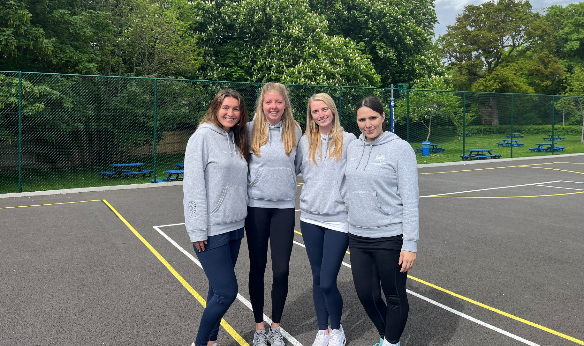

OUR DEPARTMENT

The PE department currently has seven members of staff and a PE Support Assistant. Nonsuch has outstanding facilities including 5 netball courts/6 tennis courts, a sports hall, Astro turf, 2 athletics fields, an indoor swimming pool and a further 7 tennis courts which are shared with the David Lloyd Leisure Centre on site.
Within lessons we cover all areas of the National Curriculum. At Key Stage 3 we offer netball, hockey, football, gymnastics, dance, swimming, volleyball, rounders, cricket, tennis, athletics and health and fitness. At Key Stage 4 more choice is offered with pupils taking part in activities such as trampolining, badminton, softball and aerobics. All pupils in Years 7-11 receive two hours of PE per week (i.e. 2 one-hour lessons). Students can opt to take PE as a GCSE option. We currently run PE A-Level across the Trust but will run from Nonsuch when staffing capacity allows. We follow the AQA GCSE PE Specification. Students receive two hours a week, consisting of both theory and practical lessons. Practical lessons involve activities such as netball, trampolining and athletics. We currently have 83 students studying PE GCSE across Years 10 and 11.
We run the Level 2 Community Sports Leadership Award in Year 12 as part of the elective programme, allowing students to expand their confidence and develop their individual leadership skills through sport.

With regard to extra-curricular activities, we run clubs during lunch time and we also have practices and fixtures after school. These include netball, hockey, athletics, badminton, dance, football, gymnastics, hockey, rounders, swimming, tennis, cricket and cross-country. Some clubs are run by outside instructors such as Pilates, commercial street dance and tennis coaching. We regularly take part in competitive fixtures, local leagues as well as borough and county tournaments, achieving success in many areas. We also hold an annual Gym and Dance display with over 130 students participating. We are very proud to train the ball girls for the Cinch Championships held every year at the Queen’s Club.
In addition to the extra-curricular clubs and competitive fixtures that we offer, we also run an extensive inter-house programme with students in every year group competing in many different sports including hockey, netball, football, athletics, rounders, tennis, swimming and benchball.
We are an extremely proactive and dedicated team and we pride ourselves on the extremely high levels of participation we have in curriculum lessons and the range of extra-curricular activities we offer.
Additional information about the school is also available at http://www.nonsuchschool.org and on the school and PE department Twitter account.
05/23

OUR COMMITMENT TO YOU

Staff are our most valued asset, and we place a high emphasis on staff well-being and professional development. Our Trust-wide Wellbeing Strategy puts wellbeing at the heart of all considerations and at Nonsuch High School for Girls that means:

A commitment to workload reduction

- No written reports
- Up to three data drops per year
- An assessment and marking policy that is not onerous
- A clear KS3 assessment framework that prioritises progression throughout the Nonsuch curriculum

A commitment to making the workplace a pleasant and supportive working environment

- Free access to the on-site David Lloyd Gym and Spa for staff
- Friendly and supportive staff body
- An exciting and supportive programme of professional development
- Monthly extended mid-morning breaks
- We are a school that appreciates the importance of family
- Additional leave policy that supports staff when they may need time off
- A maximum teaching load of 43/50 1-hour periods per fortnight
- A private day care nursery on-site
- Situated in 22 acres of beautiful grounds on the edge of Nonsuch Park

A commitment to supporting staff

- The school calendar and training is planned in advance across the whole year so people know what is happening and when
- In-house cover supervision team
- A highly effective and proactive support staff who play an important role in supporting teaching and learning
- Every full-time teacher has an office-based work

A commitment to staff development

- A comprehensive new staff induction programme which includes the allocation of a mentor and peer buddy
- CPD programmes, which are based both in school and across the wider Trust, tailored to individual aspirations
- An additional INSET day at the beginning of the academic year dedicated to teacher planning and preparation
- Our “No lesson judgements” policy ensures our lesson observations are developmental and supportive
- An annual cross-Trust teaching conference allowing the chance to meet and network with other staff

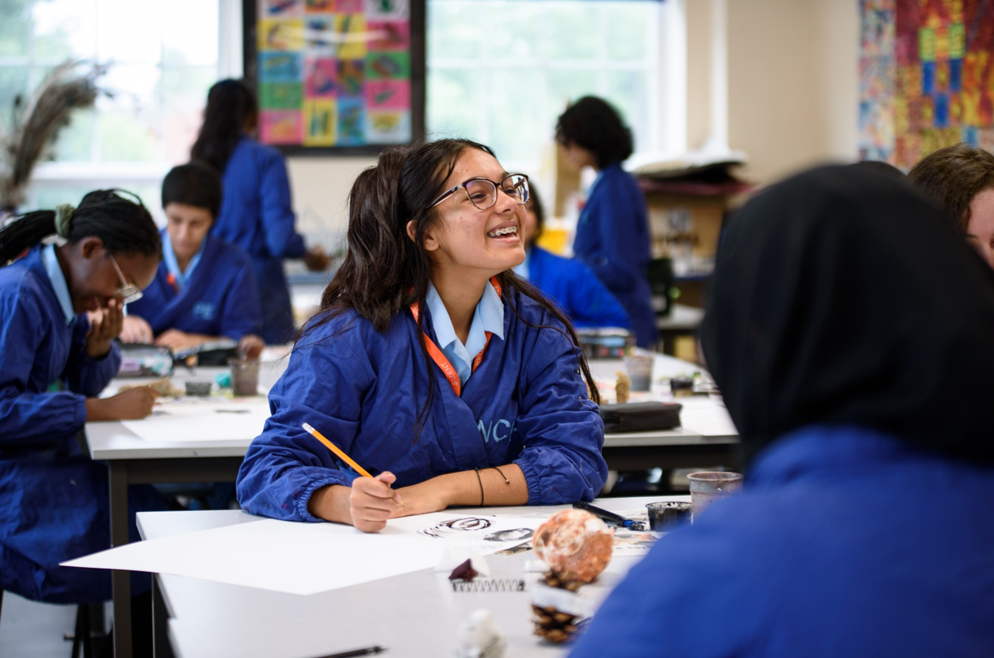

THE OPPORTUNITY

The PE Support Assistant is a vital role within the PE department and is key to ensuring outstanding PE teaching and an enriching extracurricular programme. The post involves having responsibility for resources, maintaining equipment and providing support for both PE lessons and extracurricular activities. The work carried out by the PE assistant is valued by our staff and contributes to the creation of a safe and welcoming environment both curriculum lessons and at extracurricular PE clubs. You join a highly skilled and dedicated PE team to ensure the school meets its core aim of empowering its young people to take their rightful place centre stage and to thrive in life-long learning. As a department, we aim to educate students about physical activity and the importance of lifelong participation and creating a sporting habit for life. As a PE assistant, you will have the opportunity to impart your knowledge and passion for physical activity and sport on to students in order to support our aim.

JOB DESCRIPTION

Job Title | PE Support Assistant (Gap Year Opportunity)
Reporting To | Head of Department
Salary Scale | GLT Range 1 (£20,453 FTE) pro rata  Actual salary:  £14,983 (for period from 4th Sept 2023 to 19th July 2024)
Weekly Hours | 35 hours  Monday-Friday 08.30 – 16.30 (one hour for lunch)  This may vary if helping with fixtures with later start and finish.
Annual Weeks Worked | Term time plus Inset days (39 weeks per year)
Type of contract | Fixed term

Main Duties:
IT Support
- Set up video analysis equipment prior to lessons and assist with the use of during the lesson
- Set up the projector and laptop as required
- Update the PE SharePoint
- Take and display photographs of sports activities
- Assist with the filming of GCSE PE practical activities, uploading video evidence into the shared area.
Maintain Equipment:
- Keep inventories of equipment
- Maintain equipment e.g. re-gripping rackets etc.
- Pump balls on a regular basis
- Wash bibs – liaise with the technology department about use of washing machines
Assist with fixtures:
- Email schools on a weekly basis to confirm fixtures
- Organise transport – maintain email contact with the coach company
- Prepare fixture list and distribute
- Attend away fixtures and tournaments as the second member of staff
- Provide admin support for tournaments
- Liaise with the site team at the beginning of each week to confirm fixtures
Promote PE Activities:
- Distribute notices via the class registers
- Maintain PE notice boards
- Give out notices in year assemblies/main school assemblies

Assist with Swimming Lessons:
- Assist in preparation of the pool area before swimming lessons and remain poolside, as well as in the pool if required, during the lessons.
- Undertake lifesaving qualification if required.
- Oversee changing rooms before and after the lessons
Assist with Lessons/Extra-curricular Activities:
- Set up equipment prior to lessons e.g. trampolines, boxes and springboards
- Provide assistance in lessons including swimming, if required e.g. EAL/SEN, lower ability students
- Liaise with external coaches.
- Assist with or run lunchtime and after school clubs
- Input assessment levels into the PE assessment database
Provide administrative support for whole-school PE events
- Sports Day
- Gym and Dance display
- Sport Relief Week
- Sports Awards Evening
- End of Year Sports Assembly
- Inter-house competitions
General Duties:
- Oversee PE lost property to ensure efficient return of items
- Update the department’s weekly planner and monthly fixtures board
- Complete the ‘clubs this week’ notice for the board
- Update PE department calendar with details of whole school events (from the school calendar) as well as to keep track of bus bookings and when staff will be out of school.
- Ensure changing rooms are left tidy at the end of the day
- Any additional administrative duties required by the department.

The Job Description will be subject to periodic reviews to fit in with the needs of the school and provide development opportunities as appropriate. It is not a comprehensive set of tasks, but sets out the main expectations of the school in relation to the postholder’s responsibilities and duties at this time.
The school will endeavour to make any necessary reasonable adjustments to the job and the working environment to enable access to employment opportunities for disabled job applicants or continued employment for any employee who develops a disabling condition.

This job description is current at the date shown, but following consultation with you, may be changed by the Headteacher (or designated person) to reflect or anticipate changes in the job which are commensurate with the salary and job title.

05/23

PERSON SPECIFICATION

Area | Essential | Desirable | Method of Assessment
Qualification | - A-Level or equivalent - gap year student |  | Certificates
Experience | - Interest and ability in school PE | - Relevant coaching qualifications  - Experience of working with children and young adults | Interview  Reference
Knowledge and Skills | - Strong organisational skills  - Ability to communicate effectively across the whole school community  - Wide range of interest in sports  - Ability to produce and maintain outstanding school displays  - IT skills |  | Application  Interview  Reference
Personal Qualities | - Ability to work effectively in a team and a proactive team member  - Enthusiastic with a “can do” attitude  - Flexible and adaptable to changing needs and priorities  - Positive, even tempered and calm under pressure  - Able to maintain confidentiality and discretion  - Professional appearance  - Good timekeeper  - Sense of humour |  | Application  Interview  Reference

05/23

APPLICATION PROCESS

Safeguarding
The Girls’ Learning Trust is committed to safeguarding and promoting the welfare of children and young people and expects all staff and volunteers to share this commitment. Candidates are expected to demonstrate a sound understanding of leadership of and contribution to a safeguarding environment. The successful candidate will be required to undergo an enhanced DBS with barred list check followed by safeguarding training as part of their induction.

Data Protection
As part of our recruitment process, Girls’ Learning Trust collects and processes personal data relating to job applicants. The Trust is committed to being transparent about how it collects and uses that data and to meeting its data protection obligations. For further information about this and to read our Data Protection and Freedom of Information Policy, please visit: www.girlslearningtrust.org/our-governance/policies

Application Process
We operate a safer recruitment process. All applications should be via an official application form (available on our website) and sent to: vacancies@nonsuchschool.org

Closing Date
Applications must be received by no later than Monday 17th July 2023 at 9 a.m.

Interviews
Interviews will take place on: Tuesday 18th July 2023

Notification & Feedback
Candidates who have taken part in interviews will be notified as soon as possible – please ensure that you have provided day and evening numbers on which you can be reached. Constructive feedback will be provided for all candidates invited to interview.

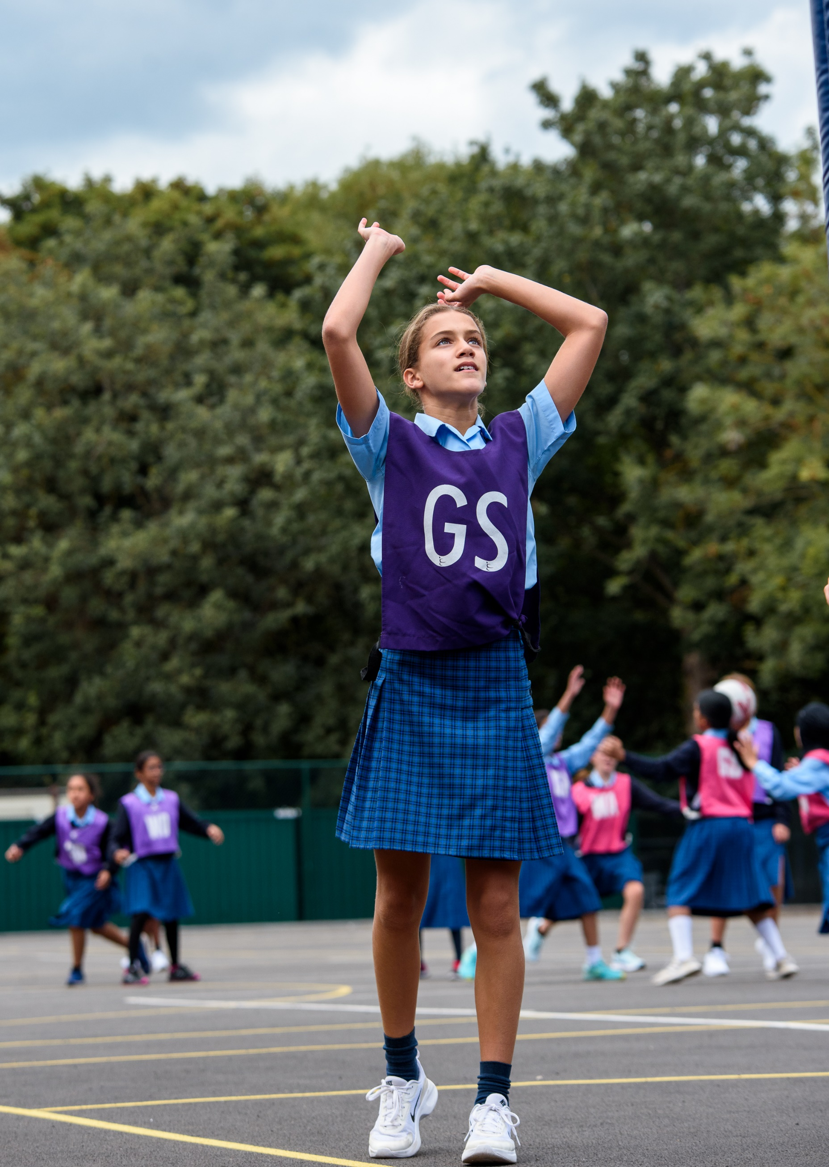

www.girlslearningtrust.org

