WESTFIELD PRIMARY SCHOOL AND NURSERY – ALL ABOUT US

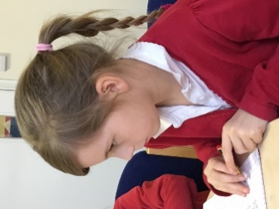
Westfield School is a friendly, successful, 14 class, non-denominational school located in Westfield, Radstock which is at the southernmost point of Bath and North East Somerset.
In October 2018 Westfield Primary School joined the Midsomer Norton Schools Partnership Academy Trust.
The school is situated in a pleasant area within easy reach of Bath, Bristol, Wells, the Mendip Hills and all points west.
The main school building is just over thirty years old and has been augmented by a modern Key Stage 2 block. The site includes a large playing field bordered by mature trees, two playgrounds and a shared swimming pool. The school also has a successful nursery on site which is staffed by a highly enthusiastic and committed team. The school has its own breakfast and after school clubs providing childcare care from 8am to 6pm Monday – Thursday and 8am to 5pm Friday.
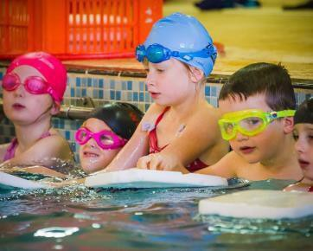

Currently Westfield School has 381 pupils (plus 52 nursery children). Due to numerous housing developments in the immediate area along with the school’s increasing popularity and reputation in the community, numbers continue to rise.

The school is arranged into three teams, phase 1 (EYFS and Yr1), phase 2 (Years 2 and 3) and phase 3 (Years 4, 5 and 6). Along with the Head and Deputy, the team leaders make up the Senior Leadership Team. The strong year group teams plan and assess together to ensure quality provision. We have a highly motivated and skilled team of teachers and in addition to this, we are fortunate to have a large group of teaching assistants. The teaching assistance support the children in a wide range of intervention groups as well as having a key role in pastoral care.

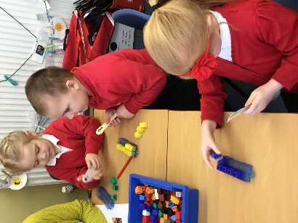
Our school is a not only a place for academic progress but also a place of personal development, we believe that through wider learning and achievement comes personal growth, not just success in the SATs; every child really does matter.
The school has a highly successful nurture class which has attracted visits from many professionals of neighbouring schools as well as professionals from the local authority.
In order to foster self-esteem, teamwork and respect for others, we invest a lot of energy in PSHE, drama, music and sport; as well as in our extra-curricular clubs and our house system. The behaviour of the children is very good and we attribute this largely to our positive school ethos.

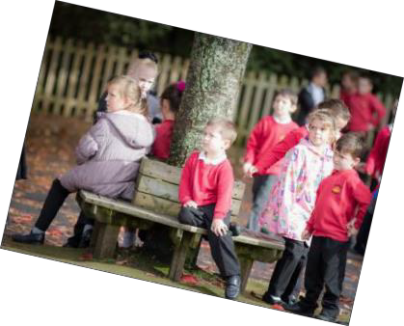
Our major emphasis remains on raising standards which we are continually doing. Amongst other things, we are doing this by implementing a curriculum more closely based on the interests of the learners. School sport is very successful and we find that we can build on children’s esteem, both individually and as a school, by encouraging children to take part and celebrating their success. Celebrating success in all areas is very important to us – not only for the children but for the whole school community.
About Our School

Attainment and progress by the end of KS2 have improved so much that in 2018 we were in the top 10% of schools nationally. This is due to the consistently high expectations of both of children and of staff.
All members of the school community are valued for the part they play and they have a say in the school’s development.
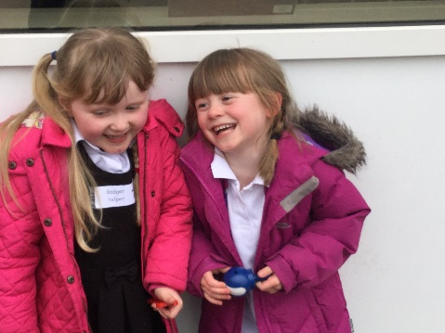
The TAs meet regularly for training sessions and discussions and lunchtime supervisors have termly meetings.
The pupils themselves take on roles and responsibilities such as buddies, house captains and members of the School Council.
We have supportive parents who like to help in the school together with an active Westfield Parents Association.
The Governing Body is committed and works hard for the school.

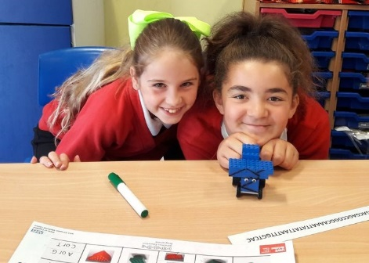
Staff who join our team can look forward to plenty of support and professional development. In return, we expect colleagues to be ambitious for themselves, for the school and for the children.
The nursery has been successful in obtaining the Healthy Outcomes Certificate for Early Years whilst the school has also achieved the DPH award.
We are very proud to be the first school in BANES to be awarded the Achievement for All quality mark.

We believe that Westfield School’s children are exceptional, they are happy, keen, motivated and prepared to work hard and they deserve the best education we can give them.
There is no substitute for coming to see them, so, please give us a call and make an appointment to come and have a look round.
We look forward to seeing you.

