January 2018

Dear Prospective Applicant

Thank you for taking an interest in the post of Assistant Headteacher at Wheatley Park School from September 2018.

I believe this post offers a superb opportunity for a candidate of the highest calibre to play a pivotal role in Wheatley Park School’s journey to becoming sustainably ‘outstanding’ (in every sense of the word) in accordance with our twin values of Everyone Learning and Everyone Caring. We are taking the approach of selecting the best candidate and then shaping the role around them, as opposed to selecting the candidate who best fits a pre-ordained role. I hope this flexibility will also appeal to you.

Since joining Wheatley Park in January 2017, it was immediately apparent that the value of Everyone Learning was more than just an empty strapline. In addition to the students themselves, teachers and leaders all viewed themselves as dedicated learners, receptive to feedback and always striving to use research-based best practice in the pursuit of excellence. Since September 2017, we have introduced the value of Everyone Caring to further build upon the strong nurturing ethos within which students, teachers and leaders alike are all encouraged to take responsibility for each other’s welfare. This provides the ideal ‘high challenge but low threat’ environment for an ambitious leader to thrive in.

We are currently working towards a three year school improvement plan (available in summary form on our website) with a clear focus on getting the ‘basics’ of impeccable behaviour for learning and high attendance right this year to provide a more stable platform for the innovative teaching and learning practice that is flourishing within the school (aided by our one to one Chromebook programme). We have already seen considerable gains in these areas this year and the successful candidate will join a school that is brimming with confidence in its capacity to stand alongside the very best.

If you are an exceptional candidate who is highly motivated to help take us on the next step of our journey and excited to work with a truly comprehensive intake in a stunning parkland setting, please do not hesitate to apply. I would direct you to the final paragraphs of our advertisement if you would like to arrange a visit or have further questions.

I wish you all the best if you do decide to proceed with your application.

Yours sincerely
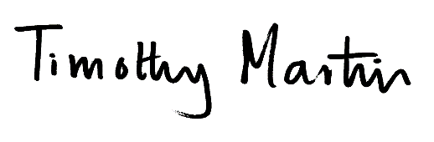
Tim Martin
Headteacher

