

Information for Candidates
Cover Supervisor


 | 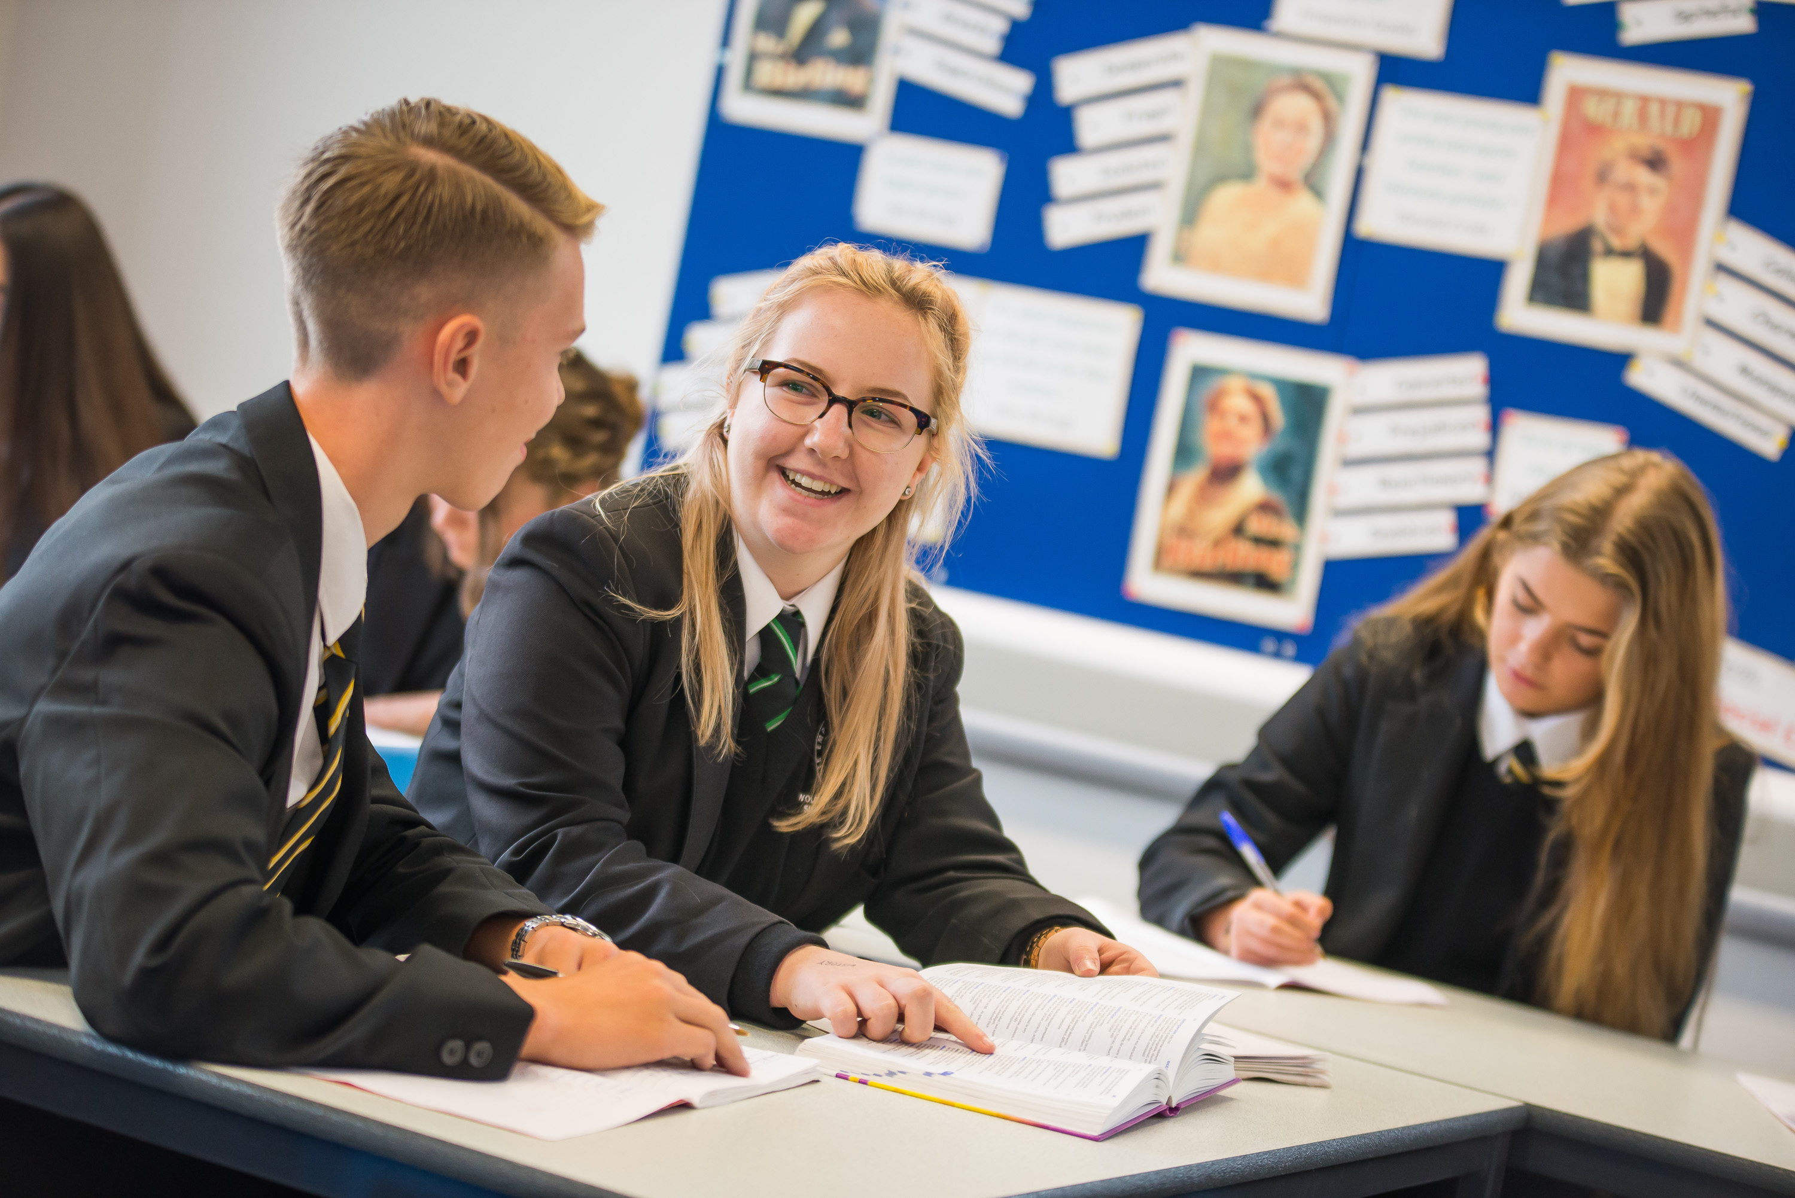 | 

Wolfreton School and Sixth Form College
Well Lane
Willerby
East Riding of Yorkshire
HU10 6HB

Headteacher and Chief Executive Officer |  | Dave McCready
Associate Headteacher |  | Susanne Kukuc
Telephone Number |  | 01482 659356
Email |  | enquiries@wolfreton.co.uk
Website |  | www.wolfreton.co.uk










Well Lane
Willerby
East Riding of Yorkshire
HU10 6HB
Tel: 01482 659356
enquiries@wolfreton.co.uk www.wolfreton.co.uk

September 2017

Dear Applicant

Thank you for your interest in our vacancy for a Cover Supervisor.

Wolfreton School and Sixth Form College is a large and forward thinking school and is a part of a newly formed Multi Academy Trust ; The Consortium Academy Trust (TCAT). We are an ambitious community and recognise the impact of exceptional staff on the development of our positive and engaged student body.

Our Cover Supervisors work proactively to communicate work set and support students in carrying out their work in the absence of teaching staff. To be successful in this they will need to feel confident that with training they will be able to direct young people in their activities, have a presence in the classroom, maintain discipline and create a calm and productive environment for learning.
They are able to work both independently and as part of a team, be enthusiastic about working with children, committed to providing help and support and be interested in how children learn. We expect our Cover Supervisors to be keen to develop their own learning in this area and be able to use their initiative to progress this vital role which also support students who present behavioural difficulties, helping to build confidence and self-esteem.
The school’s core working day for support staff is 8.15am to 4.30pm (Friday 4.00pm), 45 minute lunch break. Cover Supervisors need to be flexible with the timing of lunch breaks as a part of the role is to support lunchtime detentions.
Last Summer we moved into our new single site, purpose built school. With state of the art facilities and a real commitment to the values encapsulated in our strapline, ‘The Wolfreton Way – Excellence, Endeavour and Respect’, the school really is at an exciting stage of its development.

You will find information about the school, the role and the application process in this pack. Please visit our website www.wolfreton.co.uk for further information about Wolfreton School and Sixth Form College.

How to apply
Complete the enclosed application form and return to -
Wolfreton School and Sixth Form College, Well Lane, Willerby, E Yorkshire, HU10 6HB

(Electronic applications are accepted. Please email to enquiries@wolfreton.co.uk)

The closing date is 8:00am am Monday 18 September 2017.

We regret we are unable to acknowledge receipt of postal applications. If you have not heard from us within two weeks of the closing date you should assume that your application has been unsuccessful on this occasion.

I look forward to receiving your application and wish you every success with it.

Yours sincerely

D A McCready
Headteacher

OUR VALUES and OUR GOALS

At Wolfreton, we want everyone to fulfil their potential, to excel and to leave prepared to achieve all of their ambitions. To enable this to happen, we are all committed to simple and straightforward values and goals.

OUR VALUES

Excellence We encourage our students to be INSPIRATIONAL

Endeavour We promote the qualities of
DETERMINATION and COURAGE

Respect We are firm advocates of
FRIENDSHIP and EQUALITY

OUR GOALS

Create
An inclusive caring environment that enables every student to enjoy learning and achieve their academic potential.

Prepare
Responsible young adults who value learning, helping them to make a positive contribution to society.

Develop
Self-confidence, motivation, aspiration and commitment in every student, celebrating all achievements.

Respect
Every young person’s right to learn while encouraging them to stay safe, be healthy and enjoy equal opportunities.

Provide
All students with a broad and balanced curriculum, enabling them to develop and achieve economic well-being.

GENERAL SCHOOL INFORMATION

Wolfreton School and Sixth Form College is a large comprehensive school with over 1500 students on roll, including 230 in the Sixth Form. We are a successful school with a positive and engaged student body and a dedicated and talented staff.
The school is set in the attractive leafy suburbs of the East Riding of Yorkshire close to the Wolds and only seven miles from the market town of Beverley. The catchment area covers the pleasant residential districts of Willerby, Kirk Ella and Anlaby in the East Riding of Yorkshire. These are relatively affluent areas with good quality housing and access to varied leisure opportunities. Proximity to the M62 ensures easy access to the motorway network and other major cities in Yorkshire and beyond.
Historically Wolfreton was a split-site school, however in August 2016 we took possession of our new single site school. Having had the opportunity to work with the design team and construction company during the build period, many have had an input into the new school. This has ensured that the building really can deliver. Staff and students alike are now enjoying the benefits of high quality accommodation, equipped with the latest technology and specialist facilities that are among the best in the region.
Wolfreton is a good and ambitious school. This was recognised by Ofsted in our most recent inspection in October 2013, when the achievement of students, quality of teaching, behaviour and safety of students and leadership and management were all judged to be good. Since then, we have seen continuing improvements across the school. Staff are ambitious and students are too. Levels of progress are also good and in the new measure, the school achieved a positive Progress 8 score of 0.24 in 2016. Students are keen to work with staff and take advantage of the many opportunities they are offered.
Standards of attainment at Wolfreton exceed the national average. In 2017, 87% of students gained level 4 to 9 in English and 79% gained level 4 to 9 in Maths. Students enjoy access to a broad and balanced curriculum, and specialist teaching ensures that engagement and progress can continue to increase for all.
The school is a disciplined and well-organised environment. We have high standards of school dress and have clear expectations on punctuality, attendance and behaviour. Our students are positive and respond well in all aspects of school life.
The Sixth Form College is focussed on providing high quality teaching and care to secure the best achievement and outcomes for all. As a school, we have a long history of partnership working in this area, being a part of ‘The Consortium’, a widely recognised successful sixth form partnership with two other local schools. Students are able to study at Wolfreton as well as having the option to study subjects at either of the other Consortium schools. The Sixth Form has a dedicated suite of teaching rooms and facilities within the building, giving it a bespoke Sixth Form College feel in this area. Sixth Form students play a full roll in the life of the school, but equally will continue to enjoy the advantages of this dedicated provision.
Wolfreton teachers are known for their caring approach with all students and we are committed to providing strong and effective pastoral support. Our established House system creates a smaller family feel in a large school. Each tutor group belongs to one of our five Houses, with tutors in this team led by a Head of House who is a member of the teaching staff, and a non-teaching House Pastoral Manager. A Senior Pastoral Manager also works across the Houses to ensure that we can deliver the very best for students. Heads of House are committed to developing the ethos of their House. As well as recognising successes, they focus on student progress and lead valuable opportunities to work collaboratively through inter-house competition and charity challenges.

As a school we firmly believe opportunities and experiences play a huge role in enabling young people to develop their skills and attributes beyond the classroom. The school prides itself on the wide range of extra-curricular opportunities offered to our students. Annually, students have the chance to join or take part in over 250 teams, clubs, and events. Staff give a great amount of time to these and the students and school have achieved many accolades in the widest range of fields.
The school has a strong community ethos. We have built close links with the world of business and have developed links both nationally and internationally, for example with the Rushanje School in Uganda, who we continue to support through charity initiatives.
Wolfreton remains a popular choice for secondary education. Our annual intake of 270 students is taken mainly from five neighbouring primary schools, with whom we have excellent and close relationships. We are also committed to high quality induction and ongoing training and staff development. Wolfreton has retained the Investor in People Award for 18 years; in our most recent assessment we were awarded the IIP Gold Standard.
The school’s core working day for support staff is 8:15am to 4:30pm (Friday 4:00pm), 45 minute lunch break.
Multi Academy Trust
Wolfreton has enjoyed a long, successful informal partnership at Sixth Form Level with two local secondary schools, Cottingham High School and Hessle High School.
The Consortium Academy Trust, based in the East Riding of Yorkshire, was formed in September 2017 by the coming together of Cottingham Academy Trust, The Hessle Community Academy Trust and Wolfreton School and Sixth Form College to form a new Multi Academy Trust, approved by the Department for Education (DfE) as an Academy Sponsor.
It is not envisaged that there will be any significant changes to the day to day operation of each school and staff, although employed by the MAT, will be recruited to a particular school. There will however be opportunities for interested staff to engage in MAT-wide activities in order to enhance their professional development.
The MAT marks an exciting time in the development of Wolfreton School and Sixth Form College and further details are available to potential applicants if required.

Wolfreton School and Sixth Form College
Job Description
Cover Supervisor
37 hours per week, term-time plus 5 days
Point 17, £17,772 (£14,978 pro rata)
MAIN PURPOSE OF THE JOB
Working in partnership with the teacher:

- to instruct students in relation to the work left by the subject teacher
- to ensure students are provided with the necessary resources to facilitate learning
- to register and record student attendance in lessons
- to answer students’ queries in relation to the instructions left by the subject teacher
- to liaise with the Curriculum Area Leader in relation to the work set by subject teachers as appropriate
- to supervise the class for the duration of the lesson
- to ensure classes enter and leave classrooms in an orderly manner
- to ensure the classroom is left tidy and ready for the next lesson after dismissing the class
- to mark work as appropriate
- to report to the appropriate senior member of staff at a given point in the day
- to assist in establishing good order within the school, including undertaking duties as necessary
- to deal with, record and report incidents of inappropriate behaviour, in accordance with the school’s behaviour policy and procedures
- to support and supervise after school study support activities
- to work with support staff allocated to the teaching area
- to work to agreed school policies and procedures

Working in partnership with Support:
- to facilitate participation and learning, helping to build confidence and self-esteem, so that all students, including those who present challenging behaviour, are enabled to reach their full potential alongside their peers
- to take responsibility for producing packs of work (in collaboration with Subject Leaders) for students who are excluded from school
- to arrange work from departments for students in isolation

Supporting the school by:
- supervising lunch and after school detentions
- assisting with morning and lunch break supervision of students
- helping with educational visits and outings
- attending staff meetings, teacher training days and training courses as appropriate
- supporting school admin processes, as required

Performs other duties as reasonably correspond to the general character of the post and are commensurate with its level of responsibility

The school’s core working day for support staff is 8.15am to 4.30pm (Friday 4.00pm), 45 minute lunch break. Cover Supervisors need to be flexible with the timing of lunch breaks as a part of the role is to support lunchtime detentions.

.

PERSON SPECIFICATION FOR COVER SUPERVISOR

Category | Essential | Desirable | Evidence
Qualifications and Training | - Experience working with young people  - Good standard of basic education, equivalent to NVQ 3 | - Experience of working with young people in a learning environment  - ICT qualification/training  - Certificate in Support/Learning | Application form/  Interview
Skills, knowledge and aptitude | - Excellent communication skills  - Ability to deliver effective supervision of young people  - Ability to provide a supportive learning environment  - Ability to work using own initiative in responding to challenging situations  - Ability to remain calm  - Ability to establish good professional relationships with colleagues at all levels  - Willingness to take responsibility  - Commitment to own learning | - IT skills  - Understanding of numeracy and literacy applications  - Understanding of an effective classroom environment  - Understanding of the variety of ways that children can learn | Application form/ Interview
Personal Attributes | - Interpersonal skills  - Energy and enthusiasm  - Self-motivation  - A positive role model for young people and colleagues.  - Ability to develop effective professional relationships with students and staff.  - Organisational skills  - Good health record  - Professional appearance  - Sense of humour | - Flexibility and adaptability  - Listening skills | Interview

