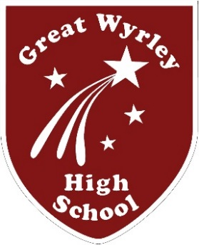
Are you an English specialist?
Do you have a passion for Teaching and Learning?
Can you transform student outcomes through creativity and flair in the classroom?

Then we have the post for you!
Required for January 2018 temporary in the first instance for two terms until 31st August 2018.
Teacher of English, MPS-UPS £22,917 - £38,633pa

We require, for January 2018, an inspirational and ambitious teacher of English, temporary (in the first instance for two terms with remuneration up to 31 August 2018), to assist in driving this curriculum area to its next stage of development. You will work closely with the Subject Leader of English in ensuring that the highest standards of teaching and learning and achievement remain a priority. You will need to demonstrate a clear vision and enthusiasm for English and be committed to improving the outcomes of students.

The successful candidate will be an experienced and well qualified individual that has:
- a commitment to ensuring that every child can access high quality teaching;
- the ability to deliver consistently good/outstanding lessons;
- excellent and up to date knowledge of teaching and learning;
- a commitment to Great Wyrley High School’s high expectations and ethos;
- an ambitious vision for the teaching of English;
- the ability to motivate students to drive up standards;
- the resolve to make a real difference to the lives of our students.

For further details or to arrange a visit please contact Mrs Rosemary Bannister on 01922 419311 ext 166
Details of this role, including a job description, person specification and the application forms can be downloaded from the school website at http://www.gw-hs.org/useful-links/vacancies/
Completed applications should be sent to the Headteacher at the above address or emailed to headteacher@gw-hs.org by Monday 16th October 2017 at 12pm.
Interview will take place on Friday 20th October 2017.
Please note, because of the nature of this job, if you are successful in your application you will be subject to an enhanced Disclosure and Barring Service with barred list check. This will be done by means of applying for a DBS certificate through the Disclosure and Barring Service. Disclosures include details of cautions, reprimands or final warnings as well as convictions, spent or unspent. Clearance will be obtained before employment commences.
Great Wyrley High School is committed to safeguarding and promoting the welfare of children and young people and expects all staff and volunteers to share this commitment.

