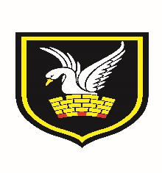 | Carshalton Boys Sports College  Winchcombe Road  Carshalton  Surrey  SM5 1RW

Modern Foreign Languages Department

In the MFL department we are passionate about our communicative and interactive approach to language learning. The team consists of five vibrant and committed teachers who are all passionate about their subject, a fact supported by results that are well above the national average.

French and Spanish are introduced in Year 7, with pupils having the option to choose their preferred language before they commence. They will continue studying these until Year 8 when they select their options. Students then follow a three year AQA GCSE course and we also offer A Level French and Spanish, again using AQA. Languages are a very popular option choice this year, hence the need to expand the department.

As part of our faculty we also have an integrated EAL department, encouraging boys to take GCSEs in their home language and we operate a successful Target Language Policy used extensively and consistently across the Department.

The Modern Foreign Language Department has a wide range of extra-curricular activities and trips in place which aim to encourage pupils to expand their own knowledge of language and culture; this includes the very popular and successful yearly residential trip abroad to Málaga in Spain.

February 2018

