
job description
progress mentor.
reports to: Head of Learner Support
hours: Permanent. Full time role, 35 hours per week, term time only
salary: Sixth Form Colleges National Pay Spine Point 11-14 - £26,097 - £28,549 (FTE) pro rata to £22,313 - £24,409
start date: as soon as possible
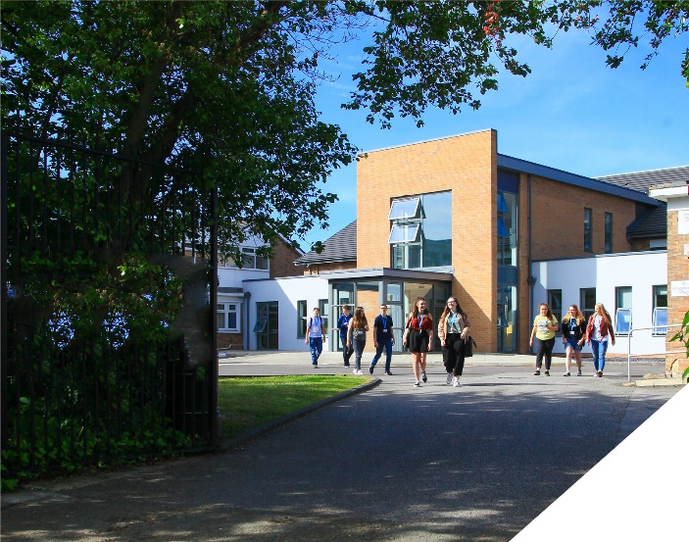
about the role.
This is an important role supporting a cohort of the most vulnerable students in the College, those who have a social worker, are registered young carers are living independently and have challenging personal circumstances. Consequently, this role will involve you dealing with social care teams and other external agencies. We are looking to appoint someone pro-active who will use this role to champion and support these vulnerable students by ensuring that all barriers to participation are removed. The role requires you drive high attendance and a positive and aspirational attitude to learning. This role is ideal for anyone who has the desire to make a meaningful impact on the lives of our most disadvantaged young people by ensuring that each has a comprehensive and individualised package of wrap-round support. The role complements the work undertaken by other cross-college support teams, particularly the Tutor team and the Learning Support team.
Below gives a sense of the range of responsibilities involved in the role but is not exhaustive.

  - To act as the student’s point of contact within College in terms of providing information, advice and guidance to support their academic and personal progress.
  - To liaise with external stake-holders involved in the student’s care and to produce (where necessary) a Personal Education Plan (PEP) to support students with social services intervention and to attend relevant meetings off-site where appropriate.
  - To join the College Safeguarding Team and keep CPOMS up-dated as necessary.
  - Ensuring there are no financial or other barriers to students accessing all the opportunities available to them in College.
  - To be as innovative as possible to ensure you make a practical difference to the student’s progress in college.
  - To monitor and support attendance and to make home visits if necessary to promote attendance and engagement.
  - To support students whose attendance has resulted in missed learning and to monitor the student catching up work through LAB slots and other interventions.
  - To monitor Sapien and provide targeted support and intervention to raise each student’s achievement and aspirations.
  - To work with all staff connected with each student (teachers, tutor, learning support team) to implement a coordinated and personalised strategy to drive achievement.
  - To support and promote Careers Information, advice and guidance by encouraging work experience placements, attending careers events and university open days.
  - To support and promote student engagement activities including clubs and societies, volunteering, sports and the acquisition of life skills.
  - To work with the student on unifrog and encourage their career aspirations, including supporting them in writing their personal statement for university
  - To provide ‘drop-in’ support for these students to encourage them to achieve academically and personally.
  - To support and promote the BePART ethos in terms of the value of learning and the powerful contribution it makes to social mobility.

Administration
- To complete all necessary administration associated with the role.
- To attend College events which take place outside normal working hours

The position is ideal for any individual who wants to develop in a unique and innovative job where no two days are the same and where your day to day work is highly rewarding. Whilst the role has prescribed hours, Monday to Friday, there will be times when flexibility will be required to work outside of these hours when urgent matters arise and at arranged events that occur outside of the College day (this time can be claimed back)

about the College.
This is an exciting opportunity to join a highly successful and innovative sixth form College. The College has won multiple national awards, including the UK Sixth Form College of the Year by TES in 2018, and this followed being graded outstanding in all areas by OFSTED. This year the College was awarded College of the Year by Educate North. All staff play a vital role in the experience that students have with us and ultimately their success.

The College is committed to its core values of Positivity, Ambition, Resilience and Thoughtfulness, and these values shape everything we do. Our ethos is centred on the scientific evidence that tells us that everyone can achieve success through purposeful hard work as opposed to the talent myth, and as such, the College is in itself an engine for social mobility.

The College currently has a 16 to 19-year-old student population of 1450+ and there is high demand for places. The College recently completed a £1.7m expansion project as student applications continue to increase year on year.
person specification.
Experience | essential | desirable
Experience of working with children and young people | 
Experience of working with families who have challenging circumstances |  | 
Knowledge / Skills / Abilities
Flexibility, enthusiasm and the ability to relate well to staff and students | 
Knowledge of children’s social care processes |  | 
Ability to work part of a team | 
Ability to demand high standards from yourself and others | 
Ability to form and maintain appropriate relationships and personal boundaries with young people | 
To demonstrate a commitment to
The Colleges values of Positivity, Ambition, Resilience & Thoughtfulness | 
Personal development and training | 
Safeguarding & promoting the welfare of students | 
Equality & diversity | 
Other
To be flexible to the varied day to day demands | 
Current full driving licence | 

how to apply.
If you are ambitious and determined to make a meaningful difference in one of the country’s leading sixth form colleges then we would be thrilled to have you join our team.

Please complete the Application Form for Support staff and write a Letter of Application of no more than 2 sides of A4 explaining how your qualifications and experience match the requirements of the Person Specification detailed above.

closing date: Noon, Wednesday 12th March 2025
Interviews to take place: Thursday, 13th March 2025
Successful applicants will be invited for interviews and assessments on Tuesday 3rd December.

General Information
Birkenhead Sixth Form College has a commitment to safeguarding and promoting the welfare of students and expects all staff and volunteers to share this commitment. If you are invited for interview, your suitability to work with children will be explored as well as your suitability for the post.
All posts are subject to Enhanced Disclosure Clearance through the Disclosure & Barring Service.
The College is an Equal Opportunities employer and all members of the College have a personal responsibility to implement the policy, to carry out their responsibilities in accordance with it and to maintain an equality of opportunity for all.
The Governors and staff of the College take their duties under the Disability Discrimination Act (as amended by the Special Educational Needs Act 2001) very seriously. They will ensure that all reasonable adjustments are made to ensure that disabled people are treated fairly and that they are not placed at any substantial disadvantage. The College is committed to interview all applicants with a disability who meet the minimum criteria for the post and to consider them on their abilities.

Reference Checking

On the application form, you are asked to provide details of two employment referees (preferably your line manager from your current and previous or most recent employer/s), who can comment on your suitability for the post. References from relatives or individuals writing in the capacity of friends will not be accepted.

The College will seek references on short-listed applicants before interview, and will approach previous employers for information to verify suitability for the post, dates of employment, particular experience or qualifications, attendance / punctuality history and details of any disciplinary offences.

In addition, if you are currently working with children or young people, on either a paid or voluntary basis, your current employer will be asked about your suitability to work with children and any disciplinary offences relating to children or young people. This will include any offences for which the penalty is time expired (that is where a warning could no longer be taken into account in any new disciplinary hearing for example) and whether you have been the subject of any child protection concerns, and if so, the outcome of any enquiry or disciplinary procedures. If you are not currently working with children but have done so in the past, that previous employer will be asked about those issues. Please note providing false information is an offence and could result in your application being rejected, or dismissal without notice if you have been appointed and possible referral to the police.

