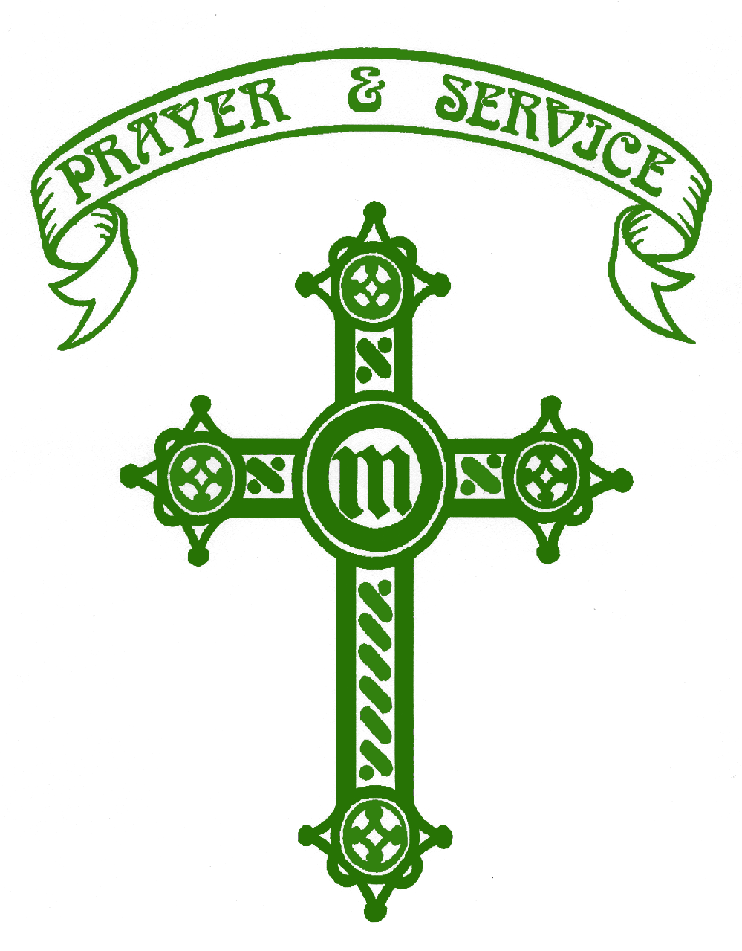

St Monica’s Roman Catholic High School

THE HUMANITIES DEPARTMENT

The History team, who are an essential part of the Humanities Department at St. Monica’s, are committed to high standards, both within the curriculum and in this highly successful extra-curricular programme.

History has an examination pass rate which is consistently above the national average. In 2018 68% of students achieved 9-4 in History with 24% of students gaining 9-7.

The department has three full time History specialists all teaching from year 7 through to year 11. As of September 2019 years 7 to 9 will be taught in ability groups and years 10 and 11 will be taught according to the option blocks. The successful applicant will be expected to teach across the full ability and age range.

At Key Stage 4 students follow the AQA syllabus. This is supported by the AQA specific textbooks and a vast array of other resources.

At Key Stage 3 the main source of teaching material is derived from the SHP and Oxford series of textbooks. The schemes of work are in line with the new History curriculum that was implemented in September 2014.

The History department has a suite of rooms, all containing interactive whiteboards.

In terms of extra-curricular activities year 9 students have participated in a local history project in collaboration with Bury Archives. They have also produced a news bulletin for the scrutiny of a BBC News Editor to develop their understanding of interpretations. In 2016 Key Stage 3 students took an active role in Heaton Park’s Battle of the Somme centenary commemorations; students created tiles that formed part of the Path of Remembrance, performed on stage and appeared on Newsround. Students also collaborated with the Art Department to create an art installation as part of Manchester’s Yom Hashoah commemorations. We are looking to expand on the extra-curricular activities in line with the new GCSE specifications. The department also plays an active role in teaching and learning across the school and many of the team have led teaching and learning workshops.

If you need any more information on the department please contact Mrs Jane Flaherty, Head of Humanities and Lead Teacher of History at the school, or email her at j.flaherty@stmonicas.co.uk

Applicants should make particular reference in their letter to the following:

- Catholic ethos
- State clearly what exam and syllabus experience they have
- Any relevant exam results
- Be committed to extra-curricular activities
- It would be an advantage that the successful candidate is able to teach a second subject.

