




Application Pack
Head Teacher



ADVERT

Inspirational Headteacher for
The Bridge School, Halton

Position: Headteacher
Location: The Bridge School, Halton
Salary: L21-L25
Start Date: September 2025



Dear Prospective Applicant,
We are excited to announce an exceptional opportunity to lead The Bridge School in Halton as our new Headteacher. As the Chair of Management Committee, I am reaching out to visionary leaders who are passionate about making a profound impact on the lives of our students and the broader community.
Halton is currently undergoing a significant transformation, and The Bridge School stands at a pivotal juncture in its journey. We are seeking a dynamic and innovative Headteacher who can guide our school through this exciting phase of development. Our vision is to honor the traditional strengths of our Pupil Referral Unit (PRU) while expanding our offerings to include a robust Section 19 provision and beyond.
The ideal candidate will possess:
- A proven track record of leadership and management in an educational setting.
- A deep commitment to inclusive education and the ability to inspire and motivate both staff and students.
- The vision to integrate traditional PRU elements with new, forward-thinking educational strategies.
- Strong communication skills and the ability to build positive relationships with all stakeholders.
At The Bridge School, we believe in fostering a nurturing and supportive environment where every student can thrive. We are looking for a leader who shares our dedication to creating a school that not only meets the diverse needs of our students but also prepares them for a successful future.
If you are a passionate and visionary leader ready to take on this rewarding challenge, we would love to hear from you. Please submit your application outlining your vision for The Bridge School, by 21st April 2025
Join us in shaping the future of education at The Bridge School and making a lasting difference in the lives of our students.
Warm regards,
Mrs S V Jones
Chair of the Management Committee
The Bridge School, Halton

About Us:
The Bridge School is a Key Stage 3 and 4 Pupil Referral Unit (PRU) located in Halton, dedicated to supporting students, families, and schools across the region. We provide a nurturing and supportive environment for up to 99 children and young people, where students can overcome emotional and behavioural barriers to learning, achieve qualifications, and grow as individuals and community members.
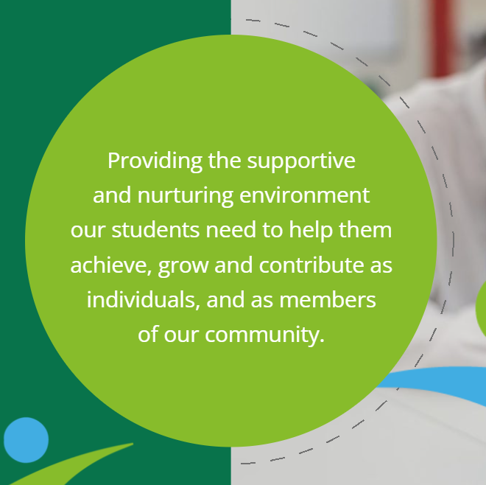
Visit our website to find out more about what we offer: Bridge School |
The Role:
We are seeking an inspirational and dynamic Headteacher to lead The Bridge School in 2025 and beyond!
The successful candidate will be a visionary leader with a passion for inclusive education and a commitment to making a positive impact on the lives of young people.

Key Responsibilities:
- Provide strategic leadership and direction to the school, ensuring high standards of teaching, learning, and student achievement.
- Foster a safe, inclusive, and supportive school environment that promotes the well-being and personal development of all students.
- Work collaboratively with staff, students, parents, and external agencies to address the unique challenges faced by our students.
- Develop and implement innovative strategies to improve student outcomes and address emotional and behavioural barriers to learning.
- Ensure the school meets all statutory requirements and maintains a strong focus on safeguarding and child protection.

A Welcome from the Director of Education, Inclusion and Provision, Halton Borough Council.

This is an incredibly exciting time for Halton! As a Local Authority, we are thrilled to be working with the Management Committee to appoint to this key role for Halton.
The successful candidate will have the opportunity to work with us to redefine and shape the landscape of AP across the Borough for 2025 and beyond.

Following the publication of our new Children and Young People’s Plan, we are excited to embark upon the journey with all our school leaders and partners to develop our new Education, SEND and AP strategies to enable us to achieve our ambitions…and the headteacher of our PRU will play a vital role, not just for the school, but the borough as a whole!

We are therefore looking for a successful candidate to have the motivation and determination to be a key member of our strong partnership, with the best interests of every child within Halton at the center of all we do.

In return, you would be working within an inclusive and supporting local area, with strong relationships between school leaders, the Local Authority and wider partners.

We very much look forward to receiving your application!

Ben Holmes
Director of Education, Inclusion & Provision.

Headteacher Job Description
Post title | Headteacher of The Bridge School
Reporting to | Chair of Management Committee
Contract type | Permanent, Full Time (L21 – L25)

Please note: this job description is subject to the general conditions of service for a Headteacher as set out in the current School Teachers’ Pay and Conditions Document.

Main duties and responsibilities:

- To fulfil all the requirements and duties as set out in the School Teachers’ Pay and Conditions Document relating to the Conditions of Employment of Headteachers, in line with the National Standards of Excellence for Headteachers, and to act in accordance with other legislation affecting the conduct of the School.
- To have overall responsibility for leadership, strategic and operational management of the School. To lead, develop and support the strategic direction, ethos, vision, values and priorities of The Bridge School in partnership with the Management Committee and the Local Authority.
- To meet the Headteachers Standards as published by the DfE.
- To seek to achieve any performance criteria, objectives or targets agreed with or set by the School’s Management Committee in accordance with the requirements set out in the School Teachers’ Pay and Conditions Document.
- To promote and safeguard the welfare of all children and young people within the School, by ensuring that the School’s policies and procedures relating to safeguarding children and child protection are fully implemented and followed by all staff.
- To ensure that resources are allocated to allow staff to discharge their responsibilities.
- To ensure that staff, pupils, parents and others feel able to share their views and raise concerns and that these are addressed sensitively and effectively to achieve the best outcomes for students.
- To be an integral part of the strategic leadership overseeing Halton’s Alternative Provision Strategy

Management Committee Priorities

The School's Governing Body wish a particular emphasis to be placed upon the following:

- Provide outstanding leadership which motivates and inspires staff to provide a high quality education for every student and promotes the highest possible standards of achievement and wellbeing. Build leadership capacity at all levels through actively developing strategic leadership and a distributed leadership model that ensures clarity of roles and accountability.
- To lead in the provision of excellent teaching and learning and raise standards across the school in terms of academic performance and personal development so that all pupils achieve to the very best of their ability.
- To report to the School’s Management Committee on progress made against School Development Plan objectives, making recommendations as to future priorities whilst ensuring this takes account of the diversity, values and experience of the School and its wider community.
- Ability to manage the financial and human resources effectively and efficiently to achieve the School’s educational goals and priorities, ensuring best value.
- To further develop partnerships with a variety of stakeholders through collaboration especially with mainstream heads/schools or colleges/special schools to achieve best outcomes for students both within the school and beyond.
- To lead the school through rigorous self-evaluation, including quality assurance and performance management at all levels.
- To establish and sustain the school’s ethos and strategic direction in partnership with the Management Committee, Local Authority and the local community.

Conditions of Employment
The above responsibilities are in accordance with the current School Teachers' Pay and Conditions Document. It is also subject to any local agreements and LA guidance on interpreting conditions of service.

Review and Amendment
This job description may be amended at any time after consultation with the post holder. It is normally subject to annual review. Subject to the provisions of the School Teachers' Pay and Conditions Document it may be amended at the request of the Management Committee or the Headteacher but only after full consultation between them. It will be signed if agreement is reached.

If, following review and amendment, agreement is not reached, the appropriate procedures should be used for the settling of any disputes.

Where the role holder is disabled every effort will be made to supply all necessary support, aids, adaptations or equipment to allow them to carry out all the duties of the role. If, however, a certain task proves to be unachievable, job redesign will be given full consideration.

Person Specification
Attributes
Qualifications
Essential
- Qualified Teacher status
- First degree or equivalent

Desirable
- The National Professional Qualification for Headship (NPQH)
- Evidence of recent relevant study

Experience
Essential
- Proven leadership experience in a secondary school context
- Demonstrate substantial and successful teaching experience at Key Stage 3/4.
- Evidence of leading, implementing, monitoring and reviewing school curriculum.
- Experience of developing excellent teaching and challenging underperformance.
- Demonstrable experience of successful line management and staff development.
- Proven record of successfully leading whole school improvement.
- Experience of collaborative working with and developing links with the community.

Desirable
- Proven leadership experience of PRU/AP/SEND Educational settings.
- Experience of working with and/or involving school Governors/Management Committee members.

Knowledge & Understanding
Essential
- Knowledge of national educational standards and expectations.
- Knowledge of the legal framework and requirements for education and of educational policy and the process of policy making.
- Knowledge of governance at national, local and school level.
- Knowledge and understanding of data analysis; ability to use data to set targets for improvement and evaluate an action plan in relation to those targets.
- Knowledge of models of quality learning and teaching; highly effective behaviour and attendance management; and strategies for ensuring inclusion, diversity and access.
- Legal issues relating to managing a school, including equal opportunities, race relations, disability, human rights, employment and health and safety legislation.
- Confident in whole school self-evaluation and school improvement planning process.
- Up to date knowledge & understanding of the current national education agenda.
- Understanding of how children & adults learn and effectively apply their learning to their own practice.
- Understanding of the contribution of the School to the community.
- Understanding of how to evaluate and review the cost effectiveness of a major spending decision in terms of educational standards and the quality of education.
- Knowledge of duty to safeguard the welfare of all children and young people within the School, by ensuring that the School’s policies and procedures relating to safeguarding children and child protection are fully implemented and followed by all staff.

Leadership Skills
Essential
- The ability to develop and maintain a clear vision for the School skillfully articulating the vision to diverse audiences.
- To be able to plan, prioritise, implement and evaluate organisational strategies, making best use of available resources.
- Well-developed leadership skills and the ability to enthuse, inspire and motivate others.
- The ability to lead by example with integrity, creativity, clarity and resilience, demonstrating a strong moral purpose.
- Demonstrate effective decision making skills to be able to initiate, implement and monitor policies and practices.
- Demonstrate strategic thinking and leadership, a commitment to creativity.
- Ensure a whole school culture of CPD, driven by evidence, so that teaching is high quality in all subjects and areas of learning
- Ability to build relationships with the governing body and parents.
- Evidence of successful school improvement planning and delivery.

Decision-Making Skills
Essential
- The ability to listen and consider stakeholder’s views in decision making
- Ability to investigate, resolve problems and make decisions.
- Ability to make effective and strategic judgements under pressure and scrutiny.
- Collect and weigh evidence, make judgements and take decisions in line with good educational practice.
- Ability to think creatively and imaginatively to solve problems and identify opportunities.

Communication Skills
Essential
- Ability to demonstrate and communicate vision and inspire others to follow
- Effective communication skills orally and in writing to a wide range of audiences.

Self-Management Skills
- Ability to plan time and organise work effectively.
- Work under pressure
- Recognise that a work/life balance is important and take steps to manage workload of self and staff to ensure a healthy and happy life outside of work.

School Ethos
Essential
- Promote and ensure that the school is inclusive and welcoming to everyone.
- Ensure that the school builds positive character such as resilience, problem-solving and respect for all.
- Ability to support and help develop a vision for high quality education which promotes spiritual, moral and cultural development.
Personal Attributes
Essential
- To uphold and demonstrate the Seven Principals of Public Life at all times
- Demonstrate consistently high standard of principled and professional conduct.
- Energy, tenacity and the ability to work under pressure in challenging circumstances.
- Enthusiasm.
- Commitment to equality.
- Capacity to influence others.
- Adaptability to changing circumstances & ideas.
- A sense of humour and willingness to resolve difficulties by working with people face to face not solely through electronic communication.
- Reliability and integrity.

Why Join Us:
- Opportunity to make a significant impact on the lives of young people and their families.
- Supportive and collaborative working environment.
- Professional development opportunities to enhance your leadership skills.
- Competitive salary and benefits package.

If you would like to find out more, members of the Management Committee and the Local Authority would love to welcome you to an open evening at the school on Monday 3rd March 4pm-6pm during which you will be able to have a tour of the school sites and find out more about the role & answer any questions you might have. To reserve a space, please email Bev.MacQuire@thebridge.halton.sch.uk

How to Apply:
Please submit your application and a covering letter outlining your suitability for the role before the closing date on 21st April 2025.
Interviews will be completed over two days, on 28th April and 1st May 2025 (with the anticipation that some candidates will not proceed to day 2 of the assessment process)
For more information about The Bridge School, please visit our website at The Bridge School or call the school to schedule an informal discussion with the Director for Education, Inclusion and Provision.
Join us in making a difference and shaping the future of our students at The Bridge School!
The Management Committee is committed to safer recruitment practice and pre-employment checks will be undertaken before the appointment is confirmed. The Bridge School are committed to safeguarding and promoting the welfare of children and young people and expects all staff and volunteers to share this commitment. The post is subject to enhanced Disclosure and Barring Service disclosure.
“A safe and supportive environment where pupils are encouraged to reach their potential”

