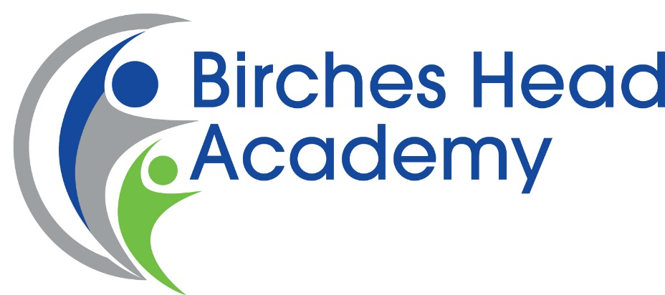

Recruitment Pack

Assistant Head: Teaching and Learning
L12-L16 (£52,414 to £57,934)

Closing Date: Tuesday 19th March 2019 at 9am
Interviews: Wednesday 27th & Thursday 28th March 2019

In the interests of economy, we regret that we are unable to acknowledge all applications. If you have not received an invitation to attend an interview by Monday 25th March please accept this as an indication that you have been unsuccessful on this occasion.

A Message from the Headteacher

Dear Applicant,

Thank you for downloading this application pack and for your interest in becoming an Assistant Head: Teaching and Learning for Birches Head Academy, in Stoke-on-Trent.

This is an exciting time at Birches Head Academy as the Academy has made dramatic improvements and seen a complete culture change in recent years resulting in rapidly growing numbers of children applying for places .
The Academy works in partnership with a number of schools both locally and nationally including St John Plessington Catholic College in the Wirral, a National Teaching School, Leading Edge School and National Support School. We also work closely with many of our local Secondary schools as well as our primary feeder schools and colleges to ensure all students have the very best opportunities and outcomes.
The Academy has excellent facilities and has undergone extensive building work under Building Schools for the Future.
I have very high aspirations for the young people at Birches Head Academy. I want the very best for them. I want them to ‘Aspire to be More’. If you feel you can make a contribution to this important enterprise and help our children to be the best that they can be, then I look forward to receiving your application.
If you would like to discuss this vacancy or visit the school please contact Mrs J Bracegirdle , Head’s PA and Office Manager by email jbracegirdle@bircheshead.org.uk

Yours faithfully

Ms K Dixon
Headteacher

Our Academy Vision
We seek to build a community where our students have the social, intellectual and cultural capital to have:
- Unlimited ideas and dreams
- A vision of what they want to achieve in life and how to achieve it
- A strong sense of duty and of service to others
- Care and compassion for each other
- Choice filled lives and be good people
Above all else, we want our students to experience fullness of life, where the sort of person that they become is of paramount importance. This is articulated in our motto “Aspire to be More”
We want to be the best school in the city and one of the best in the country, so that all our pupils have the best education and pupils to model positive behaviours based on mutual respect and social integrity. Our community has a consistent culture of high expectations so that everyone can achieve their full potential. We will celebrate achievement and swiftly address underachievement. By doing this we will instil into our pupils a desire and the means to be the best and make a positive difference in our world.
The Senior Leadership Team
We are keen to expand the capacity of our current senior leadership team to continue to lead the rapid improvements the school is making providing the best education for all learners and to be judged at least “Good” by our next Ofsted visit. The team currently comprises of the Headteacher, Deputy Head (Pastoral), Deputy Head (Curriculum), and one Assistant Head (Outcomes). Our extended leadership team includes a Senior Teacher and Senior Support Staff.
The Context
The City of Stoke-on-Trent is in the West Midlands and has a population, of 249,000, which is predominately white British but with a significant minority ethnic community. Ambitious plans are underway to transform and renew the City through major investment in health, housing, economic development, and education. The ‘Potteries’ as Stoke-on-Trent is affectionately called is renowned for its world class ceramics industry and industrial heritage. The Midlands power house is driving economic growth and renewed prosperity.

The City boasts a strong cultural tradition with its ceramics heritage and Performing Arts tradition.

With a 10% increase in the number of children, education is of critical importance to the future prosperity of the City, and the BSF programme has established excellent facilities for our young people.

Our Academy Values
As a student of Birches Head:
• I will have self-belief and the social skills to continue to succeed in an ever-changing world
• I will take pride in my efforts and have the confidence to celebrate my successes
- I will embrace challenges and opportunities; I will make a positive contribution with honesty and integrity

Staff of Birches Head will:
• Inspire you to grow in confidence, resilience, self-respect and with a sense of responsibility
• Foster a sense of pride in you and celebrate your successes
• Expand your horizons, challenge you to reach your full potential and realise your aspirations

Job Description
Birches Head Academy is committed to safeguarding and promoting the welfare of children and young people and expects all staff and volunteers to share this commitment.
The successful candidate, in partnership with the Headteacher and Deputy Headteachers will provide vision and leadership for the school, maintaining and developing conditions that enable outstanding learning.
To ensure that the aims of the school are implemented, so that the school’s vision is realised.

This post is subject to an Enhanced DBS Identity Check under the rehabilitation of Offenders Act (1974).

Candidates called for interview will be required to provide photographic proof of identity, proof of address and original qualification documents.

Assistant Headteacher: Teaching and Learning

Job Description

Job Description Assistant Headteacher – Teaching & Learning
Job Title: Assistant Headteacher - Teaching & Learning
Key purpose: School Improvement
Accountable to: the Headteacher
Accountable for: Line management of departments, quality of teaching and learning across the Academy.

Key Accountabilities
Shaping the future | Work with the leadership team to develop a strategic view for the school in its community.  • Analyse and plan for the future needs and further development of the school within the local, national and international contexts.  • Keep abreast of developments in teaching and learning and education more broadly to add value by innovation. Student wellbeing
Student Wellbeing | • Work with the leadership team to secure and sustain effective student support systems in the school.  • Ensure that the highest standards of behaviour and attendance are maintained.  • Leading teaching and learning
Leading Teaching and Learning | • Work with the leadership team to secure and sustain outstanding teaching and learning throughout the school.  • Monitor and evaluate the quality of teaching and standards of students; achievement.  • Use benchmarks to set targets for improvement as a whole school and departmental level.
Developing self and working with others | • Take responsibility for specific aspects of the leadership, motivation, support, challenge and development of staff.  • Lead and train staff.  • Identify talent and develop staff towards goals.
Leading and managing the organisations | • Lead aspects of the school’s development plan.  • Lead the development of BHA teaching and learning policy  • Lead quality assurance processes to maintain and enhance the effectiveness of teaching and learning
Securing Accountability | • Assist the Headteacher in accounting for the efficiency and effectiveness of the school to the governors.  • Systematically review and monitor standard using the voice of all stakeholders.  • Take responsibility for student progress and the implementation of whole school improvements.
Strengthening the community through collaboration and partnerships | • Be able to encourage and collaborate with people within and beyond the school community

Duties
As stated in the School Teachers Pay and Conditions Document 2018 the post of assistant head teacher consists of:
a) formulating the aims and objectives of the school;
b) establishing the policies through which they are to be achieved;
c) managing staff and resources to that end;
d) monitoring progress towards their achievement;
e) undertake any professional duties of the Headteacher reasonably delegated by the Headteacher.

Person Specification
PERSON SPECIFICATION FOR ASSISTANT HEAD: Teaching and Learning
TEAM: Senior Leadership team
Personal Attributes
 | Essential |  | Desirable
 | Attribute | Stage Identified | Attribute
Qualifications | - Qualified Teacher Status*  - Graduate* | A | - Additional relevant qualifications*  - Evidence of further study, particularly in the field of educational management*  - NPQH* | A  A  A
Experience | - At least 2 years’ experience as a Middle Manager or Local Authority subject work  - Team Leadership  - Successfully leading change | A | - Experience of managing a whole school responsibility  - Teaching experience in more than one school | A  A
Knowledge & Skills | - An excellent classroom practitioner  - The ability to manage, inspire and motivate staff  - Outstanding inter-personal and communication skills  - Evidence of the ability to manage change  - The ability to demonstrate a good grasp of strategies required to achieve their potential  - An awareness of current developments and initiatives in secondary education  - ICT skills | A,R  A, R, I  I  A,R,I | - Knowledge and experience of school improvement/ strategic planning  - Knowledge and experience of engaging all stakeholders in securing consensus  - Target setting and Assessment for Learning  - Knowledge of Accelerated Learning approaches | A  A,R,I  A,I  A,I
Personal Qualities | - A willingness to participate fully in the life of the school  - The potential for further promotion  - Good time management  - Ability to motivate and inspire | A, I  A,R, I  A, R, I  A, R, I
A = Application, I = Interview, R = Reference *Shortlisted candidates should bring with them copies of their qualifications

How to Apply
If you decide to apply for this post please complete an application form: curriculum vitae alone will not be accepted. Your formal letter of application (supporting statement) should be no longer than 2 sides of A4 and should address:

- Why the post attracts you
- Outlines your previous experience and how it would help to fulfil this role.

Please return your completed application to: jbracegirdle@bircheshead.org.uk (Office Manager)

Please note, it is the policy of Birches Head Academy to contact shortlisted candidates only.

Key Dates

Closing Date: 19 March 2019 at 9am
Interviews: 27 & 28 March 2019

Academy Location

Birches Head Academy:
Birches Head Road
Stoke on Trent
ST2 8DD
01782233595
Email: info@bircheshead.org.uk

Additional Information

Ofsted Reports: www.ofsted.gov.uk

Information about Stoke City council: www.stoke.gov.uk

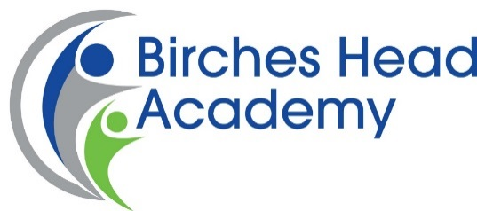

Reference Consent

The School/Academy obtains references as part of the pre-employment process. As part of the reference details relating to your employment, our standard form asks for your absence record e.g. number of days and number of occasions in the last two years, details of any disciplinary records you might have on file and information on your conduct and performance.

Upon receipt of this data it would be reviewed by the appointing manager and HR will hold this information on your personal file for the duration of your employment, it would then be destroyed in line with current requirements.

In line with the new General Data Protection Regulation and Data Protection Act 2018, we require your consent to request this information from your referees.

In order to consent to the School/Academy requesting the information outlined above please sign and date the below to confirm that you are happy for us to proceed on this basis.

Name: …………………………………………....

Signature: …………………………………………….

Date: ……………………………………………..

Once completed, please return this form to:- Mrs J Bracegirdle, Office Manager

