

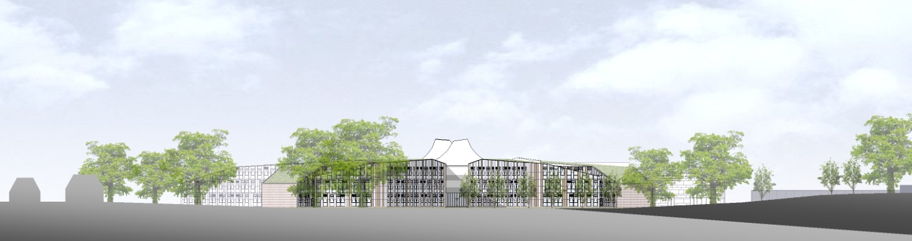

**ST BARTHOLOMEW’S SCHOOL**

**CO-ORDINATOR: NUMERACY**

**FULL-TIME, PERMANENT**



**Andover Road**

**Newbury**

**Berkshire**

**RG14 6JP**

**Tel: 01635 521255**

**Email:** [**recruitment@stbarts.co.uk**](mailto:recruitment@stbarts.co.uk)

**Website:** [**www.stbarts.co.uk**](http://www.stbarts.co.uk)

Dear Colleague,

Thank you for your interest in the position of Co-ordinator: Numeracy at St Bartholomew’s School. I hope that the details contained in this pack will provide you with a clear picture of this post and give you a flavour of the school and its values. This post really is an exciting opportunity as you will be joining a highly achieving faculty in the school with outstanding facilities.

Working at St Bartholomew’s is very rewarding, and the Governors and I look forward to hearing from you if you feel you have the qualities and experience we are looking for.

If you would like to have a discussion with me or the Head of Mathematics and Computing about this post or require any further information, please contact Human Resources on the above number or [recruitment@stbarts.co.uk](mailto:recruitment@stbarts.co.uk).

Yours faithfully,



Julia Mortimore

Headteacher

**ABOUT OUR SCHOOL**

**Academic Success**

For the last 4 years St Bart’s has secured the highest level of student attainment in West Berkshire state schools. We think our academic success is something to be very proud of.

Our key headlines are:

1. This year 83% of our students achieved both GCSE English and Mathematics at level 4 or better and 29% of all grades were 9 – 7.
2. Last year our Progress 8 score was 0.66 which put St Bartholomew’s in the top 8% of schools nationally which we are very proud of and this year it is again strong at 0.48.
3. A level results are above national averages with 27% of all grades A*/A and 75% of all grades A* – C.

**Ofsted and School Development**

This is an important appointment for the school at an exciting time when we are working towards becoming outstanding as recognised in our recent short Ofsted Inspection. At St Bartholomew’s we all work together as a team to share good practice, and really develop outstanding teaching and learning to ensure every student makes expected or greater than expected progress.

Every member of staff is part of an Action Research Group and you will also contribute to whole school development in this way. The staff at St Bartholomew’s care very much about the community and are ambitious for the school in terms of learning and enrichment opportunities for all the students.

Teaching at St Bartholomew’s School is a rewarding experience. Our students are eager to learn, well behaved and proud of their school, and this was reflected in our last Ofsted inspection which judged students’ behaviour and safety as outstanding. As a school we are committed to ensuring that all the students and staff realise their full potential. Students leave the school as good citizens and this is underpinned by an exceptional house system and a vast range of extra curricular activities.

**Professional Development**

The professional development of staff is a significant factor in ensuring that we achieve our aim of improving on our previous best and there are rich professional development opportunities at St Bartholomew’s (see CPD offer on our website under Job Opportunities) at all levels. We are praised for our induction and NQT programmes for new staff which are supportive and thorough. Coaching is available for all staff across the school upon request, or maybe you’d like to become a Coach yourself?

**Our School**

Our modern building reflects the importance of the House system, with House blocks (Curnock, Davis, Evers and Patterson) sited around a covered outdoor Hub space.

Our school buildings include outstanding teaching facilities: drama and dance studios, extensive music practice rooms, IT and media suites, specialist design technology rooms and well-equipped laboratories. Sports provision is exceptional including a multi-purpose sports hall, a well-equipped gym hall, an outdoor synthetic turf pitch, a multi-use games area and extensive playing fields.

The wide range of extra-curricular enrichment offers all students new opportunities for learning and enjoyment. This includes clubs and activities such as debating, equestrian, moth club, craft and horticulture, as well as Chinese and Latin classes and a huge range of activities in music, drama and dance. House competitions and activities involve all students. Sporting traditions are very strong with an exceptional range of sports teams competing successfully at the highest standard. Our students love representing their school.

**What’s in it for me?**

1. Excellent IT infrastructure.
2. Smaller than average class sizes.
3. All staff are issued with their own laptop.
4. All faculties have their own office within which teachers have their own designated workspace.
5. A subsidised meal at Activity Time.
6. Ample on-site parking.
7. Staff may be eligible for student places at the school for their children.
8. Staff Forum – an opportunity for staff to meet and voice their suggestions for improvements to the school.

**The Faculty**

The Mathematics and Computing Faculty aims to enable all students to reach their maximum potential by employing a variety of teaching methods on a range of courses. Imaginative use of practical and open-ended activities is encouraged, and the faculty aims to use ICT effectively to enhance learning.

The Mathematics and Computing Faculty has a strong ethos of teamwork.

At present the faculty consists of 16 Mathematics specialist and 3 Computing specialist members of teaching staff, plus 2 part-time Teaching Assistants. The Mathematics Faculty has eleven teaching rooms and an ICT suite, all on one floor, together with two faculty office/storage areas. The department is well resourced with books, practical equipment and 30 Netbooks. All rooms have an interactive whiteboard.

In Maths at Key Stage 3, 135 students are set into five groups by ability. Students across the curriculum are in two bands according to which House they are in, giving ten groups in each year. We annually hold a Crystal Maze Activity Day with year 8 and students in all years participate in the National Maths Challenge. There are opportunities to participate in a range of other extra-curricular activities, including chess, speed cubing, and a board games club.

At Key Stage 4, 135 students are set into six ability groups, with the class sizes benefitting from the addition of the extra group. We are currently following the AQA GCSE Specification. Most Year 11 students in the highest sets will also be entered for the AQA Level 2 Certificate in Further Mathematics.

In the Sixth Form we offer A level courses based on the Edexcel specifications. We currently have 4 A Level Maths and one separate Further Maths group in each of years 12 and 13. Each year a substantial proportion of Further Mathematics group gain double A/A* grades. In addition we offer the opportunity to take the Core Maths Level 3 qualification to those students who have achieved a GCSE grade 4 or above and want to continue to study Maths, but not at A Level.

Students in Year 12 are able to study a one-year GCSE course.

**The Post**

* We are seeking to appoint a suitably qualified inspiring Co-ordinator: Numeracy to join the Mathematics and Computing faculty with effect from 1 September 2020 on a permanent basis.
* The position is full-time.
* Applications are welcome from newly qualified and experienced teachers.

**The Salary**

* The successful candidate will be appointed to the main or upper pay scale in accordance with her/his experience and qualifications.

**How to Apply**

Full post details, an application form and instructions on how to upload your completed application are available via the Jobs & Training / Job Opportunities section on the School’s website:

[**www.stbarts.co.uk**](http://www.stbarts.co.uk)

(Please note that curriculum vitae and covering letters cannot be accepted)

Successful candidates will be subject to a DBS enhanced check along with other relevant employment checks.

## Closing date: Sunday 19 January 2020

Thank you for considering St Bartholomew’s School, we look forward to hearing from you.