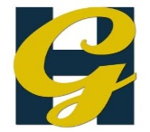
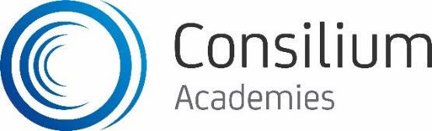

Heworth Grange Modern Languages Department

The Modern Languages department is team of 6 experienced teaching staff who use exciting and innovative teaching strategies to enhance the achievement and enjoyment of pupils from years 7 through to 13. Most pupils study either Spanish or Italian in year 7; the majority of pupils in year 8 study French, with about half also taking Italian or Spanish. In year 9, the majority study one language, with most pupils taking French, and some taking Spanish or Italian. We currently have GCSE groups in all languages in all years of Key Stage 4, and offer all three languages at A Level.

Teaching and Learning in Modern Languages at Heworth Grange

The department prides itself on consistently developing Teaching and Learning, with the aim that all pupils are inspired and engaged by Modern Foreign Languages, and make real progress as linguists.

We are actively involved in whole school CPD, and are keen to implement new ideas that will improve Teaching and Learning. The focus of recent departmental CPD has been on reviewing our schemes of work; this will remain a priority over the coming months. Regular departmental meetings are used to discuss teaching and learning and to develop new resources.

Standards of attainment in GCSE Italian (75% Grades 4-9) and Spanish (60% Grades 4-9) have been consistent and attainment is improving in GCSE French. Attainment at A level is good and many of our pupils choose to go on and study Modern Languages at degree level.

