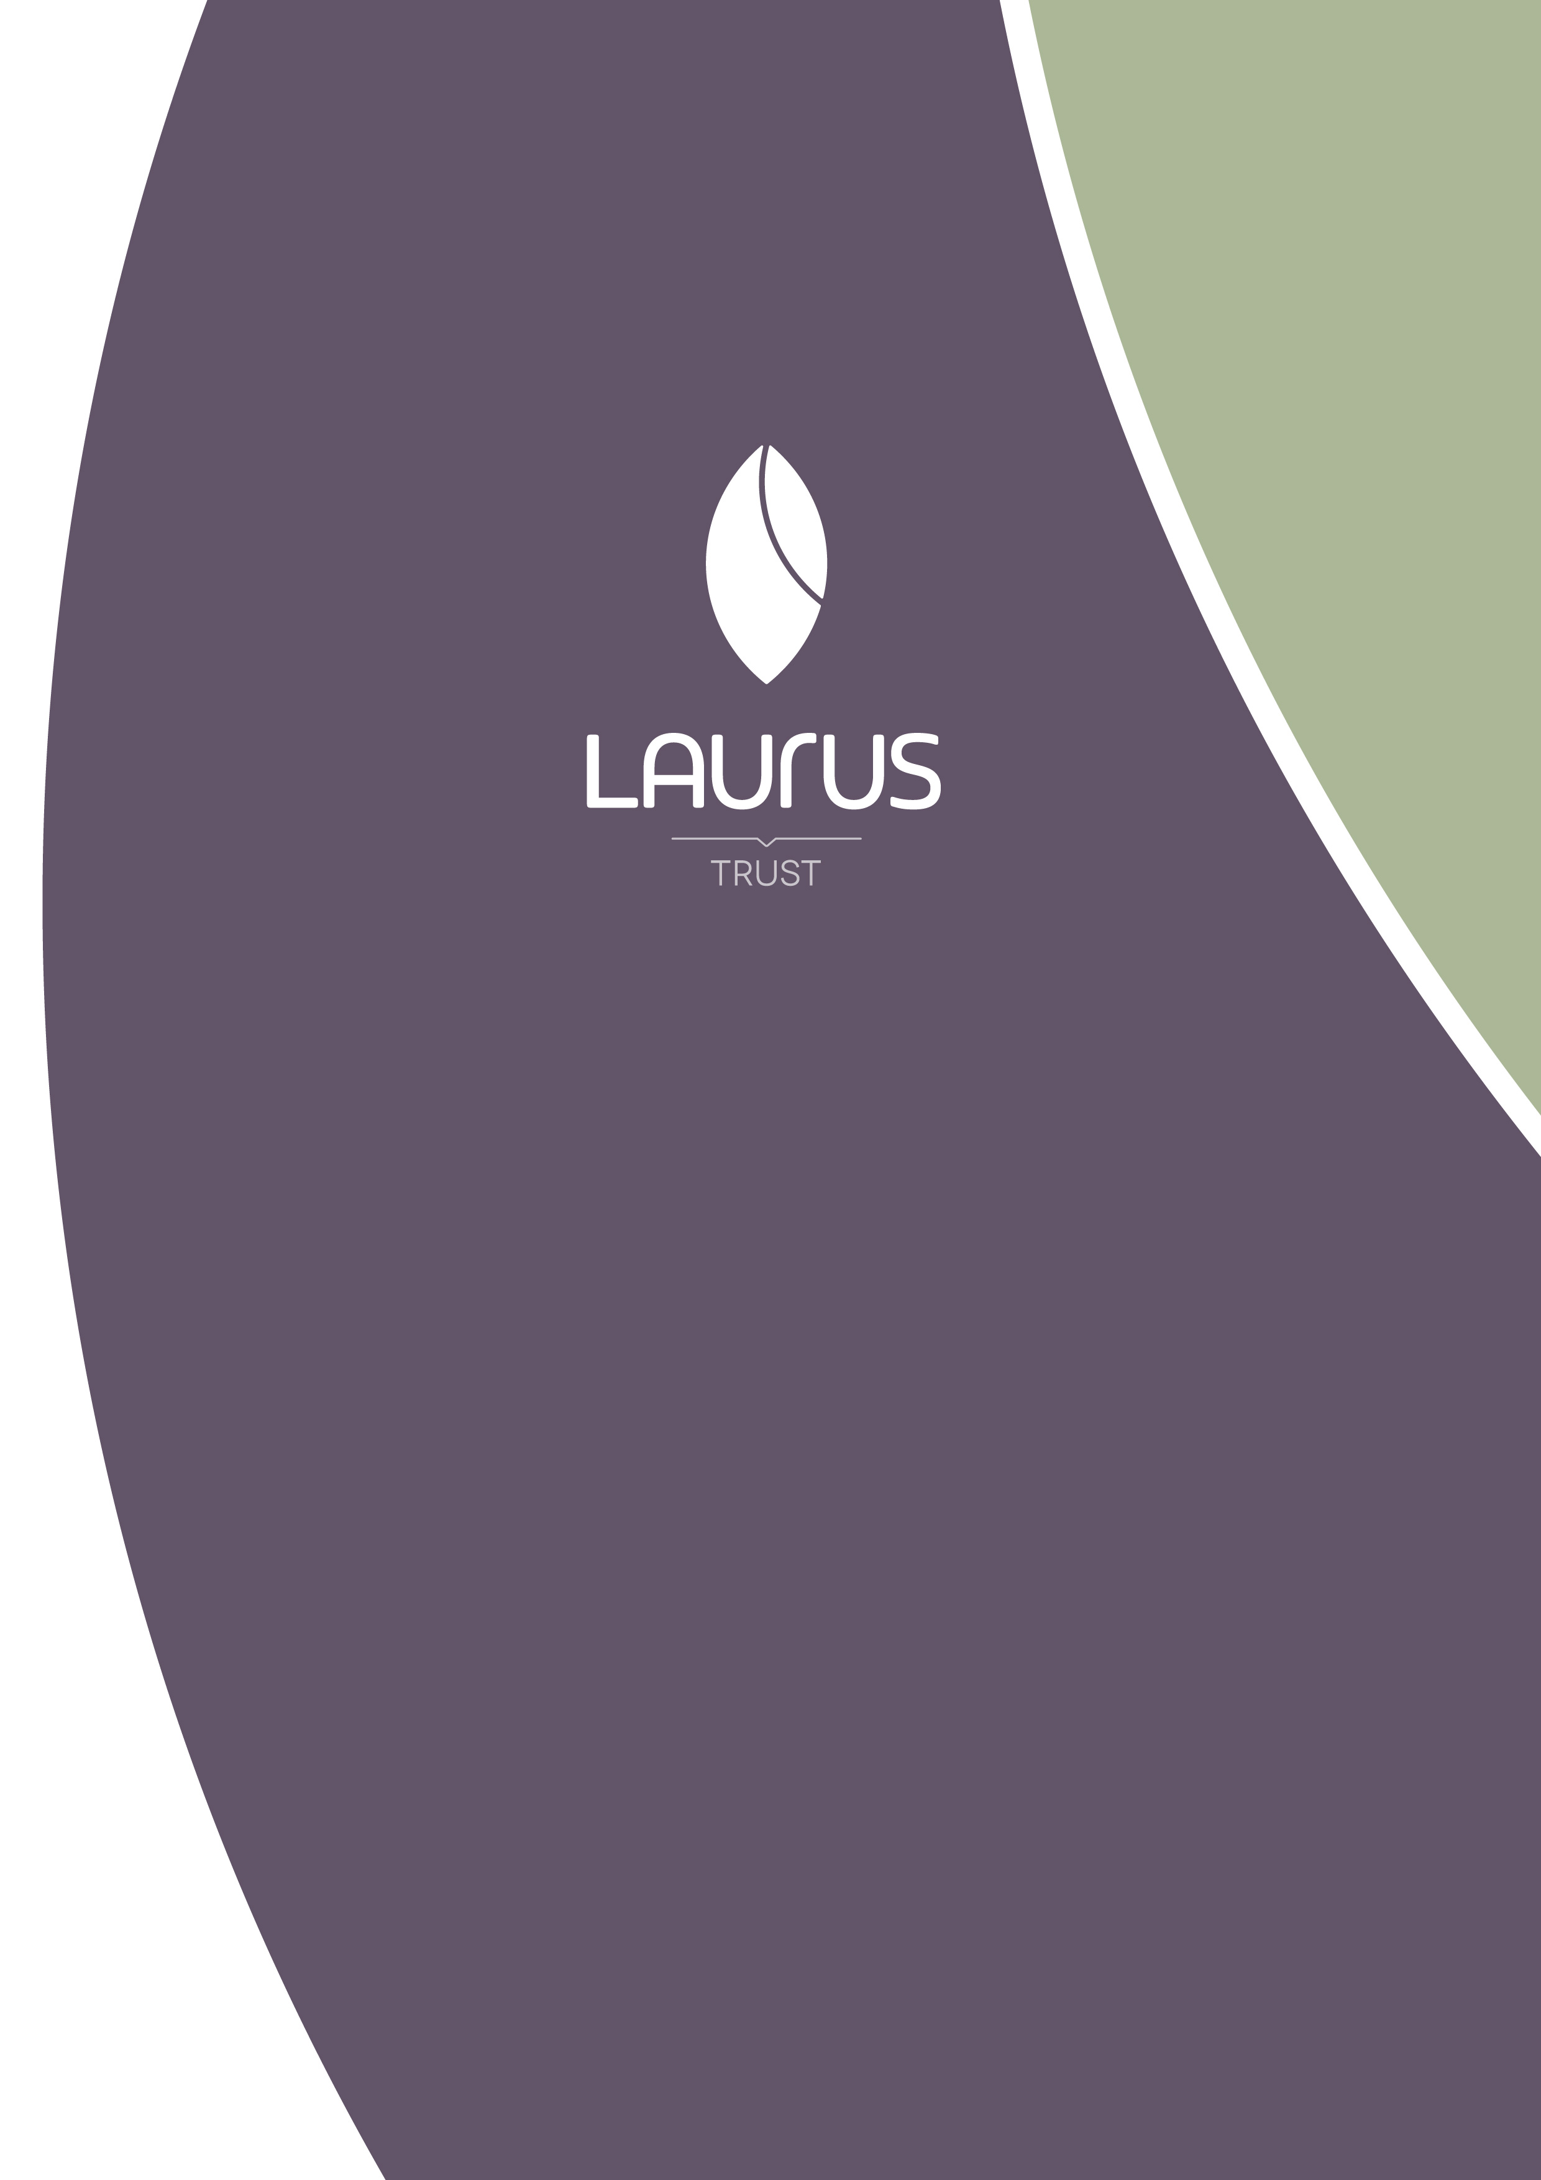
Languages at Laurus

Languages at Laurus

At Laurus schools all students study a Language from Year 7 and take their final GCSE examinations in that Language at the end of Year 9. Our students benefit from at least 8 hours of Language lessons per fortnight in Years 7, 8 and 9. Last year, 97% of our Year 9 cohort sat their GCSE in French, German or Spanish. 76% of those students achieved a grade 5 or higher and 38% achieved a grade 7 or higher.

We believe that it is important to develop our students’ ability to speak and think simultaneously in a Language. Students are challenged to respond without preparation in discussions in class and this leads to them forming strong oracy skills. There are three principle features of the Languages curriculum in Laurus schools which ensure that students become confident and successful communicators in French, German or Spanish:

Speak First – Students are learning how to communicate in another language and this begins with speech. Students quickly build their confidence from day one in Year 7, which allows them to respond naturally to each other and their teacher, being comfortable using the taught language, aiming to achieve excellent pronunciation.

Creative Contexts – We want students to learn a language through a range of compelling contexts which will take them beyond their previous experiences or engage them through creative themes. We teach through topics such as Fairy Tales, The Rainforest, Artists, Architects and Writers, Festivals, Mysteries and Film amongst others.

Scaffolding the Learning – Students need to understand how language is built and connected together. The curriculum in languages has been carefully devised so that grammar is sequenced according to prior learning so that students are given the ability to master key concepts at every stage of their journey.

Co-Curricular enrichment
We believe that students should have the opportunity to experience as many of the different sides to learning a language as possible. In order to support this, we offer a range of enrichment opportunities both within and outside of lessons. These include poetry competitions, opportunities to explore festivals and traditions in other countries, language taster sessions in new languages, visits abroad to the countries where the taught languages are spoken, visiting speakers from universities and the opportunity to mentor and teach younger students.

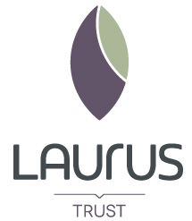 | Laurus Trust  Cheadle Hulme High School  Woods Lane, Cheadle Hulme  Cheadle, SK8 7JY  laurustrust.co.uk

